Board charter

Purpose
This charter summarises the legal foundation, governance arrangements and key policies of the Disability Worker Registration Board of Victoria (Board).

Legal foundation
The Disability Service Safeguards Act 2018 (the Act) is to ‘promote the quality, safety, responsiveness and sustainability of the disability workforce’.
The Act establishes the Board and gives it functions and powers to help achieve this purpose.
The Act also establishes the Victorian Disability Worker Commissioner and Commission.

Disability Worker Regulation Scheme
The Board, Commissioner and Commission are independent entities. They work closely together to operate the Disability Worker Regulation Scheme. They have different, and related, functions. In summary:
- the Board regulates registered disability workers and students
- the Commissioner regulates unregistered disability workers, and
- the Commission supports both.

Inter-relationship
This image shows how the three entities interact:
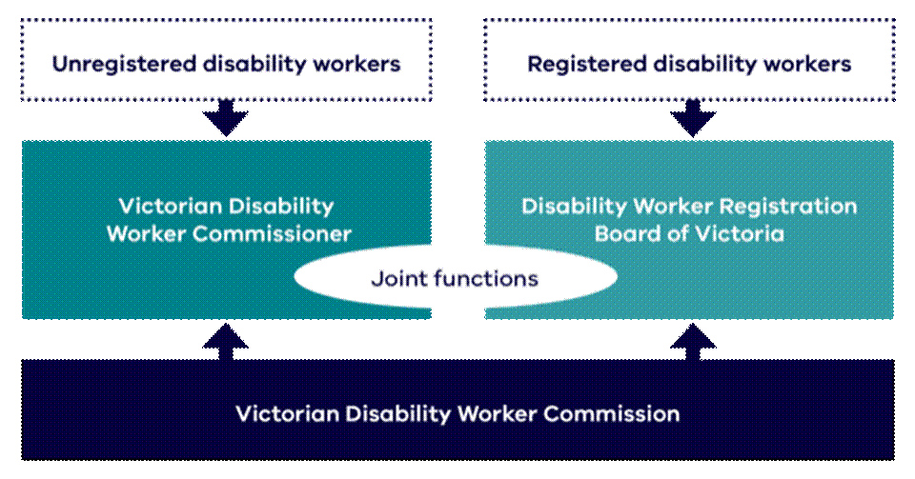

Responsibilities
This table summarizes the key tasks of each entity.
Entity | Responsibilities
Board | Registers disability workers  Sets standards for registration  Can register disability students  Regulates the conduct of registered workers and students.
Commissioner | Head of the Commission  Regulates conduct of unregistered disability workers  Can ban workers within Victoria
Commission | Supports Commissioner and Board  Handles complaints, notifications and investigations about workers  Shares information about disability worker regulation  Maintains the:  - Board’s register of registered workers, and  - Commission’s register of prohibited workers

Regulatory management agreement
The Act requires the Board and Commission to enter into a regulatory management agreement. This must cover:
- fees disability workers and disability students must pay under the Act
- the Board annual budget
- services the Commission provides the Board to carry out its functions under this Act.

Obligations
Board members
- comply with the Board Code of Conduct and Code of conduct for directors of Victorian public entities - VPSC
- uphold the Scheme values of diversity and inclusion, independent and fair, fearless and accountable, trust and respect, empathy and dignity
- Demonstrate the Victorian public sector values of responsiveness, integrity, impartiality, accountability, respect, leadership and human rights.

The Board has set policies with which members must comply. These include, for example, conflict of interest, declarations of private interest, privacy and gifts benefits and hospitality.

Governance

Appointment
The Governor in Council appoints Board members, on the recommendation of the Minister for Disability. This includes a chairperson
Terms are up to three years. Members can be re-appointed, and in some cases temporarily extended to enable recruitment.

Payment
Payments to Board members must comply with guidelines set by the Governor-in-Council. These are available at Board appointment, remuneration and diversity guidance | vic.gov.au.
The guidelines cover:
- meetings and activities members can be paid for.
- rates. These depend on which ‘category’ an entity is. The Board is category ‘Group C, Band 2’.
- reimbursement of expenses.

Powers and delegation
The Board has statutory powers. It has delegated some of these.
They are covered by the Board delegation policy.

Meetings and decisions
The Act requires:
- the chairperson runs the meeting, or, if the chairperson is absent, members appoint a member to do so
- the Board must keep accurate minutes
- to make valid decisions, the Board needs a ‘quorum’ of over half of current members.
As a general practice, the Board aims to seek consensus. However, if not possible, the Act provides:
- decisions are made by voting, and
- in the case of a tie, the person running the meeting has an extra ‘casting’ vote.
The Commission supports the Board to carry out its functions. As part of this, Victorian Disability Worker Commissioner and Commission Directors attend meetings to support discussions. Other staff may attend, depending on the agenda, when relevant to their responsibilities.
The Board may invite other attendees as guests for all or part of meetings. For example, representatives from the Department of Families, Fairness and Housing or other regulators.

Secretariat
The Commission provides secretariat services to the Board, as part of its role to support the Board. This includes supporting the Board to receive accessible processes, papers and meetings.

Accountability

External
The Board shares an Audit and Risk Committee with the Commission. This is designed to meet the Board’s obligations under the Financial Management Act 1994 in relation to compliance and risk management.
The Audit and Risk Committee consist of independent people who are not Board members or Commission staff. It provides assurance and advice to the Board and Commission. It also administers the Board and Commission internal audit plan.
More information is in the Audit and Risk Committee Charter.

External
The Board is subject to the external scrutiny bodies and mechanisms that apply to the Victorian public sector. These includes the Victorian Auditor General’s Office, the Independent Board-Based Anti-Corruption Commission and freedom of information legislation.

Related documents

External compliance and guidelines
Code of conduct for directors of Victorian public entities - VPSC
Guide to public entity board governance | vic.gov.au
Board appointment, remuneration and diversity guidance | vic.gov.au
Towards best practice guide for regulators | vic.gov.au
Governance principles for boards of public sector entities in Australia – 2023 – Governance Institute of Australia

Review and currency
The Board reviews this charter every three years, or sooner if required by operational, legislative or policy change.

Version history
Release notice
Version | Date of effect | Amendment details | Amended by
1.0 | 12 May 2026 | Initial release
Approved by: | Acting Board Chair |  | Approved on: | 12 May 2026
Next review due: | May 2029

