Victorian Disability Worker Commission and Disability Worker Registration Board of Victoria
Strategic plan 2024–27 (accessible)

Acknowledgement of Country
The Victorian Disability Worker Commission and Disability Worker Registration Board of Victoria proudly acknowledges and celebrates First Nations people and their ongoing strength in upholding some of the world’s oldest living cultures. We acknowledge the Traditional Custodians of the lands throughout what is now Victoria, where we live and work, and pay our respects to their Elders, past and present.
Traditional Custodians maintain that their sovereignty has never been ceded. The strength, resilience and pride of First Nations people, their cultures, communities and identities continue to grow and thrive today despite the impact of colonisation.
The Commission celebrates the important contribution of First Nations communities in supporting and progressing the rights of those with disability.
Accessibility statement
The Victorian Disability Worker Commission aims to make its information and publications accessible to all. This Strategic plan has been designed in both a PDF and accessible Word format. If you require an alternative format, please email the Commission <info@vdwc.vic.gov.au>.
The Commission and Board are statutory entities of the State Government of Victoria created under the Disability Service Safeguards Act 2018.
© State of Victoria (Victorian Disability Worker Commission and Disability Worker Registration Board of Victoria) 2024
The Victorian Disability Worker Commission and Disability Worker Registration Board of Victoria Strategic plan is licenced under a Creative Commons Attribution 4.0 licence.
You are free to re-use the work under that licence, on the condition that you credit the State of Victoria (Victorian Disability Worker Commission and Disability Worker Registration Board of Victoria) as author, indicate if changes were made and comply with other licence terms. The licence does not apply to any images, photographs or branding, including the Victorian Government logo, Victorian Disability Worker Commission logo, the Disability Worker Registration Board of Victoria logo and the logos used to certify registration as a registered disability worker.
Copyright queries may be directed to the Victorian Disability Worker Commission <info@vdwc.vic.gov.au>.
ISSN 978-1-76130-700-3 – Online (pdf/word)
Published October 2024
Victorian Disability Worker Commission
Level 20, 570 Bourke Street
Melbourne VIC 3000
Phone: 1800 497 132
Email: info@vdwc.vic.gov.au
Web: www.vdwc.vic.gov.au

Message from the Commissioner and Chair of the Registration Board
We are pleased to present the Victorian Disability Worker Commission and Disability Worker Registration Board of Victoria’s Strategic plan for 2024–27.
Since the Disability Worker Regulation Scheme started on 1 July 2020, the Victorian Disability Worker Commission and Disability Worker Registration Board of Victoria have operated to protect people with disability and build a stronger, safer disability sector.
Now in its fifth year of delivering regulatory operations for the Commission and fourth year for the Board, we are pleased that our work to date has helped improve quality of care and service standards across the Victorian community for people with disability.
This plan builds upon the strong foundations laid in our Commission and Board Corporate plan 2022–24 and lessons we have learnt since the Scheme’s establishment. It affirms our commitment to people with disabilities by keeping people with disability at the heart of what we do and in every decision we make.
We have identified three pillars for the next three years where we will have the greatest impact. These pillars are:
- Registration and workforce standards for workforce quality
- Safety and compliance
- Strategic engagement.
These pillars aim to strengthen trust in disability workers, improve knowledge and capabilities in the workforce, ensure there is an accessible, responsive and balanced process to improve safety and compliance and strategically engage with government, the sector and the disability community.
To meet the demands of the future and adapt to the changes in our operating environment anticipated over the next three years, our Strategic and our separate Corporate plan both outline how we will achieve these pillars to drive change and improve quality and safety for people with disability in the short and long term.
We have also identified a set of enablers – investing in the capability of our staff, monitoring and evaluating our work, maintaining strong systems, supporting strong relationships and managing risk effectively – that will guide and support the realisation of our Strategic and Corporate plans.
We look forward to working with our dedicated staff, members of the Registration Board, stakeholders and the wider disability community to deliver on this plan. Together, we will continue to uphold the rights of people with disability and drive safer, higher quality services delivered by a skilled and valued workforce.

Dan Stubbs
Commissioner
Victorian Disability Worker Commission
Melanie Eagle
Chair
Disability Worker Registration Board of Victoria

About us

Who we are
The Victorian Disability Worker Commission (the Commission) and the Disability Worker Registration Board of Victoria (the Registration Board) regulate disability workers who provide services to people with disability in Victoria.
We are an independent statutory authority and ministerial appointed Registration Board established under the Disability Service Safeguards Act 2018 (Vic) (DSS Act) to reduce the risk of neglect and abuse of people with disability and improve the quality of disability care and service by ensuring workers are appropriately skilled and qualified.
Although the DSS Act establishes us as distinct legal entities, the Commission, the Registration Board and the Victorian Disability Worker Commissioner (Commissioner) work together to regulate disability workers in Victoria.
The graphic opposite illustrates the relationships between the roles of the Commission, the Commissioner, and the Registration Board.
Interrelationships between the Commission, the Commissioner and the Board
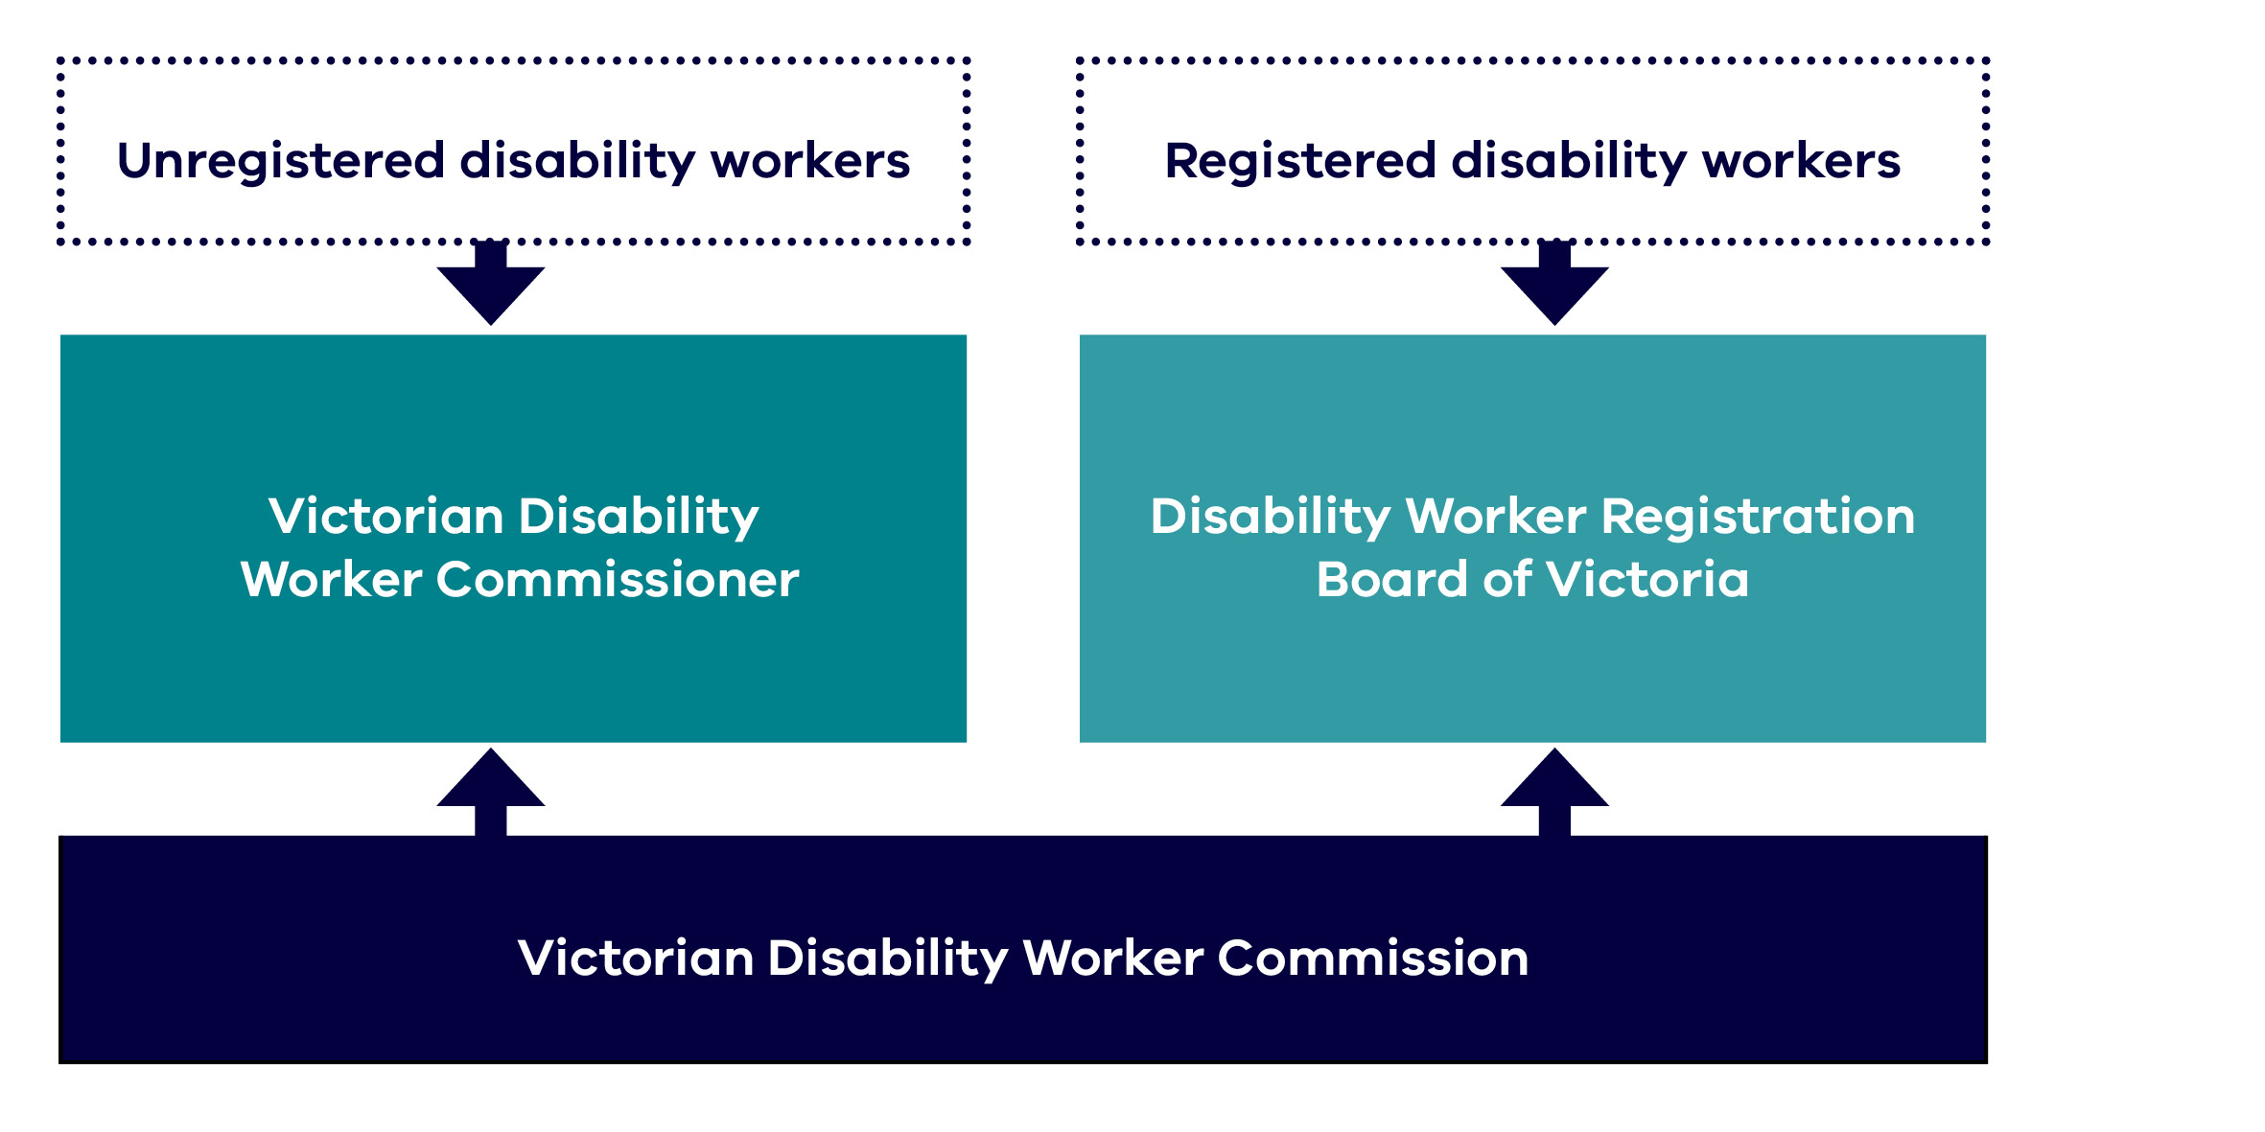

What we do
Our role is to regulate disability workers providing services to people with disability in Victoria to minimise harm, increase the quality of disability services provided by workers, and support service users to choose high-quality, safe workers.
We achieve this by:
- setting expectations of workers via the Code of Conduct for all disability workers offering a voluntary registration scheme for disability workers designed to lift workforce standards and promote and recognise registered disability workers
- encouraging, assessing and managing complaints, referrals, and mandatory notifications about disability worker conduct
- monitoring and enforcing compliance with mandatory standards, registration and practice standards for workers
- maintaining and building relationships with co-regulators, regulatory partners and service users.
For a full list of Board and the Commission functions please see the DSS Act.

Who we regulate
We regulate disability workers who provide a disability service to a person with a disability in Victoria. We also regulate supervisors and managers of disability workers providing a service.
Disability workers provide a disability service to a person with disability so that they can undertake day-to-day activities such as communication, social or economic participation, social interaction, learning, mobility, self-care, and self-management.
Our duty holders, that is, the people who hold a duty to abide by the DSS Act, including the duty to abide by the Code of Conduct and make mandatory notifications include:
- Disability workers who provide disability services to a person with disability in Victoria, regardless of how they are funded.
- Managers and supervisors who oversee, direct or are responsible for disability workers.
- Employers of disability workers, who have obligations to make mandatory notifications.

Our regulatory approach
Our regulatory approach describes the work that we undertake, how we make our decisions and the types of actions that we can undertake to support our vision for people with disability to be able to choose services that best meets their needs and supports their quality of life free from abuse and neglect.
The Commission and Board published their regulatory approach on the Commission’s website on 22 May 2023.
By working with stakeholders, we seek to prevent, minimise, or avoid harms of concern and deliver on our desired regulatory outcomes. We use many tools in support of this approach including:
- raising awareness and educating
- setting standards for disability workers
- encouraging voluntary registration
- supporting compliance with the Code of Conduct and standards
- monitoring compliance and complaints.
Our regulatory principles are collaborative, effective, accountable, fair and inclusive.
Our regulatory approach
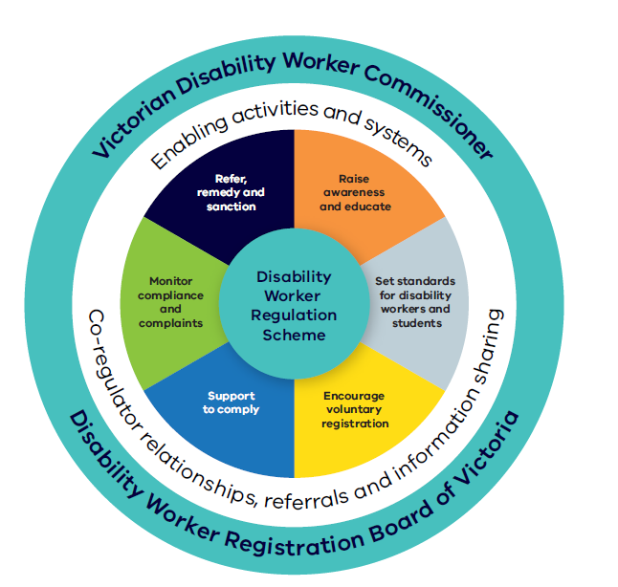
Alternative text for diagram: A circular diagram depicting the regulatory approach. The outer ring depicts the Victorian Disability Worker Commissioner and the Disability Worker Registration Board of Victoria as the 2 statutory bodies delivering the Disability Worker Regulation Scheme. The next ring depicts the over-arching ways these bodies apply their authority and influence: enabling activities and systems, co-regulator relationships, referrals and information sharing. The inner ring depicts the methods used to deliver the approach: Raise awareness and educate; set standards for disability workers and students; encourage voluntary registration; support to comply; monitor compliance and complaints; refer, remedy and sanction.

Our operating environment
We exist to protect one of Victoria’s most vulnerable communities: people with disability.
In Victoria, about 21%, or more than 1 in 5 people, identify as having a disability. According to studies, 32% of people with disability sometimes or always need help with self-care, mobility or communication.
Disability workers provide essential services to support people with disability to live lives to their full potential. Of the 1.35 million Victorians with disability (living in households), three in five (60.5% or approximately 800,000 people) needed assistance with at least one activity of daily life.
When those 800,000 need a support worker or disability support practitioner to assist them, we regulate that work for its safety and quality.
Many Victorians receive support outside the NDIS framework. Research conducted by RMIT for the Commission found there are approximately 155,000 workers in Victoria providing a disability service to a person with disability. This work is diverse, ranging from assisting with shopping, cooking or cleaning, providing self care, tutoring and training, supporting individual participation in social and recreational activities and allied health professionals providing clinical and therapy services. Of the 1.4 million Victorians who had disability, over 1.2 million had a limitation with at least one of the core activities of communication, mobility or self-care, and/or a schooling or employment restriction.
Disability workers do crucial work to support our communities and people with disability. Disability support work, however, is complex. It needs a workforce with the skills and expertise to provide safe, quality supports.
More broadly, there are pressures on supply of the workforce in the disability sector. There is ongoing competition for workers from other sectors and relatively low pay rates contributing to high turnover. The workforce also has a higher proportion of sole practitioners than originally anticipated, adding complexity to the environment in which the Scheme operates.
Victoria’s new Social Service Regulator, which commenced operations in mid-2024, is anticipated to bring changes to the regulatory landscape across all social services, including the disability workforce. In 2024, the Victorian Government announced that the Commission and Board will merge with the Social Services Regulator. The Commission and Board will work collaboratively with the Victorian Government and the new Regulator to ensure a smooth establishment, transition and maintain strong safeguards for people with disability.
Nationally, the disability sector is also rapidly evolving. There is increasing focus on improving the quality of the disability workforce regardless of how they are funded. The need for a national regulator of the disability workforce is broadly acknowledged, highlighting growing opportunity for regulators across the sector to collaborate. This occurs against the backdrop of broader cultural changes that will require deep engagement with people with disability.
Consultation and engagement with people with disability and the wider sector remains central to ensure that the regulation of disability workers is implemented in a person-centred way. The return to more face-to-face stakeholder engagement post-COVID provides opportunities to further increase awareness and understanding of the Commission and Registration Board’s roles.
The Commission and Board will continue to work with the Department of Families, Fairness and Housing, key stakeholders and other key regulators and agencies to achieve quality and safety outcomes for people with disability and support the professionalisation of the disability workforce in this evolving environment.

Our values
Our values inform what we do and how we do it.

Diversity and inclusion
- We have inclusive recruitment and employment practices that foster diversity in our workforce.
- We ensure that diverse communities see themselves in who we are and what we do.
- We are committed to being an accessible workplace and an accessible regulator for our diverse stakeholders.

Independent and fair
- We treat everyone with respect, listening to all parties involved.
- We do what we say we will do and take proportionate action.
- The community sees our processes and decisions as independent and transparent.

Fearless and accountable
- We use our powers to hold others accountable for their actions.
- We are responsible for our actions and are open to scrutiny and feedback.
- We continually evaluate and improve our operations.

Trust and respect
- We are respectful and professional with colleagues and the community.
- We foster trust by assessing matters impartially.
- We have confidence in and are respectful of each other’s skills and capabilities.

Empathy and dignity
- We take a person-centred approach to everything we do.
- We ask people what they need from us and how we can work with them.
- We are responsive and flexible to support the diverse communities and people we serve.

Our Scheme Strategic plan 2024–27
The Strategic plan builds on the strong foundation laid by the 2022–24 Corporate plan. The Strategic plan 2024–27 is designed to further strengthen the regulatory functions of the Commission and Board. The plan has three pillars in total, representing where the Scheme needs to concentrate its efforts to support people with disability over the period of the Corporate and Strategic plan. The pillars are supported by enablers that support the function and delivery of the work of the Commission and the Registration Board.

Our Scheme Strategic plan 2024–27
[Note that this figure has been converted to text for improved accessibility]

Vision
People with disability can choose services that best meet their needs and supports their quality of life, free from abuse and neglect.

Purpose
We regulate all workers providing disability services in Victoria, regardless of how the services they provide are funded, setting standards for registration and training, resolving complaints and prohibiting unsafe workers.

Guiding principle
People with disability who use disability services have the same rights as other members of the community.

Pillars

Registration and workforce standards for workforce quality
Objective: We have an accessible responsive and balanced notifications, complaints and assessment system
How we’ll do this:
- Requiring all Victorian disability workers to comply with the Code of Conduct.
- Advising stakeholders about their obligations under the Code of Conduct.
- Reviewing existing standards to align with sector changes.
- Ensuring consistent best-practice guidance to comply.
- Engaging with the community and the sector to understand ways to improve and prioritise standards for registered workers.
- Providing clear, accessible information on the benefits of voluntary registration.
- Improving registration processes for timely decision-making.
Enablers:
- Continuing to recognise and invest in the capacity and capability of Commission staff and Board.
- Monitoring and evaluating our work to provide the evidence base and to consider opportunities for continuous improvement in the context of change.
- Maintaining strong systems, technology, internal policies, and processes.
- Supporting a strong relationship through clear communication between the Board and Commission and robust governance measures.
- Managing risk effectively in our work.

Safety and compliance
Objective: An accessible, responsive and balanced process for notifications, complaints, investigations, and enforcement.
How we’ll do this:
- Targeting communications, particularly to those who will benefit from greater awareness about complaints processes.
- Working with service providers to promote safety through mandatory notification reporting.
- Engaging with the community, sector, and key stakeholders to understand their experience of and satisfaction with complaints processes.
- Enhancing efficiency through improvements in the complaints, notifications, and enforcement processes.
- Maintaining referral pathways through a ‘no wrong door’ policy.
Enablers:
- Continuing to recognise and invest in the capacity and capability of Commission staff and Board.
- Monitoring and evaluating our work to provide the evidence base and to consider opportunities for continuous improvement in the context of change.
- Maintaining strong systems, technology, internal policies, and processes.
- Supporting a strong relationship through clear communication between the Board and Commission and robust governance measures.
- Managing risk effectively in our work.

Strategic engagement
Objective: We build an evidence base, evaluate our work, and are a trusted and influential advisor to government, the sector, and disability community.
How we’ll do this:
- Continuing to recognise and invest in the capacity and capability of Commission staff and Board.
- Monitoring and evaluating our work to provide the evidence base and to consider op-portunities for continuous improvement in the context of change.
- Maintaining strong systems, technology, internal policies, and processes.
- Supporting a strong relationship through clear communication between the Board and Commission and robust governance measures.
- Managing risk effectively in our work.
Enablers:
- Continuing to recognise and invest in the capacity and capability of Commission staff and Board.
- Monitoring and evaluating our work to provide the evidence base and to consider opportunities for continuous improvement in the context of change.
- Maintaining strong systems, technology, internal policies, and processes.
- Supporting a strong relationship through clear communication between the Board and Commission and robust governance measures.
- Managing risk effectively in our work.
[End of figure]

Theory of change
The Commission and Board’s theory of change links our activities, outputs, outcomes and long-term vision.
By undertaking the following activities:
- Promoting the Code of Conduct and setting and administering registration standards
- Administering registration of disability workers
- Administering an independent notifications, complaints, investigations and enforcement process
We expect to see the following outputs:
- Disability workers, and people who rely on them, are aware of the expected standards of conduct
- Disability workers comply with the Code of Conduct, regardless of how the services they provide are funded
- A registration scheme that strengthens trust in disability workers and professional capabilities
- Resolving complaints and notifications and administering prohibition powers in a consistent and timely way
Which will contribute to the following outcomes:
- Improved quality of services provided by the disability workforce
- Fewer incidents of abuse and neglect
And deliver our long-term vision: People with disability can choose services that best meet their needs and supports their quality of life, free from abuse and neglect.
The Commission and Board will do this:
- in a way that is consistent with our legislation and aligns with our statutory responsibilities
- respectfully with relevant stakeholders
- by conducting our work effectively and efficiently and by evaluating our practice.

Tracking our performance
The Commission and the Board Monitoring, Evaluation and Learning (MEL) Framework was developed to ensure the Commission, and the Board have the tools needed to make well-informed, evidence-based decisions.
This Strategic plan provides an overview of how we will achieve our long-term vision over the next three years by outlining the initiatives that will contribute to our key objectives. These initiatives are aligned to the key outcome areas outlined in our MEL Framework.
To ensure we regularly monitor our activities against our MEL framework, we undertake the following activities:
- Review of key performance indicators and measures – On a monthly basis the Commission monitors a range of key performance indicators and measures across these pillars and use them to help us inform our operations.
- Performance reporting against our Corporate plan – The Commission monitors progress against our key actions and projects monthly and updates the Board regularly on this progress.

Approach to risk management
We have taken a Scheme view of our risks (encompassing the Commission and Board). The significance of these risks will vary over time.
Broadly, these risks relate to:
- Providing adequate safeguards to prevent and respond to abuse and neglect.
- Promoting the Scheme and supporting the professionalisation of the disability workforce to enhance the quality and safety of services disability workers provide.
- The effective operation of the Scheme, appropriate resourcing and well-supported Commission and Board to deliver outcomes.
Operational risks are actively managed through ongoing internal discussions and delivery of an internal audit plan that actively addresses the way the Board and Commission operate to manage the Scheme. When required, these risks are escalated, for example to the Audit and Risk Committee or with the Commissioner and Board Chair directly.

Australian Bureau of Statistics 2022, Disability, ageing and carers, Australia: summary of findings, Australian Government, Canberra.
Australian Institute of Health and Welfare 2020, People with disability Australia, Australian Government, Canberra.
Australian Bureau of Statistics 2022, Disability, ageing and carers, Australia: summary of findings, Australian Government, Canberra.
Australian Bureau of Statistics 2022, Disability, ageing and carers, Australia: summary of findings, Australian Government, Canberra.

