December 2025 Newsletter



Update from the Acting Commissioner

Thank you to everyone who joined us at events or contacted us throughout the year to contribute to a safer, stronger disability sector. As Victoria’s independent regulator of disability workers, we continue to promote workforce quality and improved safety for people with disability using any disability service in Victoria and we look forward to continuing this important work in the new year.
As some of you may be aware, the Victorian Government recently withdrew proposed reforms in relation to disability oversight from a Bill that went before Parliament to ensure the passage of the child safety reforms before the end of the year.
This means that the functions and powers of the Victorian Disability Worker Commission (VDWC), Disability Worker Registration Board of Victoria (DWRB) and the Disability Services Commissioner (DSC) will not be merged into the Social Services Regulator. These entities will continue to operate as standalone statutory entities.
The VDWC will continue to regulate unregistered disability workers and the DWRB will continue to administer the voluntary registration scheme for and regulate registered disability workers.
I’m pleased to confirm I have been appointed as Acting Commissioner to 9 May 2026.
We're excited to present a short end of year video of highlights from the year and wish you and your families a happy festive season.

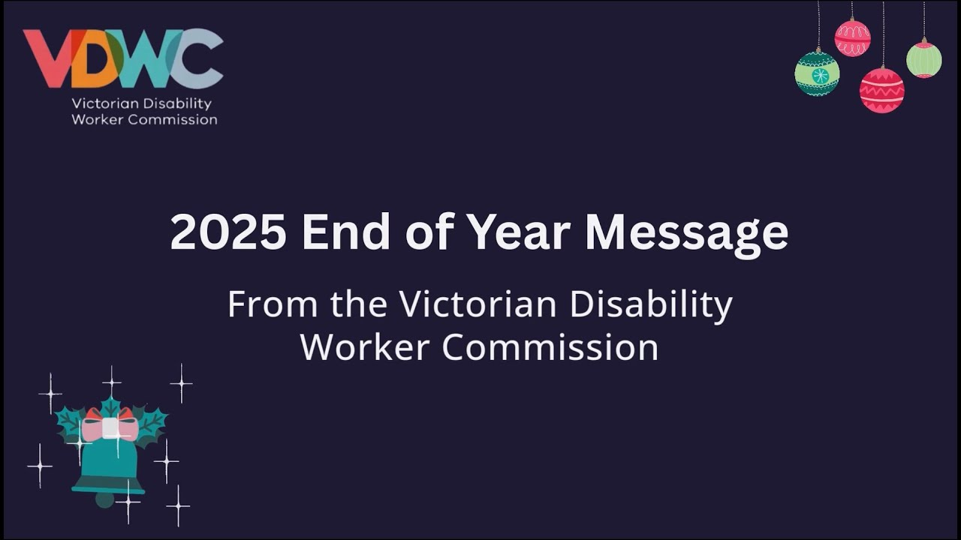
Click to watch this end of year message from the Victorian Disability Worker Commission. Please note this will open in a new window.

If you have trouble accessing the video please click
https://youtu.be/U5zumsb41OU

Looking ahead to next year, we look forward to more engagement with the community, starting with the VALID Having a Say Conference at the end of January - I hope to see many of you there! We also have plans to continue our information sessions across regional Victoria, to hear about local issues and build understanding about how we can assist the disability community to participate fully in the community.

Commission opening hours over the festive season

The Commission will be closed from Thursday 25 December 2025 and will reopen on Monday 5 January 2026.
If you have a concern about the conduct or behaviour of a disability worker, or a query about worker registration, please leave a message on our phone line 1800 497 132 or email the Complaints team at complaints@vdwc.vic.gov.au or the Registration team at registration@vdwc.vic.gov.au during this time.
These messages and emails will be checked regularly and the Commission will get back to you as soon as possible.

Disability sector news and updates

ASQA regulatory action continues
The Australian Skills and Quality Authority (ASQA) continues to take action to cancel the registration of certain Registered Training Organisations (RTOs) providing disability or social support qualifications, affecting some disability workers across Australia. The Commission continues to monitor and act where this action affects disability workers.
Please see our public statement which includes links to information available.

Out and about

We were delighted to attend the Melbourne Disability Expo last month!
Over two days, our team connected with people with disability, disability workers, providers, and community members to share information about disability worker registration, provide information on our complaints service, our Training and Development Catalogue, and our role in safeguarding the sector and raising workforce quality.
Thank you to everyone who visited our booth to learn more and have a chat with us. We loved hearing your questions and feedback and we look forward to doing it all again next year.

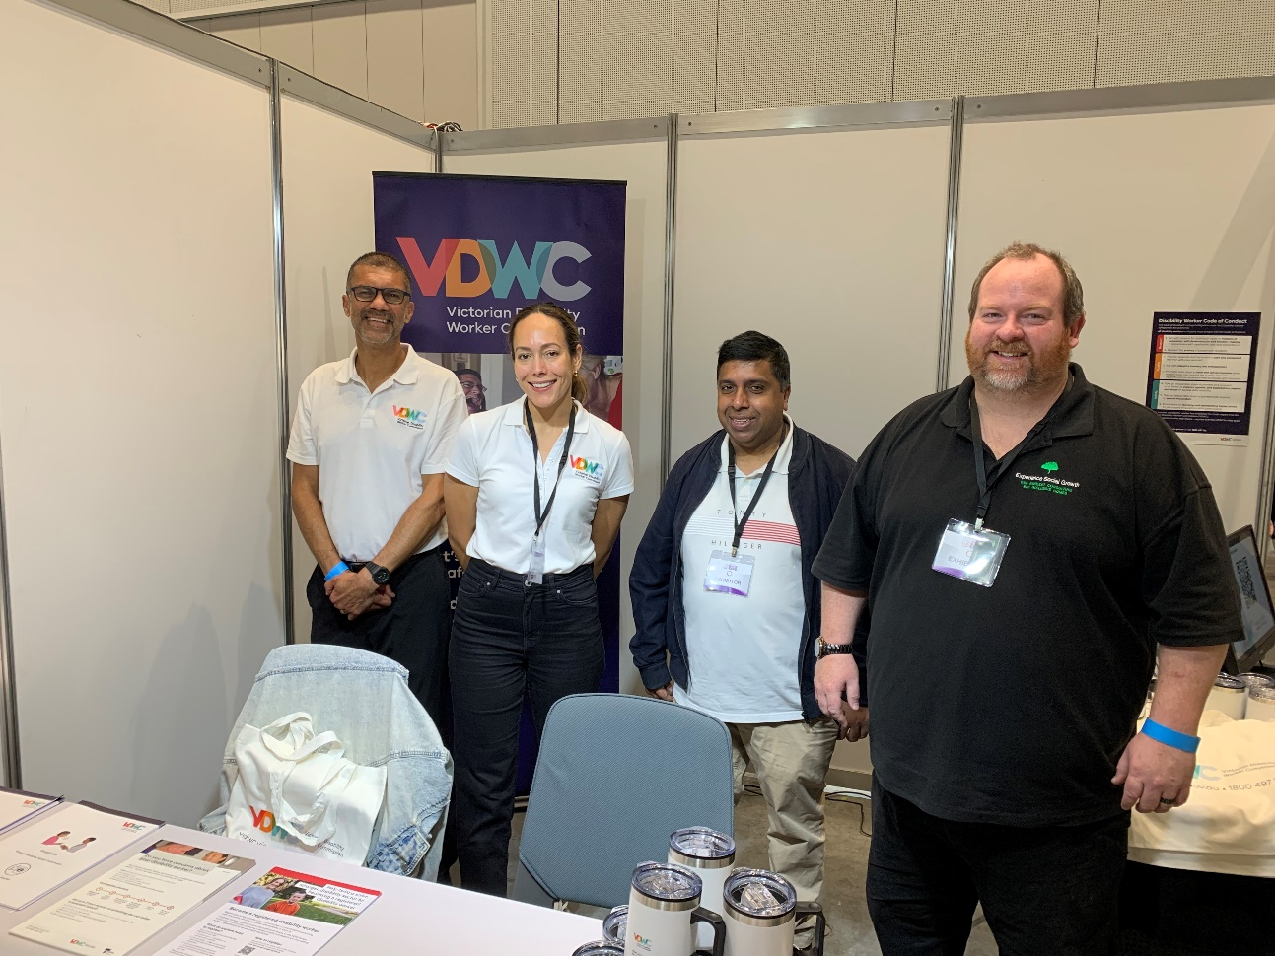

This image shows VDWC staff standing at the Commission’s booth with Disability Worker Registration Board member Patrick Wilsmore at the Melbourne Disability Expo.

What's on in the sector

VALID Having a Say Conference 2026
The Victorian Disability Worker Commission is proud to be participating in and sponsoring the VALID Having a Say Conference once again in 2026. Acting Commissioner Kate Maddern will present the keynote speech, we will have an expo booth and run a workshop. We look forward to meeting and chatting with people from right across the disability sector.
Dates and times:
- Tuesday 27th January 10.30am to 4.00pm
- Wednesday 28th January 9.30am to 4.00pm
- Thursday 29th January 9.30am to 1.00pm
Venue: Costa Hall, Deakin University, Waterfront Campus, Gheringhap Street, Geelong.
For more info visit valid.org.au/having-a-say/

Do you need to update your email address?

Are you changing jobs soon and going to have a new email address? Let us know if you change your email address to keep receiving our eNewsletter. Contact us at info@vdwc.vic.gov.au and we will update your details.

Keep in touch
If our e-newsletter was forwarded to you and you'd like to subscribe please go to: vdwc.vic.gov.au/subscribe
If you have any questions or comments, please get in touch via our website Contact us page, send an email to info@vdwc.vic.gov.au or call us on 1800 497 132.
For more information visit vdwc.vic.gov.au













Our mailing address is:
Level 1, 2 Lonsdale Street, Melbourne, VIC 3000
Want to change how you receive these emails?
You can update your preferences or unsubscribe from this list.

