October 2025

Continuing professional development

Factsheet: Obligations of registered disability workers

Accessible

Continuing professional development (CPD) supports registered disability workers to improve and broaden their skills, knowledge and expertise, and develop qualities required for delivering safe and responsive support services to people with disability.

CPD standard requirements
Registered disability workers are required to undertake CPD activities as part of their registration obligations.
The CPD standard requires registered disability workers to complete at least 10 hours of continuing professional development for each registration year.
If you have been registered for less than a year, you must meet pro rata CPD requirements.
As a registered disability worker, you are responsible for your own professional development in accordance with the CPD standard.
Figure 1: Annual continuing professional development cycle
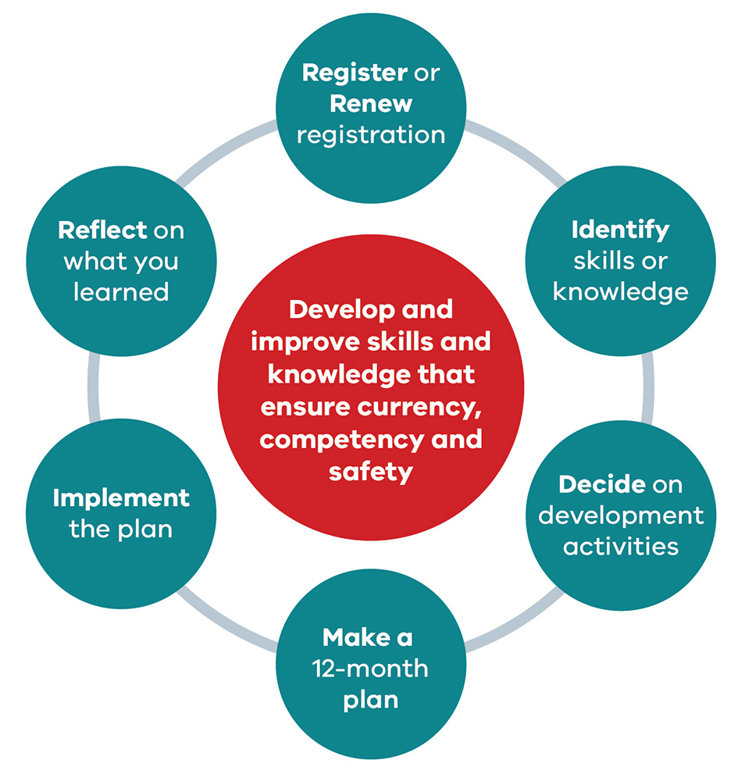

How to meet the CPD standard
- Complete at least 10 hours of CPD activities each year.
These activities should develop and improve your knowledge and skills to practice safely. CPD activities must:
- build on your existing disability worker knowledge and skills
- be related to your area of practice.
If you have been registered for less than a year, you must meet pro rata CPD requirements.
- Declare you completed the CPD standard requirements and include details of your CPD when you apply to renew your registration.
You will be asked for details of each CPD activity:
- the name of the CPD activity
- the name of the CPD activity provider
- date completed
- where you did the CPD activity (such as street address, online, from books)
- how many hours you did.
If you undertake development activities for the purposes of CPD requirements of another regulator or professional association, those activities may be counted towards your disability worker registration if they relate to disability practice.
- Keep a record of CPD activities completed throughout the year.
You must keep a record of your CPD activities. The Disability Worker Registration Board of Victoria (the Board) may ask to see evidence to confirm your declaration that you have met the CPD standard and details of your CPD activities.
The easiest way to keep a record of your CPD activities is to keep an activity log. You can find an activity log template on the Continuing Professional Development page of the Victorian Disability Worker Commission’s website <https://www.vdwc.vic.gov.au/registration/CPD>.

What if I do not meet the CPD standard?
The Board may consider a request for a full or partial exemption from CPD standard requirements in exceptional circumstances.
If you do not meet the CPD standard, and have not been granted an exemption, the Board may:
- renew your registration subject to
- a condition; or
- refuse to renew your registration.
If the Board proposes to renew your registration subject to a condition or to refuse to renew your registration, we will invite you to respond to the Board’s proposal. The Board will consider any submission you make before deciding your application.

How can I find more information?
You can find out more by visiting the Continuing Professional Development page of the Victorian Disability Worker Commission’s website <https://www.vdwc.vic.gov.au/registration/CPD>.
For more information you can:
call 1800 497 132 or
email registration@vdwc.vic.gov.au.

About the Victorian Disability Worker Commission
The Victorian Disability Worker Commission is an independent body established to better protect people with disability and build a stronger, safer disability sector. It is responsible for the Disability Service Safeguards Code of Conduct, establishing the minimum expectations for all workers in Victoria supporting people with disability, and the complaints service. It can accept complaints and notifications, with powers to investigate and ban workers who put people’s safety at risk.

Visit our website <vdwc.vic.gov.au> or call 1800 497 132
Sign up to our newsletter
Follow us on Facebook, LinkedIn and/or Instagram

