April 2025

Do you have concerns about your disability worker?

Factsheet

Accessible

The Victorian Disability Worker Commission has a confidential complaints service – and we can take action if something isn’t right.
Anyone can make a complaint about a disability worker, including about:
- their standard of work
- their knowledge, skill or judgement
- their suitability for disability worker registration
- their capacity to provide services safely
- an alleged breach of the Disability Service Safeguards Code of Conduct.

Complaints process
Image below of the six complaint process steps
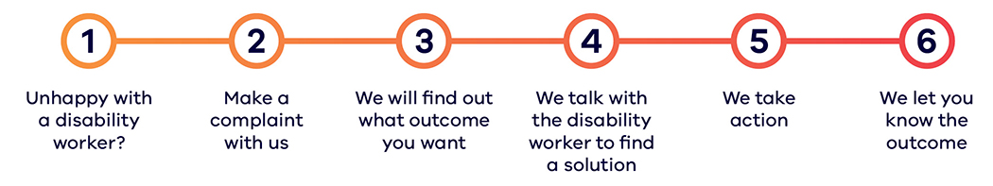

Not sure if your concern is something you can lodge a complaint about?
Our friendly team can assist you. There are several ways you can make a complaint to us.
- You can call us on 1800 497 132
- Submit an online form via vdwc.vic.gov.au/complaints
- Meet us face-to-face
We offer in-language interpreters if required.

Is it OK to complain about a disability worker?
Yes, it is OK to complain about a disability worker. It’s important that disability workers know when you aren’t happy or if something is wrong. Making a complaint can assist disability workers to make positive changes in their work and practice. Making a complaint is a great way to improve services for everyone. If you are not sure whether you want to make a complaint, you can still call us to talk about what is happening for you. We can help you with advice and information, and you can decide if you want to make a complaint.

Do I need to give my personal details?
We will accept anonymous complaints, and you can ask for your identity to remain confidential. If you choose to remain anonymous, this may limit how we can investigate or address the matter, and potentially the outcome of the complaints process. Where you choose to give us your details, we will collect, use, store and protect personal information as we are required to do by law.

About the Victorian Disability Worker Commission
The Victorian Disability Worker Commission is an independent body established to better protect people with disability and build a stronger, safer disability sector. It is responsible for the Disability Service Safeguards Code of Conduct, setting the minimum expectations for all workers in Victoria supporting people with disability, and the complaints service. It can accept complaints and notifications, with powers to investigate and ban workers who put people’s safety at risk.

Visit our website <vdwc.vic.gov.au> or call 1800 497 132
Sign up to our newsletter
Follow us on Facebook, LinkedIn and/or Instagram
Image below of a disability worker assisting a person with a disability
