
Stakeholder Engagement Framework

Acknowledgement of Country
We proudly acknowledge Victoria’s First Nations peoples and their ongoing strength in practising the world’s oldest living culture. We acknowledge the Traditional Owners of the lands and waters on which we live and work and pay our respect to their Elders past and present. We acknowledge the ongoing role of the Aboriginal community in supporting those with disability.

Accessibility statement
The Victorian Disability Worker Commission aims to make its information and publications accessible to all. This annual report has been designed in both a PDF and accessible Word format. If you require an alternative format, please email the Commission <info@vdwc.vic.gov.au>.
The Commission and Board are statutory entities of the State Government of Victoria created under the Disability Service Safeguards Act 2018.
© State of Victoria (Victorian Disability Worker Commission and Disability Worker Registration Board of Victoria) 2023
VDWC Stakeholder Engagement Framework is licenced under a Creative Commons Attribution 4.0 licence.
You are free to re-use the work under that licence, on the condition that you credit the State of Victoria (Victorian Disability Worker Commission and Disability Worker Registration Board of Victoria) as author, indicate if changes were made and comply with other licence terms. The licence does not apply to any images, photographs or branding, including the Victorian Government logo, Victorian Disability Worker Commission logo, the Disability Worker Registration Board of Victoria logo and the logos used to certify registration as a registered disability worker.
Copyright queries may be directed to the Victorian Disability Worker Commission <info@vdwc.vic.gov.au>.
ISBN 978-1-76130-441-5 (Print) (pdf/online/MS word)
Published November 2023
Victorian Disability Worker Commission
Level 20, 570 Bourke Street
Melbourne Victoria 3000
Phone: 1800 497 132
Email: info@vdwc.vic.gov.au
Web: <https://www.vdwc.vic.gov.au/>

Purpose of the Stakeholder Engagement Framework
The Victorian Disability Worker Commission (VDWC) was established with a guiding principle that people with disability who use disability services have the same rights as other members of the community. At its core, the quality of our stakeholder engagement determines its success.
We implement the Disability Worker Regulation Scheme (the Scheme) that is leading the way in better protections for people who use disability services and promoting a high-quality workforce.
Meaningful stakeholder engagement is a strategic objective for VDWC:
- As part of the disability sector where ‘nothing about us without us’ is a core tenet, so engagement that is person-centred, honest, transparent, and empowering is required to build trust in the Scheme and what it does. Without trust, people will not engage with the Scheme and its functions. For people with disability, carers, workers and providers, engagement that is fair and transparent means increased reporting and understanding of better practises to reduce abuse and neglect.
- As a regulator operating across different workforces, engaging constructively with other regulator and Government stakeholders to develop efficient and effective coordination of cross referrals, information sharing, and memorandum of understandings mean a more joined up and efficient experience for people with disability and carers.
- As a voluntary registration body, engagement with disability workers builds awareness and understanding of the value of being a registered worker.
- As a newly established Commission, quality engagement means we can understand those we serve, how we can do better and be relevant to our stakeholder’s needs. Quality engagement delivers quality evaluation of our performance, and supports our ability to evolve, to innovate, to be relevant and progress our purpose.
This Framework outlines the principles that drive our engagement, the key stakeholders we engage with, the types of engagement we use, the methods of engaging and how we evaluate the success and value of our engagement.
The Commission adopts a best practice approach to engagement using the International Association for Public Participation Spectrum (IAP2) framework.
The IAP2 Spectrum, widely adopted by Victorian Government departments and agencies, describes five levels of engagement that can be used with stakeholders determined by the objective, outcomes, timeframes, resources and levels of concern or interest in the project. The figure below lists the five levels of engagement:


Engagement process model
VDWC’s engagement principles are applied in a four-step engagement process model outlined below.
The process model adopted promotes the diversity of VDWC’s stakeholders and engagement activities. The process model is easily tailored to meet the needs of different engagement activities. The engagement process model is strengthened by using the IAP2 Spectrum to assist VDWC in selecting the appropriate level of engagement required for different stakeholder groups by identifying the characteristics, stakeholder participation goals, promises to stakeholders and examples of engagement tools for each type of engagement.
Four step stakeholder engagement process adopted by VDWC
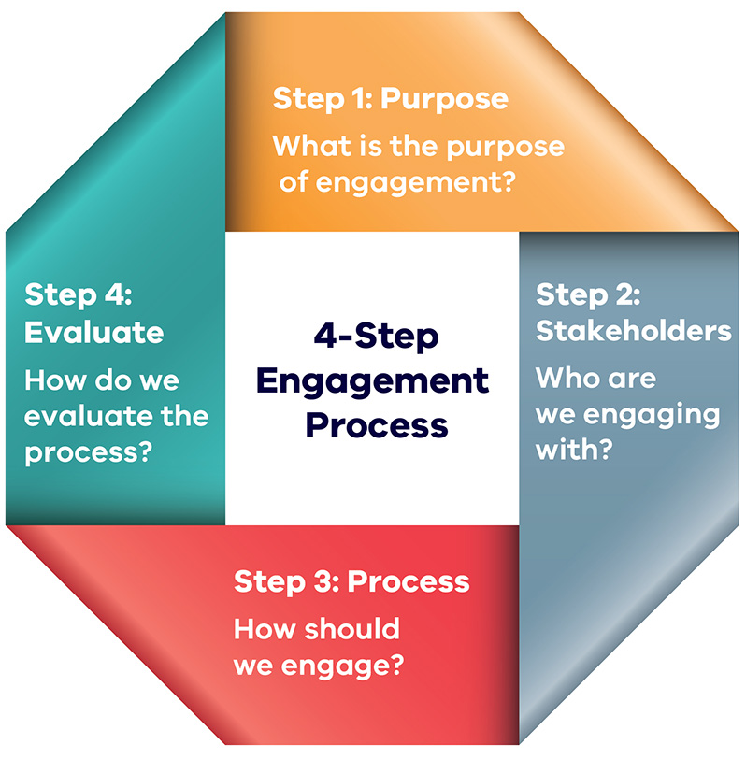

Guiding principles
The Disability Service Safeguards Act 2018 that established the Commission, includes the following guiding principles that persons with a disability to whom disability services are provided have the same rights as other members of the community:
- to be respected for their human worth and to be treated with dignity as individuals
- to live free from abuse, neglect and exploitation
- to realise their individual capacity for physical, social, emotional and intellectual development
- to exercise choice and control over their own lives
- to access information and communicate in a manner appropriate to their communication and cultural needs
- if a child, actively to involve the child’s family and any other caregivers in decisions affecting the child and to have information and support to enable this to occur
- to choose disability workers with the values, skills and qualifications that meet their needs
- to access services which support their quality of life.

Engagement principles

Purposeful
- Engagement is deliberate and is driven from our strategic plans.
- We provide clarity in the reason for engaging, knowing before engagement begins what success looks like and how it will be measured and evaluated.
- Our stakeholders’ objectives, environment, and ability to influence decisions and outcomes is clear to both us and our stakeholders.
- We respect our stakeholders by being deliberate, thoughtful and clear on our engagement, which enables them to be empowered to choose and control how they engage with us.
- We are transparent, accountable, effective, efficient, and fair in our interactions.

Inclusive
- We are person centred, seeking to engage stakeholders (especially people with disability) on their terms, instead of expecting stakeholders to adapt to a ‘business as usual’ approach to engagement.
- Our engagement is adaptable and engagement tools chosen ensure all voices are included with stakeholders empowered to participate.
- Stakeholders are supported to participate in a meaningful way, including ensuring all information and engagement is accessible and in a relevant format.
- We work with relevant experts to determine the most effective and appropriate engagement.
- By being inclusive we are respecting the human worth and dignity of all our stakeholders, empowering them to have choice and control by ensuring their ability to participate, provide access to information, and communicate in a manner appropriate to their communication and cultural needs.

Transparent
- We are transparent and accountable in our practises, operations and systems.
- We provide accessible information so stakeholders can participate in a meaningful way and foster a culture of sharing ideas.
- We explain the engagement process, the stakeholder’s role
in the engagement process, and communicate how their input will inform the project or activity.
- We are clear in how decisions impacting stakeholders are made, and about their ability to participate in that decision.
- By being transparent, we empower stakeholders to exercise choice and control over their own lives, access information and communicate in a manner appropriate to their communication and cultural needs, allowing stakeholders with disability who use disability services to choose disability workers with the values, skills and qualifications that meet their needs.

Timely and respectful
- The Commission will engage stakeholders early and agree on when and how to engage.
- Identify and explain the engagement process.
- Include meeting schedules, and response times
for information requests or feedback.
- Provide appropriate notice to stakeholders regarding engagement opportunities to maximise stakeholders’ involvement.
- By being timely and respectful, the Commission is respecting stakeholders and being accountable, effective, transparent, and fair.

Our stakeholders
The Commission engages with a wide range of stakeholders in diverse ways that are determined by the purpose of the relationship between the stakeholder and the Commission. The table below outlines the groups and definitions in terms of our interactions.

Stakeholder groups and definitions
Person with disability who uses disability services
Any person with disability who also uses disability services as defined by the Disability Service Safeguards Act 2018.
Friends, families, and supporters of people with disability (often referred to as ‘carers’)
We consider participation opportunities while respecting the priority of the perspective of the person with disability.
Disability worker
A worker who comes under the Disability Worker Regulation Scheme for providing disability services to a person with disability.
Disability support providers and employers
An organisation that provides disability services and employs disability workers and practitioners who come under the Scheme.
Government and regulators
Government and regulatory bodies that we have either a formal, legislated, or natural relationship with because of similar legislative responsibilities or purposes.
Organisations of people with disability and their advocates
Represent interests that are impacted by the Scheme.
Organisations that represent disability workers and providers/employers
Represent interests that are impacted by the Scheme.
Diverse communities
Communities that the Commission wants to proactively engage with to ensure their experience and priorities are reflected in the Scheme.

Stakeholder engagement activities
The Framework relates to the full spectrum of engagement activities VDWC undertakes with stakeholders in achieving its business objectives of stronger safeguards and a quality workforce, including:
- Digital communications – email correspondence, VDWC website, e-newsletter, social media
- Advice services – telephone and email correspondence
- Education resources – guides, webinars, videos, factsheets, website content
- Public presentations – educational events and conference presentations
- Relationship management – meetings with stakeholders
- Consultation processes – reference groups and policy consultation.

Measuring and evaluating our engagement
By evaluating and measuring outcomes from our engagement and learning from it, we adopt a continuous improvement approach to stakeholder engagement.
We embed measuring and evaluating stakeholder engagement as part of our stakeholder engagement plans to assess:
- the engagement that was done
- the quantity of engagement
- the quality of engagement
- fulfilling our promise: did we do what we said we would do after our stakeholder engagement.

About the Victorian Disability Worker Commission
The Victorian Disability Worker Commission is an independent body established to better protect people with disability and build a stronger, safer disability sector. It is responsible for the Disability Service Safeguards Code of Conduct, establishing the minimum expectations for all workers in Victoria supporting people with disability, and the complaints service. It can accept complaints and notifications, with powers to investigate and ban workers who put people’s safety at risk.

Visit our website <vdwc.vic.gov.au> or call 1800 497 132
Sign up to our newsletter
Follow us on Facebook, Instagram and/or LinkedIn

