April 2024

Disability worker registration information for students

Factsheet

Accessible

This factsheet contains information on disability worker registration for students who have already completed, or have nearly completed, a Certificate III or higher qualification in Disability, Individual Support or related field.
Congratulations on choosing a fulfilling and rewarding career, that makes a real difference
to the lives of people with disability.
There is a wide range of job opportunities for people who share the vision of safe, high-quality services to support people with disability.
Becoming a registered disability worker with the Disability Worker Registration Board of Victoria (the Board) <www.vdwc.vic.gov.au/about/registration-board> is one way you can stand out to potential employers once you’ve graduated.

Why register as a disability worker?
- It’s free to register and the Victorian Disability Worker Commission (VDWC) covers the cost of the associated police check.
- It shows you have the right skills and experience to deliver safe, high-quality services to work with some of the most vulnerable people in the community.
- It provides confidence to people with disability and their families.
- You are listed on the public register of Victorian disability workers <www.vdwc.vic.gov.au/registration/find-a-registered-disability-worker> where you can proudly show you have the registered disability worker tick of confidence.
- It forms part of the Victorian Government’s ‘zero tolerance’ approach to abuse of people with disability.
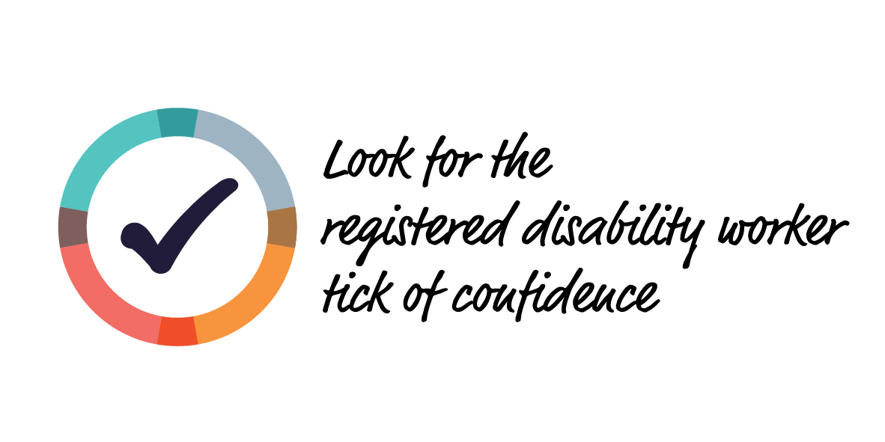

How is registration different to the NDIS check?
The NDIS worker screening check is mandatory for disability workers who work in risk assessed roles with registered NDIS service providers.
Disability worker registration is voluntary and is available to all disability workers in Victoria regardless of how the services they provide are funded.
Disability worker registration provides additional checks to the NDIS worker screening check and sets continuing professional development standards, so you can continue to be the safe choice for people with disability.

Who can register?
Disability workers who demonstrate they have the necessary knowledge, skills and experience, and that they are a suitable person to be a registered disability worker, can register.
To be registered, you must show that you:
- are qualified through formal qualifications, experience, or both
- are suitable for registration, considering factors such as criminal history, impairment, disciplinary history
- meet registration standards set by the Board:
  - pass a criminal history check (that is paid for by the VDWC)
  - be competent communicating in English
  - complete 10 hours of Continuing Professional Development each year.

How do I apply for registration?
You can apply for registration online at the Victorian Disability Worker Commission website <vdwc.vic.gov.au/get-registered>.
You can qualify for registration based on a qualification, experience, or both. You’ll need
to provide details of your:
- qualification. You’ll be asked to provide a copy of your certificate of completion or academic transcript/record of results.
- experience providing disability services. This may be work experience or a student placement* completed as part of your qualification. You’ll be asked to provide the name of the organisation where you did your work experience/placement, the type of work you did and the number of hours completed. You’ll also be asked to provide supporting evidence such as a letter, email or statement of service from your employer/placement organisation or payslips that show you are a disability worker.
*Students who have completed a relevant qualification usually need to complete 120 hours of placement to achieve the qualification. For example, it is a requirement for Certificate III in Individual Support <https://training.gov.au/Training/Details/CHC33021> to complete 120 hours of placement.

What if my qualification isn’t a Certificate III or higher in Disability, Individual Support or related field?
Qualifications in other disciplines will be considered such as community services, counselling, youth work, psychology, childcare, education and health on a case-by-case basis.
If you’re unsure whether your qualification meets the requirements for disability worker registration, contact our Registration team on 1800 497 132 or email registration@vdwc.vic.gov.au to discuss.

Find out more
For more information about disability worker registration, visit the Victorian Disability Worker Commission website <vdwc.vic.gov.au/disability-worker-registration>.

About the Victorian Disability Worker Commission
The Victorian Disability Worker Commission is an independent body established to better protect people with disability and build a stronger, safer disability sector. It is responsible for the Disability Service Safeguards Code of Conduct, establishing the minimum expectations for all workers in Victoria supporting people with disability, and the complaints service. It can accept complaints and notifications, with powers to investigate and ban workers who put people’s safety at risk.

Visit our website <vdwc.vic.gov.au> or call 1800 497 132
Sign up to our newsletter
Follow us on Facebook, X, LinkedIn and/or Instagram

