March 2024

Continuing professional development

Factsheet

Accessible

Continuing professional development (CPD) is the process through which disability workers improve and broaden their skills, knowledge and expertise, and develop qualities required for delivering safe and responsive support services to people with disability.
As a registered disability worker, you are responsible for your own professional development in accordance with the CPD standard.

Continuing professional development standard
Registered disability workers are required to undertake continuing professional development (CPD) activities as part of their registration.
The Board’s approved registration standard for CPD (the CPD standard) requires disability workers complete at least 10 hours of continuing professional development for each registration period from 1 October 2022.
Figure 1: Annual continuing professional development cycle
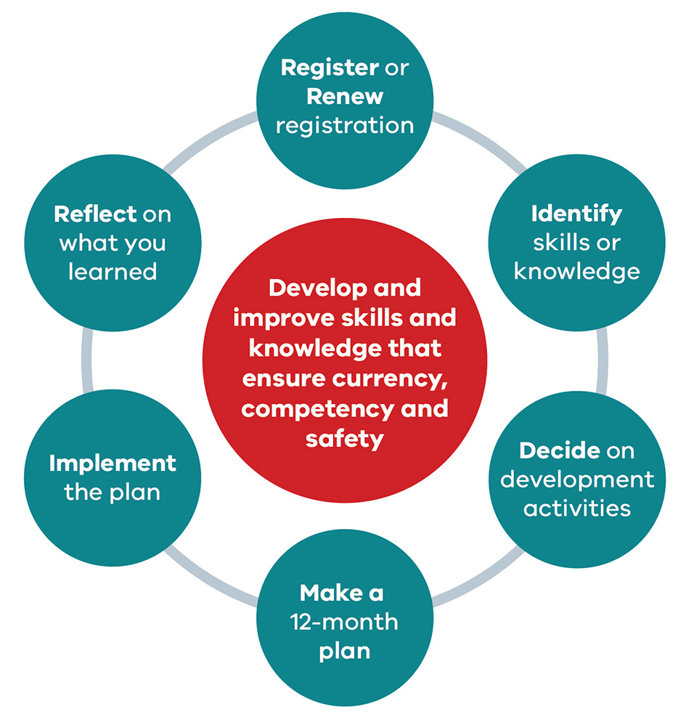

How to meet the CPD standard
To meet the CPD standard, you must:
- Complete at least 10 hours of development activities each year. These activities should develop and improve your knowledge and skills to practice safely. Development activities you complete must:
  - build on your existing disability worker knowledge and skills
  - be related to your area of practice
  - not include any compulsory training (such as first level of first aid, first level cardiopulmonary resuscitation (CPR) or the NDIS worker orientation module).
- Declare you have completed the CPD standard requirements in your renewal application and include details of the activities:
  - the courses, training or events undertaken
  - the number of hours
  - the name and location of the activity provider
  - a summary of what you learned from the activities.
If you undertake development activities for the purposes of CPD requirements of another regulator or professional association, those activities may be counted towards your disability worker registration if those activities relate to disability practice.

Keeping a record of development activities
The Board may ask to see evidence to validate your declaration that you have met the CPD standard and the detail of those activities.
Registered disability workers must keep a record of all development activities completed throughout the year, including evidence of those activities.
The easiest way to keep a record of your development activities is to keep an activity log.
You can find a blank version of the activity log on the Continuing Professional Development <https://www.vdwc.vic.gov.au/registration/CPD> page of the VDWC website.

What if I do not comply with the CPD standard?
Failure to comply with the CPD standard can result in the Board deciding to renew your registration subject to a condition or not renew your registration.
The Board has developed a CPD guide <https://www.vdwc.vic.gov.au/registration/CPD> to help you understand and meet your CPD obligation.

How can I find more information?
You can find out more by visiting the CPD Guide on the Continuing Professional Development page of the Victorian Disability Worker Commission’s website <https://www.vdwc.vic.gov.au/registration/CPD>.
For more information you can:
- call 1800 497 132 or
- email registration@vdwc.vic.gov.au.

About the Victorian Disability Worker Commission
The Victorian Disability Worker Commission is an independent body established to better protect people with disability and build a stronger, safer disability sector. It is responsible for the Disability Service Safeguards Code of Conduct, establishing the minimum expectations for all workers in Victoria supporting people with disability, and the complaints service. It can accept complaints and notifications, with powers to investigate and ban workers who put people’s safety at risk.

Visit our website <vdwc.vic.gov.au> or call 1800 497 132
Sign up to our newsletter
Follow us on Facebook, X, LinkedIn and/or Instagram

