March 2024

Registered disability worker continuing professional development guide

Effective from 1 October 2022

Accessible

Introduction
Registered disability workers are required to undertake continuing professional development (CPD) activities as part of their registration.
The Board’s approved registration standard for CPD (the CPD standard) requires registered disability workers to complete at least 10 hours of continuing professional development for each registration period, from 1 October 2022.
The CPD standard states:
The Board will require registered disability workers to complete a minimum of 10 hours of continuing professional development in the second registration period.
Continuing professional development activities will be expected to support workers to keep up and improve their knowledge and skills to practice safely, and that they be recognised for relevant learning as well as promoting their future employability.

This Continuing professional development guide helps registered disability workers:
- understand the purpose of continuing professional development
- understand how to meet their annual development requirements
- by providing tips on good practice.
The guide is not a formal guideline under the Disability Service Safeguards Act 2018.
In this guide, ‘registered disability worker’ refers to both registered disability support workers and registered disability practitioners.

Continuing professional development activities
Learning and development occurs throughout a disability worker’s career. Continuing professional development is an important foundation of lifelong learning. It helps disability workers maintain the skills needed to provide support to people with disability with diverse and sometimes very complex needs. This is particularly important with new expectations and opportunities for people with disability and how they are supported.
Continuing professional development activities (development activities) build and improve a person’s knowledge and skills in their area of work.
For disability workers, these activities help make sure:
- their knowledge is current
- they have the skills to provide safe and effective support to people with disability.
By setting continuing professional development requirements for registered disability workers, people receiving services, employers and the broader public can be confident that registered disability workers are equipped to provide high quality services.

The annual continuing professional development cycle
The cycle begins from your registration or renewal date. In each registration period, you must complete 10 hours of development activities.
Each year, the cycle aims to develop and improve your skills and knowledge to ensure currency, competency and safety.
Figure 1: Annual continuing professional development cycle
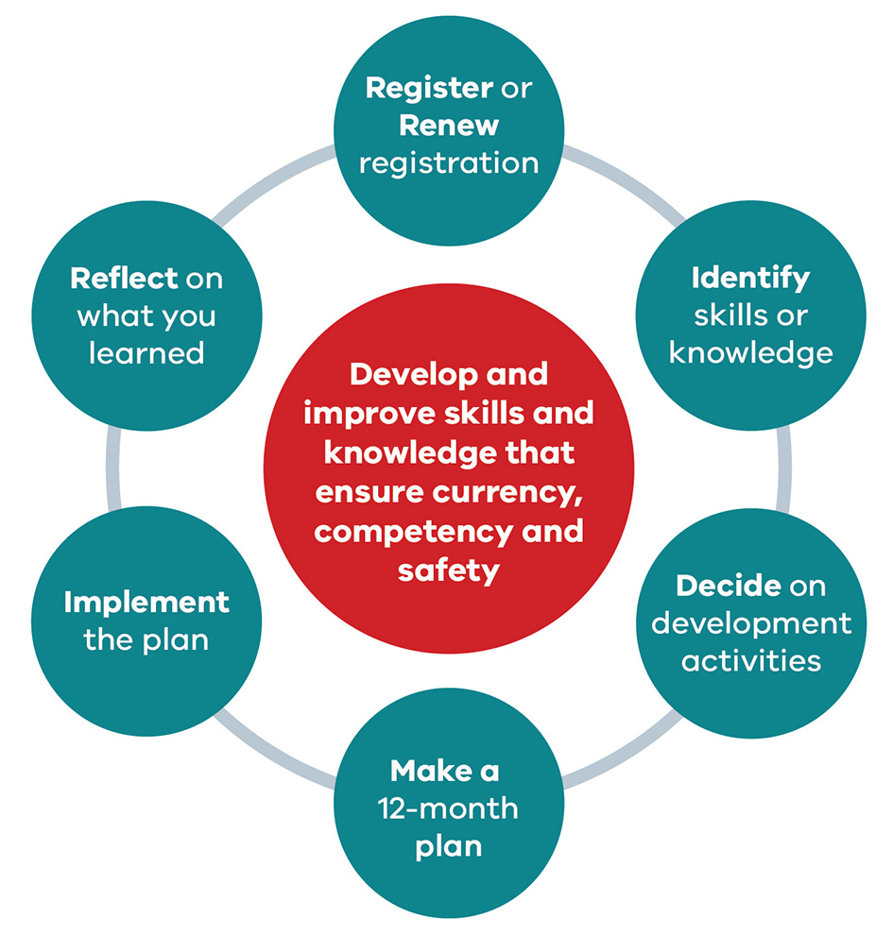

Step 1
Register or renew registration as a disability worker.

Step 2
Identify what skills or knowledge you want to improve – consider your work over the last year and talk to others to gain insight.

Step 3
Decide what development activities you want to complete – research courses, modules and other activities and decide what you will do.

Step 4
Make a 12-month plan – note what, where, when and the cost.

Step 5
Implement your plan. Fill in your activity log as you go.

Step 6
Reflect on what you learned and how you have used it this year. What else do you want to learn?

The CPD standard
From 1 October 2022, all registered disability workers must comply with the CPD standard: complete 10 hours of continuing professional development activities each registration period.
The registration period is the year from 1 October to 30 September.
The CPD standard applies to all registered disability workers. This includes:
- registered disability workers who work full-time, part-time or casually
- registered disability workers who are volunteers who provide disability services on behalf of an organisation or agency.

What if I do not meet the CPD standard?
If you do not meet the CPD standard, the Board may:
- renew your registration subject to a condition
- refuse your application to renew your registration
- take action against you under the Disability Services Safeguards Act 2018.
When you renew your registration, you must make a declaration including whether you have completed the requirements of the CPD standard.
If you declare that you have not met the CPD standard, you will be asked for more details of your circumstances, including if you have been granted an exemption.
Before the Board decides whether to renew your registration, it may contact you for more information and evidence of your circumstances.
The Board could decide to renew your registration subject to a condition or not renew your registration.
Important note: making a false declaration when you apply to renew your registration may result in the Board refusing to renew your registration.

How to meet the CPD standard
To meet the CPD standard, you must:
- Complete at least 10 hours of development activities each year. These activities should develop and improve your knowledge and skills to practice safely. Development activities you complete must:
  - build on your existing disability worker knowledge and skills
  - be related to your area of practice
  - not include any compulsory training (such as first level of first aid, first level cardiopulmonary resuscitation (CPR) or the NDIS worker orientation module).
- Declare you have completed the CPD standard requirements in your renewal application and include details of the activities:
  - the courses, training or events undertaken
  - the number of hours
  - the name and location of the activity provider
  - a summary of what you learned from the activities.
If you undertake development activities for the purposes of CPD requirements of another regulator or professional association, those activities may be counted towards your disability worker registration CPD, if those activities relate to disability practice.

Activities that count as continuing professional development
Development activities that:
- help you improve your skills and knowledge
- help you stay up to date
- are relevant to your area of practice as a disability worker.
These could be fee paying or free training and activities.
Annual compulsory training (such as first level first aid, fire safety induction, NDIS worker orientation modules) does not count as continuing professional development.
Training and development you complete with your employer that improves your skills, knowledge and practice as a disability worker can be counted towards the 10 hours of development activities each year.
The following are acceptable forms of development activities:
- online learning – individual training modules or modules that are part of a course
- practice training provided by your employer (where it is not annual compulsory training)
- webinars, workshops and conferences
- higher education and certificate courses or individual modules (such as Certificate III or Certificate IV)
- participating in a ‘community of practice’ related to your area of practice
- formal mentoring you may obtain through a professional network or from a leader in your workplace
- conference sessions, including online
conference sessions
- reading technical books and journals relevant
to your practice
- participating on a committee relevant to your practice.

How to choose development activities
You can choose your own development activities. You may ask your supervisor what training or development they think aligns with your annual performance review. You may have a specific skill or subject you want to develop for your career aspirations. Ask the people you provide services to about what skills or subject area they would like you to develop.
The NDIS Quality and Safeguards Commission has released a workforce capability framework that is relevant to the entire disability sector. The NDIS Workforce Capability Framework can help you identify capabilities, skills and knowledge to improve.
You can find the framework on the NDIS Workforce Capability website’s Framework page <https://workforcecapability.ndiscommission.gov.au/framework>.
Use the Career options guide to get some development activity ideas – available on the NDIS Workforce Capability website’s Career Options Guide page <https://workforcecapability.ndiscommission.gov.au/tools-and-resources/career-development>.
We have listed some possible development activities and examples of topics that match the capabilities in the NDIS Workforce Capability Framework’s general worker category. You can find this on the VDWC website’s Continuing professional development page <https://vdwc.vic.gov.au/registration/CPD>.

Possible training and education sources
There are many types of education and training opportunities that can count as development activities. They range from short online training courses that introduce you to knowledge and skills in a specific area to formal courses that will give you a qualification over time.
Some courses and training are general and relevant to all disability support work and others are specific to particular groups or types of work.
In addition to this guide, the Board will continue to develop continuing professional development resources to support disability workers and make these resources available online.
As a starting point, these are some of the many options available.

NDIS Quality and Safeguards Commission
The NDIS Quality and Safeguards Commission has free online training modules about specific topics related to disability practice.
- See the NDIS Quality and Safeguards Commission website’s Worker training modules and resources page <https://www.ndiscommission.gov.au/trainingcourse>.
- Search the NDIS Quality and Safeguards Commission website for elearning <https://www.ndiscommission.gov.au/search?keywords=elearning>.

Professional organisations, peak bodies and disability group specific organisations
Many professional associations offer continuing professional development courses on topics relevant to disability.
- National Disability Services, the peak organisation for disability service providers, offers online courses. You can find details of their online courses on the National Disability Services website’s eLearning page <https://www.nds.org.au/index.php/training-and-development/e-learning>.
- National Disability Practitioners, a membership peak body for disability workers, has information about training. See the National Disability Practitioners website’s Learning Hub page <https://www.ndp.org.au/learning-hub>.

Advocacy and disability-specific organisations
Advocacy and disability-specific organisations (such as Council for Intellectual Disability, Mental Health Victoria or the Spinal Cord Association) offer short courses, webinars and conferences on disability-related topics.

Employers, managers and colleagues
Your employer, managers and colleagues may be a good source of information about potential training and development opportunities.

Free online courses
Online training modules or courses about various topics relevant to disability support workers are available. You can often find these online courses by searching for the topic you are interested in.
The courses are often produced by:
- university research centres, based on research findings
- advocacy groups, disability support organisations or private consultants, based
on service development products.

TAFE colleges and registered training organisations
TAFE colleges and registered training organisations (RTOs) offer certificate and diploma level courses in disability. Many of the disability courses are free.
Information on training courses, including TAFE courses, is on the Victorian Skills Authority website <https://www.skills.vic.gov.au>. You can search for disability-related TAFE courses in Victoria on
the website.
The Victorian Government careers website, Careers.vic, has information about careers in disability which might be useful in finding courses. See the Careers.vic Disability employment page <https://careers.vic.gov.au/career-pathways/disability-employment-1907>.
The time spent doing your continuing professional development may count towards obtaining a qualification.

Universities
Some universities offer disability-related subjects as part of undergraduate programs, or postgraduate qualifications in disability.
Often you can enrol in single subjects as well as a full course.
If you have trouble navigating a university website or finding a course, try searching for ‘disability’ on their website.

Private or government organisations
Private or government organisations that promote access to training and education by collating information on their websites. For example, the TAFE Courses website lets you compare courses from universities, TAFEs and RTOs <https://www.tafecourses.com.au>.
Note: The information on these websites may link to associated providers.

Keeping a record of development activities
When you declare that you have completed the standard requirement, you will also be asked to provide:
- the courses, training or events undertaken
- details of the activities you did
- the number of hours
- the name and location of the activity provider
- a summary of what you learned from the activities.
The Board may ask to see evidence to validate your declaration that you have met the CPD standard.
Registered disability workers must keep a record of all development activities completed throughout the year, including evidence of those activities. This will make it easier for you to make the declaration in your registration renewal application.
You can also use these records with your employer for your annual performance review or when you are applying for a job with a new employer to show you are:
- an active and independent learner
- serious about a career in disability support
- committed to providing a professional and safe service to the people you support.

How to keep a record
The easiest way to keep a record of your development activities is to keep an activity log. Fill in the log every time you attend an activity that you think could count as a development activity and keep the evidence with the log. Keep these records in an electronic or paper file where you keep other important records like your employment records or tax records.
Check the log every few months to make sure you are doing enough development activities throughout the year. When you get to the end of the year, you will know you have met the standard.
Table 1 shows an example of a simple activity log. You can find a blank version of the activity log on the Commission’s website’s Continuing professional development page <https://vdwc.vic.gov.au/registration/CPD>.

Evidence you should include
Evidence of continuing professional development can be anything that shows you did a relevant development activity (other than annual compulsory training). It may include:
- a certificate of completion or participation – this could also be an email, screenshot or photo
- confirmation form, email or screenshot of your successful registration into an activity
- confirmation that you attended the activity – email, screenshot, statutory declaration or employer confirmation
- a receipt of payment for an activity with some form of validation that you attended, statutory declaration or employer confirmation
- a letter or email from your supervisor that you were a member of a particular committee and how this was a development opportunity
- a letter or email from your mentor confirming their work with you on your practice development
- a letter or email from the convenor of the community of practice
- your reflective practice notes related to the development activity – for example, when completing an online course that does not provide a completion certificate, attending a conference session, reading a technical book or journal article relating to your area of practice.
Table 1: Example activity log
Name of  CPD activity | Date undertaken | Hours taken to complete | Activity provider | Evidence of activity | Reflection – Summary of what I learned
Reflective Practice training | 6/04/2023 | 7 hours | ABC Good Practice Company | Registration form  Completion certificate | Importance of reflective practice to improve my practice and be responsive to my client. It helps me with house meetings when we talk about doing things better.
Mentorship on being an effective team leader | 2/11/2022 to 2/4/2023 | 6 1-hour sessions | NDP | Letter from mentor | Effective listening to my team and the people I support, delegating and collaborative problem solving.
Effective communication online course | 8 May 2023 | 2 hours | Lifelong Learning | Completion certificate screen shot | How to better communicate with my clients with intellectual disability. Active listening, slowing my speech, use plain English and ensure I have their attention and reflect back what I hear.

For more information
To receive this publication in an accessible format phone 1800 497 132, using the National Relay Service 133 677 if required, or email the Victorian Disability Worker Commission <info@vdwc.vic.gov.au>.
Authorised and published by the Victorian Government, 1 Treasury Place, Melbourne.
© State of Victoria, Australia, (Victorian Disability Worker Commission and Disability Worker Registration Board of Victoria) March 2024.
This work, Registered disability worker continuing professional development guide, is licensed under a Creative Commons Attribution 4.0 licence <creativecommons.org/licenses/by/4.0/>. You are free to re-use the work under that licence, on the condition that you credit the author, indicate if changes were made and comply with the other licence terms.
ISBN 978-1-76096-099-5 (pdf/online/MS word)
Available at the Victorian Disability Worker Commission’s website <vdwc.vic.gov.au>.

