The facts:

Continuing Professional Development
Continuing Professional Development (CPD) is the process through which disability workers improve and broaden their skills, knowledge and expertise, and develop qualities required for delivering safe and responsive support services to people with disability.
As a registered disability worker, you are responsible for your own professional development in accordance with the CPD standard.

Continuing Professional Development Standard
Registered disability workers are required to undertake continuing professional development (CPD) activities as part of their registration. The Board’s approved registration standard for CPD (the CPD standard) requires disability workers complete at least 10 hours of continuing professional development for each registration period from 1 October 2022.
Figure 1: Annual continuing professional development cycle

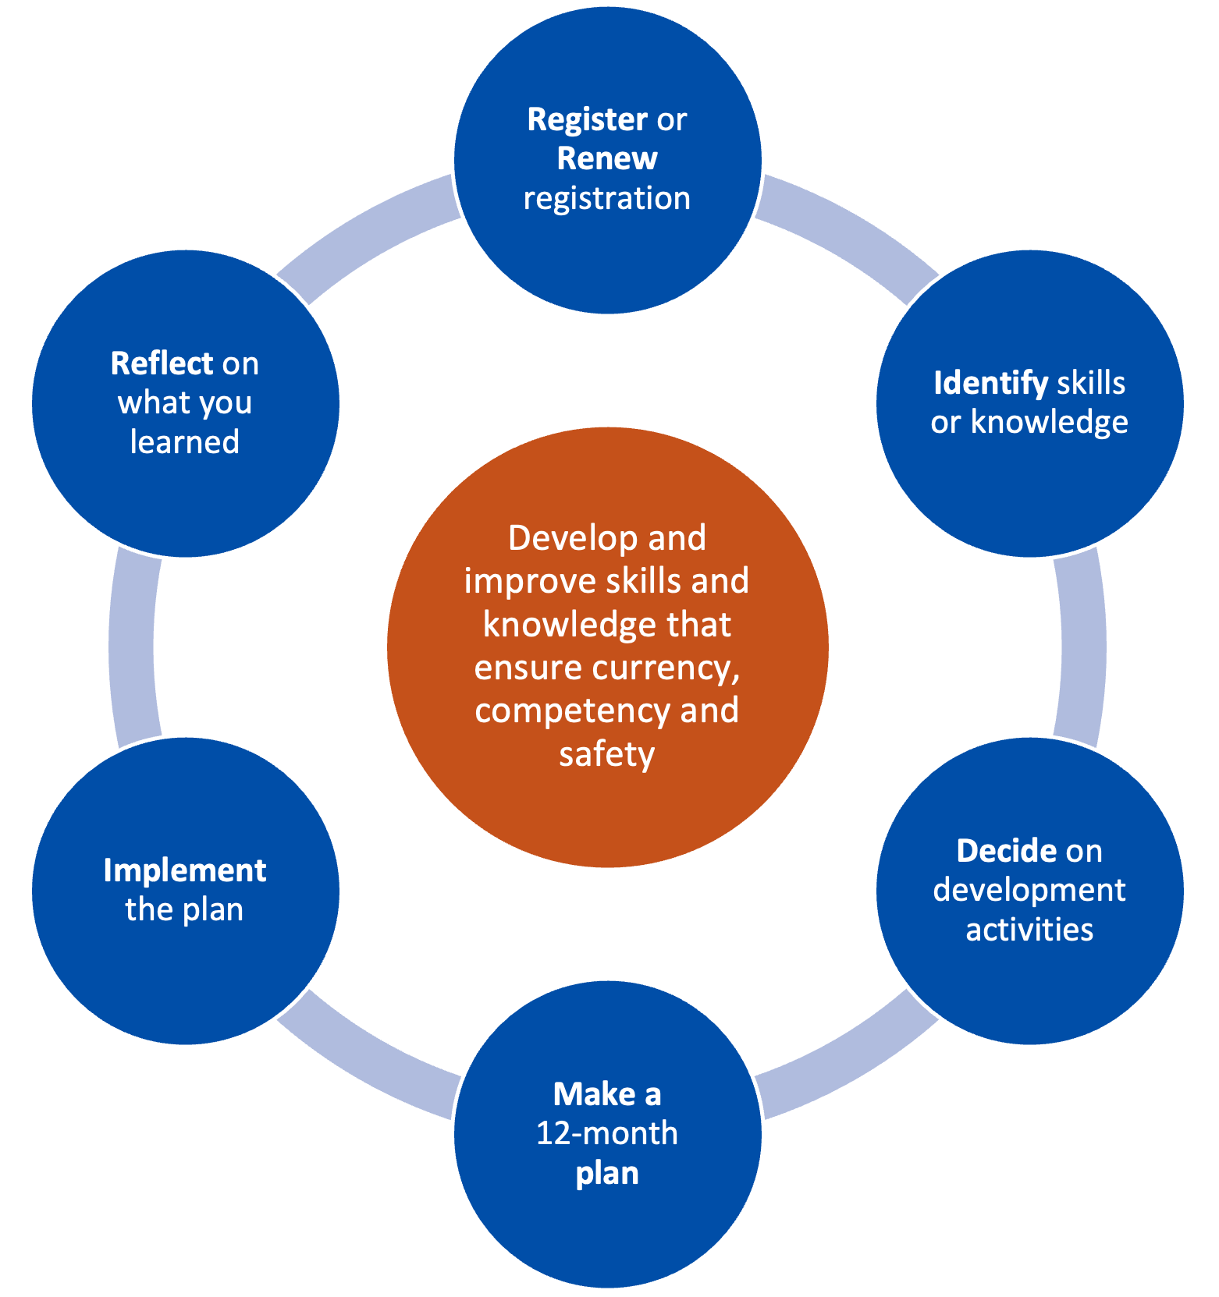

How to meet the CPD standard
To meet the CPD standard, you must:
- Complete at least 10 hours of development activities each year. These activities should develop and improve your knowledge and skills to practice safely. Development activities you complete must:
- build on your existing disability worker knowledge and skills
- be related to your area of practice
- not include any compulsory training (such as first level of first aid, first level cardiopulmonary resuscitation (CPR) or the NDIS worker orientation module).
- Declare you have completed the CPD standard requirements in your renewal application and include details of the activities:
- the courses, training or events undertaken
- the number of hours
- the name and location of the activity provider
- a summary of what you learned from the activities.
If you undertake development activities for the purposes of CPD requirements of another regulator or professional association, those activities may be counted towards your disability worker registration if those activities relate to disability practice.

Keeping a record of development activities
The Board may ask to see evidence to validate your declaration that you have met the CPD standard and the detail of those activities.
Registered disability workers must keep a record of all development activities completed throughout the year, including evidence of those activities.
The easiest way to keep a record of your development activities is to keep an activity log.
You can find a blank version of the activity log on the VDWC Commission’s website’s Continuing professional development page.

Exemptions
In exceptional circumstances, the Board may consider granting a full or partial exemption (where you must complete some of the hours) from the CPD standard. Applications for exemption will be considered on a case-by-case basis.
You can seek an exemption in certain circumstances. Some reasons to seek an exemption include:
- a lengthy period of absence, for example for parental leave
- suffering an illness that affects your ability to work and undertake development activities
- hardship or other exceptional circumstances.
You will need to provide evidence in support of your application.
Applications should be made as soon as you know you will not be able to meet the CPD standard (either fully or in part). Email your application to registration@vdwc.vic.gov.au. More information about what to include in your application is available in the CPD guide.

What if I do not comply with the CPD standard?
Failure to comply with the CPD standard can result in the Board deciding to refuse to renew your registration.
The Board has developed a CPD guide vdwc.vic.gov.au/registration/CPD to help you understand and meet your CPD obligation.

How can I find more information?
You can find out more by visiting the CPD guide on the Continuing Professional Development page of the Disability Worker Regulation Scheme website: vdwc.vic.gov.au/registration/CPD.
For more information you can:
- call 1800 497 132 or
- email registration@vdwc.vic.gov.au.

