Registration of Victorian disability workers

Newsletter article

Disability worker registration now open in Victoria

The registration of disability workers opened in Victoria on 1 July and is part of new safeguards to strengthen the disability sector.

There are different standards in place to make sure disability workers are safe and professional, but not every disability worker is covered by these rules. Voluntary registration will create greater trust and confidence in the profession by ensuring registered workers have been independently assessed.

Service providers and employers can take confidence in recruiting registered workers knowing they have been assessed to be safe, skilled and competent professionals.

You are encouraged to let your workforce or members know to register so they don’t miss out on the advantages that apply now. There is no better time for disability workers to join –– the first year of registration is free and prior experience will be recognised in lieu of any qualifications. In future years a relevant qualification will be a requirement to become a registered worker.

There are three standards that must be met for registration: A criminal history check that is consistent with the NDIS worker screen criteria; Competency in English; and Continuing Professional Development (CPD) – however CPD is not a requirement in the first year.

Workers can register under two different divisions – registered disability support worker or registered disability practitioner.

Registration can be completed online and takes approximately 45 minutes. A full list of all the information and documentation required during the registration process is available at www.vdwc.vic.gov.au/registration/how-to-register

A public register will be available on the Victorian Disability Worker Commission website providing a quick and easy way to find a registered worker online.

Registered disability workers will be issued with a registration certificate. They will be able to use the distinctive registration mark in a variety of ways to promote their registration.

You can find out more about disability worker registration on the Victorian Disability Worker Commission website www.vdwc.vic.gov.au/registration or questions about registration can be lodged at registration@vdwc.vic.gov.au.

Stay informed by subscribing to the VDWC newsletter and following on LinkedIn, Twitter or Facebook.

Social media posts

Facebook, LinkedIn
Registration of Victorian disability workers is open, providing rigorous standards for safety, skills and professionalism.
Registration makes it easier for workers to show their commitment to their work in disability, and for people seeking services to find workers they know have been independently assessed as safe, skilled and professional.
To find out more about registration, visit www.vdwc.vic.gov.au/registration

Follow the Victorian Disability Worker Commission [tag the Commission: facebook.com/VDWCommission] to stay informed.

Twitter
Victorian disability workers can now become registered. Registered workers will be independently assessed as safe, skilled and professional. Learn more at www.vdwc.vic.gov.au/registration
Follow @VDWCommission

Twitter
Victorian disability workers can now become registered. Registration supports increased professionalism in disability work, because it’s work that matters. Learn more at www.vdwc.vic.gov.au/registration
Follow @VDWCommission

Images
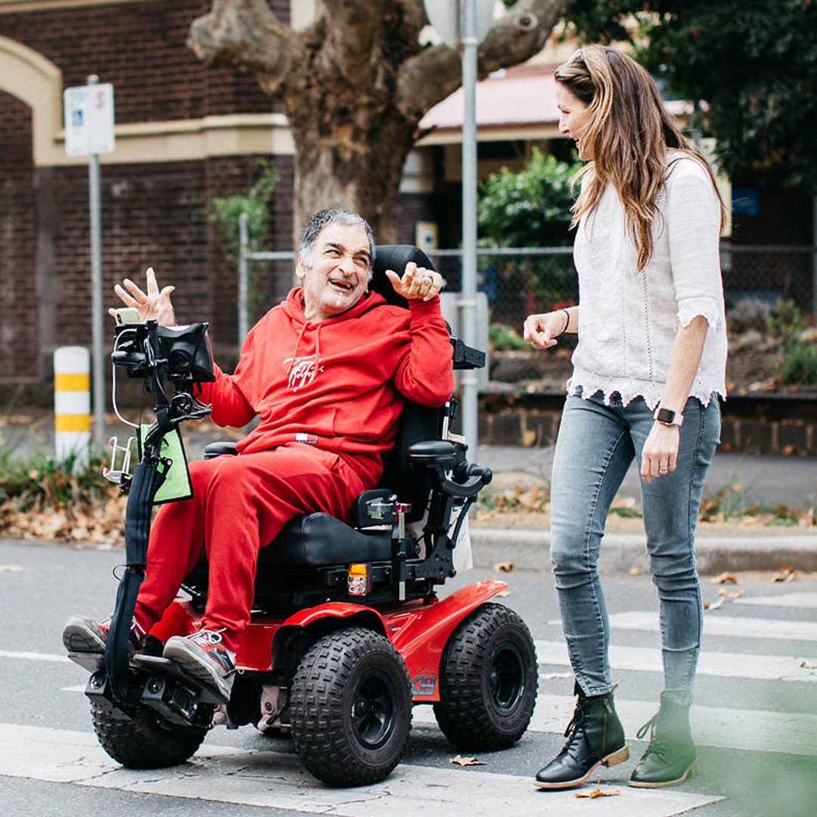

Contacts
Website: www.vdwc.vic.gov.au
Email: info@vdwc.vic.gov.au
Phone: 1800 497 132
Facebook: facebook.com/VDWCommission
Twitter: twitter.com/VDWCommission
LinkedIn: linkedin.com/company/vdwcommission

