VDWC Disability Service Provider pack
Online resources

Digital news articles

VDWC and resources available

There’s a new Victorian Disability Worker Commission: here’s what it means for you.

The Victorian Disability Worker Commission (the Commission) is a new independent body. Led by Commissioner Dan Stubbs, its job is to better protect people with disability and build a stronger, safer disability sector.
As of 1 July 2020, the Commission is now responsible for:
- a new Disability Service Safeguards Code of Conduct
- a new complaints service
- mandatory notifications that require disability workers and employers of disability workers to report certain types of conduct they see among the disability workforce in Victoria.
When notified, the Victorian Disability Worker Commission has the power to investigate and ban workers who put the safety of people with disability at risk.
The Victorian Disability Worker Commission has a range of resources to help disability workers and people with disability understand these changes and what they mean, including:
- factsheets on the <new regulations> <new Code of Conduct>, <complaints service> and <mandatory notifications>
- frequently asked questions about the new regulations
- PowerPoint presentation for meetings and events
- web and e-newsletter news stories that explain the change through a range of topics
- social media posts on a range of topics.

Read and download these resources at: vdwc.vic.gov.au/provider-resources

For more information about the new regulations, visit vdwc.vic.gov.au
Stay informed by subscribing to the VDWC newsletter and following on LinkedIn, Twitter or Facebook.

Disability Services Safeguards Code of Conduct

Seven new mandatory standards now apply to every Victorian disability worker.

As of 1 July 2020, there is now a new Disability Service Safeguards Code of Conduct to better protect the safety of people with disability in Victoria.
The Disability Service Safeguards Code of Conduct applies to all disability workers in Victoria, regardless of how a disability service is funded.
The Disability Service Safeguards Code of Conduct will ensure more comprehensive protections are in place for people with disability and remains consistent with the NDIS Code of Conduct – so it sets the same standards.
Disability Service Safeguards Code of Conduct
- Act with respect for individual rights to freedom of expression, self-determination and decision-making in accordance with applicable laws and conventions.
- Respect the privacy of people with disability.
- Provide supports and services in a safe and competent manner, with care and skill.
- Act with integrity, honesty and transparency.
- Promptly take steps to raise and act on concerns about matters that may impact the quality and safety of supports and services provided to people with disability.
- Take all reasonable steps to prevent and respond to all forms of violence against, and exploitation, neglect and abuse of, people with disability.
- Take all reasonable steps to prevent and respond to sexual misconduct.

As of 1 July 2020, anyone can make a complaint to the Victorian Disability Worker Commission about the conduct of a disability worker in Victoria. This includes complaints about breaches of the Disability Service Safeguards Code of Conduct and about the standard of safety for disability services being provided.
Find out more about the Disability Service Safeguards Code of Conduct, go to vdwc.vic.gov.au/rights-and-responsibilities/disability-worker-code-of-conduct
Stay informed by subscribing to the VDWC newsletter and following on LinkedIn, Twitter or Facebook.

Mandatory notifications
New mandatory obligations for Victoria’s disability workers - reporting worker misconduct

As of 1 July 2020, disability workers and employers of disability workers in Victoria must notify the Victoria Disability Worker Commission if they believe a disability worker has engaged in certain types of conduct.
The new mandatory obligations, which are part of establishing stronger safeguards for people with disability in Victoria, are a requirement under the Disability Service Safeguards Act 2018.
Disability workers and providers must notify if they reasonably believe a disability worker has engaged in one of these four types of conduct:
- practising as a disability worker while intoxicated by alcohol or drugs
- engaging in sexual misconduct while practising as a disability worker
- placing the public at risk of harm because the disability worker has an impairment that detrimentally affects (or is likely to affect), the disability worker's capacity to practise as a disability worker or
- placing the public at risk of harm because the disability worker practised, or is practising, as a disability worker in a manner that constitutes a significant departure from accepted professional standards.
The Victorian Disability Worker Commission considers notifications within 60 days of receiving them and can take a range of actions.
Get informed and help work towards a stronger, safer disability sector.
Find out more about notifiable conduct and how to report it, go to: vdwc.vic.gov.au/making-complaints/notifications
Stay informed by subscribing to the VDWC newsletter and following on LinkedIn, Twitter or Facebook.

Complaints

New, independent service for complaints about disability workers.
As of 1 July 2020, anyone can make a complaint about the conduct of a disability worker to the Victoria Disability Worker Commission.
The Victoria Disability Worker Commission has the power to act on and investigate complaints about disability workers who pose a risk to safety and can ban workers from providing disability services.
The new complaints service is independent. People using our disability services can report a complaint about a disability worker’s standard of work, knowledge, skill or judgement, or their capacity to provide services safely.
Under the Disability Service Safeguards Act 2018, there is also an obligation for disability workers and employers to notify the Victorian Disability Worker Commission if they believe that a disability worker has engaged in certain types of reportable conduct.
If you want to make a complaint about a disability worker in Victoria and you are unsure if the Commission can help, you can still call them on 1800 497 132 to discuss your situation.
The Victoria Disability Worker Commission has a ‘no wrong door’ policy, even if they cannot help you – they will help you find the right organisation that can.
For more information about complaints, visit vwdc.vic.gov.au.

You can make a complaint online by completing the Victoria Disability Worker Commission’s complaints form, go to: https://portal.vdwc.vic.gov.au/public/home
You can also make a complaint by calling the Victoria Disability Worker Commission on 1800 497 132 from Monday to Friday between 9.30am and 4.30pm.
Stay informed by subscribing to the VDWC newsletter and following on LinkedIn, Twitter or Facebook.

Social media posts

VDWC and resources available
Post: Facebook, LinkedIn
The Victorian Disability Worker Commission is helping build a stronger, safer disability sector.
As of 1 July 2020, there are now new regulations for all disability workers in Victoria, to better protect people with disability.
To ensure you know about the changes and what they mean, read and download these handy resources like factsheets and FAQs at: vdwc.vic.gov.au/provider-resources
Follow the Victorian Disability Worker Commission [tag the Commission] to stay informed.

Tweet
As of 1 July, Victoria has new regulations for all disability workers that will better protect people with disability. Make sure you understand the changes and what they mean for your work and your services, find information at: vdwc.vic.gov.au/provider-resources
Follow @VDWCommission

Images

Code of Conduct

Post: Facebook, LinkedIn
As of 1 July 2020, there are now new clear, consistent standards for all Victorian disability workers.
The new Disability Service Safeguards Code of Conduct includes seven standards to better protect the safety of people with disability.
It ensures protections are in place regardless of the funding of a disability service and is consistent with the NDIS Code of Conduct.
Get to know the new Code at vdwc.vic.gov.au/rights-and-responsibilities/disability-worker-code-of-conduct
To stay informed, follow the Victorian Disability Worker Commission. [tag the Commission]

Tweet
Did you know there are new, clear, consistent standards for all Victorian disability workers? Starting 1 July, you need to comply with the new Disability Service Safeguards Code of Conduct. Find out more at: vdwc.vic.gov.au/rights-and-responsibilities/disability-worker-code-of-conduct Follow @VDWCommission for updates.

Images
VDWC campaign image used previously for VDWC social media channels.
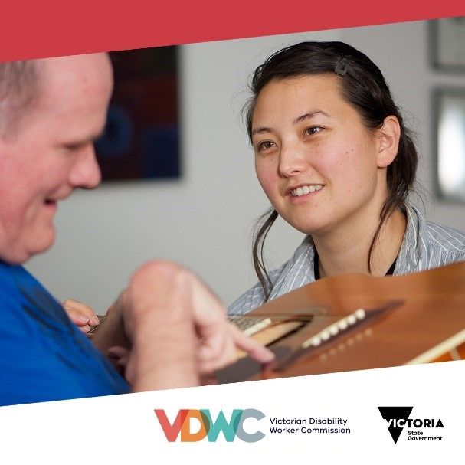

Mandatory notifications
Post: Facebook, LinkedIn
Did you know all Victoria’s disability workers are now required to notify the Victorian Disability Worker Commission about worker misconduct?
Under new regulations for Victoria’s disability sector that started on 1 July 2020, disability workers who reasonably believe a colleague has engaged in certain types of conduct need to report it.
Get informed, find out about the notifiable conduct to report and how to report it at: vdwc.vic.gov.au/making-complaints/notifications
To stay informed, follow the Victorian Disability Worker Commission for updates. [tag the Commission]

Tweet
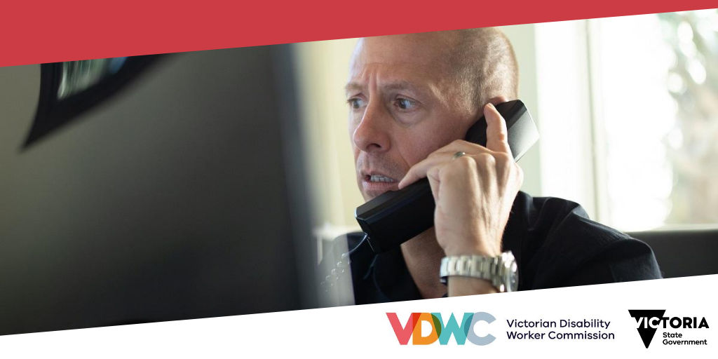
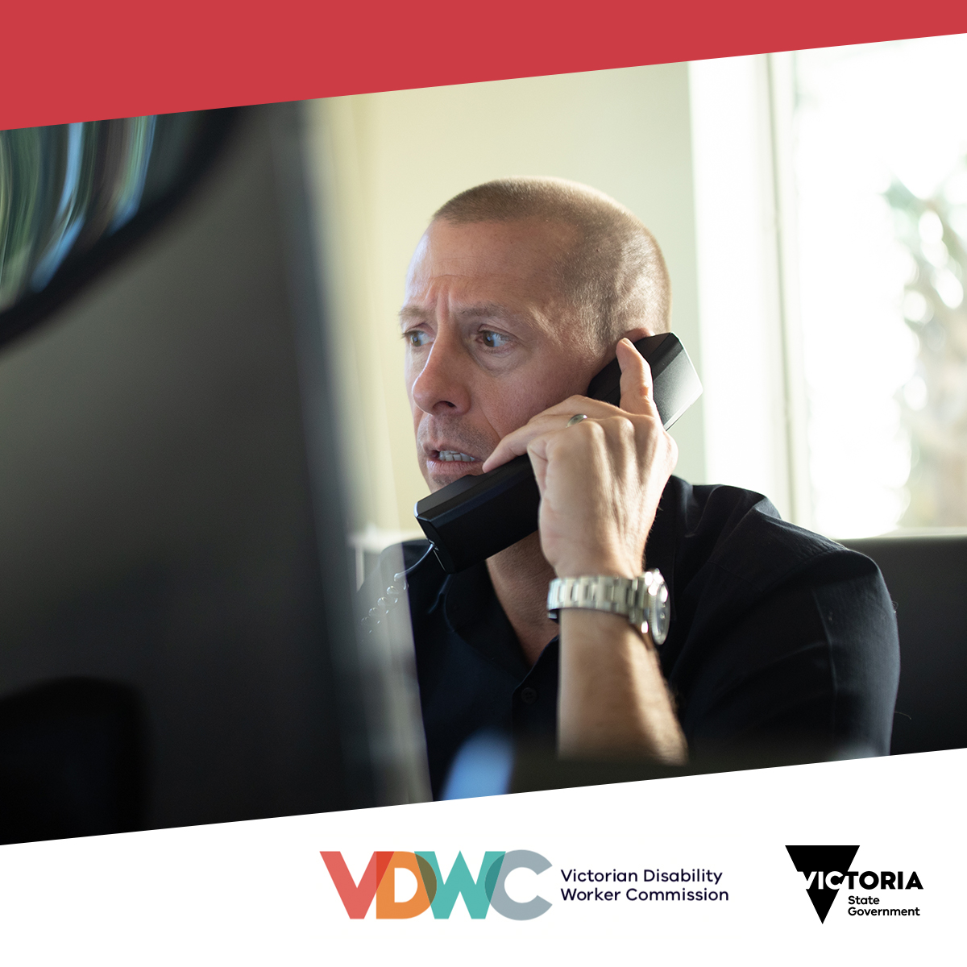
Under new regulations for Victoria’s disability sector that started on 1 July, disability workers who reasonably believe a colleague has engaged in certain types of conduct need to report it. Get information about your new obligations at: vdwc.vic.gov.au/making-complaints/notifications
Images

Complaints

Post: Facebook, LinkedIn
As of 1 July 2020, anyone can make a complaint about the conduct of a disability worker to the Victoria Disability Worker Commission.
It has the power to act on and investigate complaints about the conduct of disability workers and ban unsuitable workers from providing disability services.
You can make a complaint online. Visit https://portal.vdwc.vic.gov.au/public/home
You can also make a complaint by calling the Victoria Disability Worker Commission on 1800 497 132 from Monday to Friday, 9.30am – 4.30pm.

Tweet
As of 1 July, anyone can make a complaint about the conduct of a disability worker to the Victoria Disability Worker Commission. To make a complaint complete the form online at: https://portal.vdwc.vic.gov.au/public/home or call 1800 497 132 from Monday to Friday, 9.30am – 4.30pm.

