Privacy policy

Purpose
This policy explains how the Victorian Disability Worker Commission (including the Victorian Disability Worker Commissioner) (the Commission) and the Disability Worker Registration Board of Victoria (Board) collect, use and disclose personal and health information, including through the www.vdwc.vic.gov.au website.

About us
The Disability Service Safeguards Act 2018 (Vic) (DSS Act) establishes a registration and accreditation scheme for the Victorian disability workforce (Scheme).
In performing its functions under the DSS Act, the Commission collects, uses and discloses personal information (including sensitive information) and health information about disability workers, disability students, recipients of disability services and other related persons.
The Commission is committed to protecting the privacy of this personal and health information in compliance with:
- the DSS Act
- the Privacy and Data Protection Act 2014 (PDP Act)
- the Health Records Act 2001 (Health Records Act)
- the Charter of Human Rights and Responsibilities Act 2006 and
- the Freedom of Information Act 1982.

Responsibilities of the Commission and Board
The Commission and the Board each perform functions under the DSS Act, the key objectives of which are to promote the quality, safety, responsiveness and sustainability of the disability services workforce.

The Commission
The Commission is responsible for:
- administrative assistance to the Board to enable the Board to exercise its functions
- in conjunction with the Board, establishing and maintaining a public register of disability workers and a non-public register of disability students
- supporting the Board to perform its functions in relation to accreditation and registration
- receiving, assessing and investigating complaints and notifications and, if appropriate, referring them to the Board
- entering into an agreement with the Board about fees, the Board's budget and services to be provided by the Commission to the Board
- providing advice to the Minister about matters referred to the Commission by the Minister
- investigating and reporting on matters referred to the Commission by the Minister
- monitoring, identifying and advising the Minister about trends in relation to complaints and notifications, and other related matters
- carrying out and supporting research into the handling of complaints and ways of improving the practice of disability workers and the disability services they provide and
- providing information and education to the public about disability workers and their conduct, the complaint handling standards and the complaints and notification processes.

The Board
The Board is responsible for:
- setting standards for the registration and practice of disability workers
- accrediting training programs and supervised practice arrangements that qualify persons for registration as disability workers
- assessing the probity and qualifications of applicants for registration
- registering suitably qualified disability workers
- registering disability students to undertake supervised practice as part of an approved program of study
- dealing with matters of impairment in relation to registered disability workers and disability students
- receiving, assessing and dealing with notifications and complaints about registered disability workers and disability students
- monitoring compliance with registration and practice standards by registered disability workers
- collecting and providing data for disability workforce planning and system improvement purposes and
- regulating the advertising of services provided by registered disability workers.

The Victorian Disability Worker Commissioner (the Commissioner) is responsible for issuing Prohibition Orders, Interim Prohibition Orders and public statements in relation to unregistered disability workers.

Definitions

Personal information
Personal information is defined in the PDP Act as information or an opinion (including information or an opinion forming part of a database), that is recorded in any form and whether true or not, about an individual whose identity is apparent, or can reasonably be ascertained, from the information or opinion, but does not include information of a kind to which the Health Records Act applies.

Sensitive information
Sensitive information is a subset of personal information and is defined in the PDP Act as information or an opinion about an individual’s:
- racial or ethnic origin
- political opinions
- membership of a political association
- religious beliefs or affiliations
- philosophical beliefs
- membership of a professional or trade association
- membership of a trade union
- sexual preferences, orientation or practices or
- criminal record.

Health information
Health information is defined in the Health Records Act as:
- information or an opinion about:
the physical, mental or psychological health (at any time) of an individual or
a disability (at any time) of an individual or
an individual's expressed wishes about the future provision of health services to them or
a health service provided, or to be provided, to an individual,
that is also personal information (see definition of personal information under the Health Records Act below) or
- other personal information collected to provide, or in providing, a health service or
- other personal information about an individual collected in connection with the donation, or intended donation, by the individual of their body parts, organs or body substances or
- other personal information that is genetic information about an individual in a form which is or could be predictive of the health (at any time) of the individual or of any of their descendants.
Personal information is defined in the Health Records Act as information or an opinion (including information or an opinion forming part of a database), whether true or not, and whether recorded in a material form or not, about an individual whose identity is apparent, or can reasonably be ascertained, from the information or opinion, but does not include information about an individual who has been dead for more than 30 years.

Figure 1. Relationship between personal, sensitive and health information
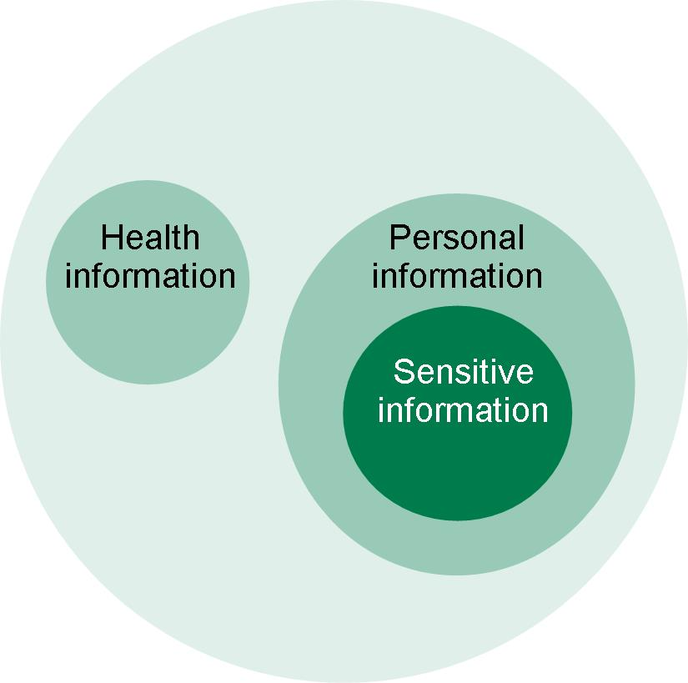

Figure 1 illustrates that health information and personal information are distinct categories. Sensitive information is a subset of personal information.

Application
This policy applies to all personal and health information collected, stored, used and disclosed by the Board or Commission about individuals including disability workers, disability students, recipients of disability services and other related persons.

Collection of information

Collection of personal and health information
The Commission may collect personal and health information about an individual as necessary to fulfil its functions.
The Commission and the Board typically collect information in the following ways:
- directly from the individual to whom the information relates
- where it is not reasonable or practicable to collect the information directly from the individual, information may be collected from a third party, such as the individual's authorised representative
- from each other, where the sharing of information between the Board and the Commission is consistent with their respective statutory functions
- from a person who makes a complaint or statutory notification under the Scheme
- from entities who provide assistance with identity verification, screening and confirmation of qualifications, particularly as relevant to assessing eligibility for registration as a disability worker or disability student. Examples of such entities include Department of Justice and Community Safety, registered document verification service providers and educational or training institutions
- from an assessor who conducts a health assessment or a performance assessment in relation to a registered disability worker or disability student
- from the Victorian Civil and Administrative Tribunal (VCAT), after a relevant matter is referred to VCAT by the Board, or by a person affected by a decision of the Commission or the Board
- from other Commonwealth, State or Territory entities under statutory information sharing arrangements and
- in other circumstances where information may be provided by a third party.

Collection of sensitive information
The Commission or the Board may collect sensitive information where:
- the individual has consented to the collection
- the collection is required or authorised under law, including the DSS Act
- the collection is necessary to prevent or lessen a serious threat to the life or health of any individual, where the individual whom the information concerns is physically or legally incapable of giving consent to the collection or physically cannot communicate consent to the collection or
- the collection is necessary for the establishment, exercise or defence of a legal or equitable claim.

Types of information collected by the Commission and the Board
The types of personal or health information the Commission or the Board collect depends on the nature of the contact with the Commission or the Board and the relevant statutory function being performed.
Personal information collected by the Commission or the Board may include (but is not limited to):
- name, address and contact details
- date of birth, sex
- where relevant to an individual’s practice or registration as a disability worker or disability student:
  - proof of identity, including relevant government records or identifiers (such as birth certificate, driver licence or Medicare card)
  - details about study, qualifications or professional experience
  - employment details
  - insurance arrangements
  - information about the individual’s mental or physical health
  - criminal history
  - details of any current or previous suspension or cancellation of registration or prohibitions relevant to providing a disability service
  - details of conduct that is notified to the Commission or is the subject of a complaint under the Scheme
  - details of a health assessment or performance assessment undertaken in relation to a disability worker or disability student in accordance with the Scheme
  - credit card or other banking information (to process registration application fees)
- where disability services provided to a particular individual are relevant to a complaint, statutory notification or other matter that is relevant to the activities of the Commission or the Board:
  - information about the individual’s disability or health and
  - information about the disability services sought or received by the individual.

Use and disclosure
The Commission and the Board uses and discloses personal (including sensitive information) and health information for:
- the primary purpose for which it was collected or
- a purpose related to that purpose (secondary purpose) where the legislative requirements for using or disclosing for a secondary purpose are met.
The Commission or the Board may use or disclose personal (including sensitive information) or health information when:
- the secondary purpose relates to the primary purpose of collection (or directly relates to the primary purpose in the case of sensitive or heath information) and an individual would reasonably expect the Commission to use or disclose it in this way
- the individual to whom the information relates has given consent for the use or disclosure or
- the Commission is required, authorised or permitted by or under law to use or disclose the information.
The Commission and the Board collect, use, hold and disclose personal and health information for a range of purposes, including, but not limited to:
- providing a mechanism through which complaints in relation to disability workers (both registered and unregistered) and registered disability students may be investigated and dealt with (which may include referral of complaints to other entities)
- receiving and dealing with certain mandatory notifications about disability workers and registered disability students
- assisting in the regulation of registered and unregistered disability workers and disability students
- supporting the Board’s referral of matters to VCAT
- maintenance of a public register of all persons in relation to whom an Interim Prohibition Order or Prohibition Order has been made
- maintenance of a record of any decisions or determinations made by panels established by the Board, or relevant decisions or determinations made by VCAT
- to assist the Board, maintenance of a public register of registered disability workers and disability workers whose registration has been cancelled, and maintenance of a private register of registered disability students and
- compilation and analysis of data pursuant to the statutory function of the Board to monitor, identify and advise the Minister about trends in relation to complaints and notifications, and other related matters.

Information sharing
While they are separate entities under the DSS Act the Commission and the Board work together to administer the Scheme and share information with each other in order to perform their functions.
The Commission and the Board may also share information with other entities as permitted or required by law, for example:
- a prescribed Commonwealth, State or Territory agency with functions relating to the identification of health practitioners or disability workers for information management and communication purposes
- entities related to the NDIS, responsible for worker screening under an Act, or Commonwealth, State or Territory agencies with functions relating to the provision of disability services
- other Commonwealth, State or Territory entities may be provided information about certain risks to health or safety posed by a disability worker or disability student
- an entity that regulates disability workers in a jurisdiction other than Victoria, if necessary for that entity to exercise its functions
- other Information Sharing Entities prescribed under the Family Violence Information Sharing Scheme or Child Information Sharing Scheme. under the Family Violence Protection Act 2008 and the Child Wellbeing and Safety Act 2005.
The Commission and the Board may have reason to disclose personal information and health information to the Department of Health and Department of Families, Fairness and Housing in order to facilitate these Departments assisting the Commission in the exercise of its functions. These Departments are also bound by the requirements of the PDP Act and are prohibited from using this information for any purpose other than the primary purpose for which it was collected or a related secondary purpose. The privacy policy for these Departments is available at https://www.vic.gov.au/privacy-vicgovau.

Data quality
The Commission and the Board take reasonable steps to ensure that any personal and health information they collect, use and disclose is accurate, complete and up to date, and having regard to the purpose for which the information is to be used, that it is relevant to the Commission’s statutory functions and activities.

Storage and information security
The Commission and the Board have security measures designed to protect personal and health information from misuse, loss, unauthorised access, modification or disclosure. The Commission and the Board will take reasonable steps to destroy or permanently de-identify personal information if it is no longer needed for any purpose in line with the Public Records Act 1973.
In relation to health information, the Commission and the Board must take reasonable steps to destroy or permanently de-identify health information if it is no longer needed for the purpose for which it was collected or any other purpose authorised by the Health Records Act, the regulations made under the Health Records Act, or any other law.

Openness
This policy sets out how the Commission and the Board manage personal and health information. An individual may make a request to obtain further general information about how the Commission and the Board manage personal and health information by contacting the Commission at info@vdwc.vic.gov.au or 1800 497 132.

Access and correction
An individual may ask for access to their information or request a correction to their information by contacting the Commission using the details above.
When contacted, the Commission will let the individual know whether it holds information about them and any further steps that that individual should take to obtain access to the information.

Unique identifiers
A unique identifier is generally a number assigned to an individual by an organisation or agency in order to identify the individual for the purposes of the organisation’s or agency’s operations.
The Commission and the Board will only:
- collect, use or disclose unique identifiers assigned by another organisation or agency:
  - as required by the DSS Act or any other law or
  - with the consent of the relevant individual and
- adopt a unique identifier that has been issued by another organisation or agency if necessary to enable the Commission or Board to efficiently carry out its functions.

Anonymity
Where lawful and feasible, individuals may have the option of not identifying themselves when dealing with the Commission or the Board.

Transborder data flows
The Commission and the Board adhere to the requirements of the PDP Act and the Health Records Act when transferring personal and health information outside of Victoria.
The only circumstances in which personal and health information may be transferred or stored outside of Victoria is when the transfer or storage meets one (or more) of the following criteria:
- the Commission or the Board reasonably believes that the recipient of the information is subject to a law, binding scheme or binding contract that provides substantially similar protection to the PDP Act or Health Records Act
- the individual has provided consent to the transfer or
- the transfer is required or authorised by law, including the express cross-jurisdictional disclosures that are required by the DSS Act.

Making a complaint about a privacy incident (breach)
An individual may make a complaint about a potential privacy incident (breach) by contacting info@vdwc.vic.gov.au or 1800 497 132.
The Commission and the Board undertake to resolve privacy complaints and breaches in a timely and fair manner.
An individual may also make a privacy complaint to:
- the Health Complaints Commissioner in relation to a complaint relating to health information: 1300 582 113 or
- the Office of the Victorian Information Commissioner in relation to a complaint relating to personal or sensitive information:1300 666 444.

References/related documents

Policies and guidelines
- VDWC Operations Manual
- Freedom of Information Policy
- Informal Release of Information Policy
- Disability Worker Registration Board of Victoria Confidentiality and Privacy policy

Compliance
This policy complies with all relevant legislation and VPS policies, in particular:
- the DSS Act
- the Privacy and Data Protection Act 2014 (PDP Act)
- the Health Records Act 2001 (Health Records Act)
- the Family Violence Protection Act 2008
- the Child Wellbeing and Safety Act 2005
- the Charter of Human Rights and Responsibilities Act 2006 and
- the Freedom of Information Act 1982.

Policy review and currency
This policy will be reviewed annually from the last approved date, or when there is a significant change in the policy.

Version history
Release notice
Version | Date of effect | Amendment details | Amended by
1.0 | 6 August 2020 | Initial release
2.0 | 15 April 2021 | Updated for FVISS and CISS requirements | General Counsel
Record no.: | VDWC/D/21/1141
Policy owner: | General Counsel
Approved by: | Commissioner |  | Approved on: | 15 April 2020
Next Review Due: | April 2022

