If you work in disability, or employ people who do, then you are

now required under law to report conduct from disability workers

that may put the people they support at risk.

All disability workers and disability employers must make mandatory notifications to the Victorian Disability

Worker Commission if they form a reasonable belief that a disability worker has engaged in notifiable conduct.

This is a requirement of the *Disability Service Safeguards Act 2018*.

What conduct requires mandatory notification?

Notifiable conduct means when a disability worker has:

1. practised as a disability worker while intoxicated by alcohol or drugs
2. engaged in sexual misconduct while practising as a disability worker
3. placed, or may place, the public at risk of harm because the disability worker has an impairment that detrimentally

affects, or is likely detrimentally to affect, the disability worker’s capacity to practise as a disability worker, or

1. placed, or is placing, the public at risk of harm because the disability worker practised, or is practising, as a

disability worker in a manner that constitutes a significant departure from accepted professional standards.

Who has to notify?

Disability workers and disability employers in Victoria are obliged to make a notification to the Victorian Disability

Worker Commission if they form a reasonable belief that another disability worker has engaged in notifiable conduct.

An employer of a disability worker means a person that employs the disability worker under a contract

of employment or a contract for services.

Mandatory notifications do not apply to employers of a disability worker if the employer receives disability services

from the relevant disability worker in the course of the disability worker’s employment. This means that a person with

disability, or their family member or carer, who has directly employed a disability worker are not subject to mandatory

notifications.

If you are a disability worker and you do not make a mandatory notification to the Victorian Disability Worker

Commission, this may constitute behaviour for which health, conduct or performance actions may be taken

against you.

When must I notify?

You must notify the Victorian Disability Worker Commission as soon as practicable after you form a reasonable belief

that behaviour that constitutes notifiable conduct has occurred. The [*Disability Services Safeguards Act 2018*](https://www.legislation.vic.gov.au/in-force/acts/disability-service-safeguards-act-2018/001) does

not define as soon as practicable. The Victorian Disability Worker Commission expects you to not delay making

a notification once you have formed a reasonable belief.

In what way?

The simplest way to make a notification to the Victorian Disability Worker Commission is to use the [webform](https://portal.vdwc.vic.gov.au/public/home).

You can also call us and tell us you want to make a notification.

Are there exceptions?

If you are a disability worker, you are not required to make a mandatory notification in the following circumstances:

* You know, or reasonably believe, that the Victorian Disability Worker Commission has already been notified

of the worker’s conduct.

* You are employed or engaged by an insurer that provides professional indemnity insurance in relation to

the disability worker who is a subject of the notification and you formed the reasonable belief as a result of

a disclosure made by a person to you in the course of a legal proceeding or providing legal advice arising from

the insurance policy.

Key terms

**What is ‘reasonable belief’?**

Before making a mandatory notification, you must form a ‘reasonable belief’. To do so, you generally need direct knowledge (not just a suspicion) of the incident or behaviour that led to a concern.

You might directly observe the incident or behaviour. You may have a report from a reliable source or sources about conduct they directly experienced or observed. In that case, you should encourage the person with the most direct knowledge of the incident or behaviour to consider whether to make a notification themselves.

Mandatory notifications should be based on personal knowledge of reasonably trustworthy facts or circumstances that would justify a person of reasonable caution, acting in good faith, to believe that the concern and a risk to the public exists.

These principles about forming a ‘reasonable belief’ come from legal cases. In short, a reasonable belief is a state of mind based on reasonable grounds. It is formed when all known considerations, including matters of opinion, are objectively assessed and taken into account.

**What is sexual misconduct?**

Sexual misconduct is a broad term encompassing any unwelcome acts or behaviours that are experienced by the person with disability as being sexual in nature. This includes physical and verbal actions committed without consent or by force, intimidation, coercion or manipulation. It includes sexual violence and exploitation but is not limited to actions which constitute a criminal offence. It includes when a disability worker has at any time, including outside of work hours:

* engaged in sexual activity with a service user, whether or not that person has given consent
* made sexual remarks about a service user
* touched a service user in a sexual way
* engaged in sexual behaviour in front of a service user.

There is frequently a power imbalance between a disability worker and a service user. When delivering services, workers are expected to adhere to the highest standards of behaviour, be respectful and take every action to make sure people with disability are safe. This means having professional boundaries in place for relationships between staff and people with disability, and preventing and responding to any inappropriate behaviours by anyone towards a person with disability, including sexual misconduct.

If a disability worker engages in sexual activity with someone who was previously a service user, this may also be sexual misconduct. Whether this constitutes sexual misconduct will depend on the circumstances.

**What is ‘impairment’?**

The *Disability Service Safeguards Act 2018* defines ‘impairment’ as ‘a loss or abnormality of structure or function of an intellectual, cognitive, neurological, sensory, psychological or physical nature, whether permanent or temporary’.

To make a mandatory notification about a disability worker who has an impairment you must form the reasonable belief the impairment has, or is likely to have, a detrimental impact on the disability worker’s capacity to practise and has placed, or may place, the public at risk of harm.

You do not need to notify the Victorian Disability Worker Commission if the disability worker has effective controls to manage the impairment and reduce the risk and severity of harm to the public, such as:

* treatment
* taking a break from practice, such as sick leave
* modified scope of practice
* strategies used to manage impacts of impairment
* compliance with monitoring and supervision.

**What is ‘a significant departure from professional standards’?**

‘Accepted professional standards’ includes reference to documents like the code of conduct. It covers both practice and professional behaviour.

A significant departure is serious (not slight or moderate) and would be obvious to any reasonable person who practises as a disability worker.

About the Victorian Disability Worker Commission

The Victorian Disability Worker Commission is a new independent body. Led by Commissioner

Dan Stubbs, its job is to better protect people with disability and build a stronger, safer disability

sector. It is responsible for the code of conduct, establishing the minimum expectations for

all workers supporting people with disability, and the complaints service. When notified,

it has the power to investigate and ban workers who put people’s safety at risk.

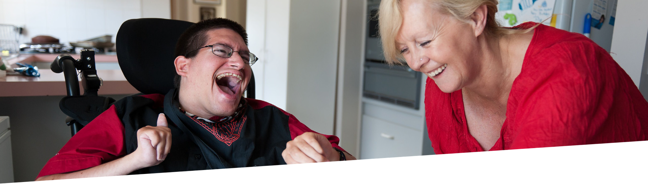

**Stay up to date**

Visit our website [vdwc.vic.gov.au](http://www.vdwc.vic.gov.au/)

Sign up to our [newsletter](https://mailchi.mp/0b946807739a/newsletter-subscription)

Follow us



Help build a stronger,

safer, disability sector.