Victorian Disability Worker Commission and Disability Worker Registration Board of Victoria
annual report
1 July 2021 to 30 June 2022

Acknowledgement of Country
We proudly acknowledge Victoria’s First Nations peoples and their ongoing strength in practising the world’s oldest living culture. We acknowledge the Traditional Owners of the lands and waters on which we live and work and pay our respect to their Elders past and present. We acknowledge the ongoing role of the Aboriginal community in supporting those with disability.
Accessibility statement
The Victorian Disability Worker Commission aims to make its information and publications accessible to all. This annual report has been designed in both a PDF and accessible Word format. If you require an alternative format, please email the Commission <info@vdwc.vic.gov.au>.
The Commission and Board are statutory entities of the State Government of Victoria created under the Disability Service Safeguards Act 2018.
© State of Victoria (Victorian Disability Worker Commission and Disability Worker Registration Board of Victoria) 2022
The Victorian Disability Worker Commission and Disability Worker Registration Board of Victoria annual report 2021-2022 is licenced under a Creative Commons Attribution 4.0 licence.
You are free to re-use the work under that licence, on the condition that you credit the State of Victoria (Victorian Disability Worker Commission and Disability Worker Registration Board of Victoria) as author, indicate if changes were made and comply with other licence terms. The licence does not apply to any images, photographs or branding, including the Victorian Government logo, Victorian Disability Worker Commission logo, the Disability Worker Registration Board of Victoria logo and the logos used to certify registration as a registered disability worker.
The publication of this annual report complies with requirements under the Financial Reporting Direction 30B regarding its design, use of colour and images, standard sizing and other publishing requirements.
Copyright queries may be directed to info@vdwc.vic.gov.au
ISSN 2653–2360 – Online (pdf/word)
Published September 2022
Victorian Disability Worker Commission
Level 20, 570 Bourke Street
Melbourne Victoria 3000
Phone: 1800 497 132
Email: info@vdwc.vic.gov.au
Web: vdwc.vic.gov.au

Responsible bodies’ declaration
The Hon. Colins Brooks
Minister for Disability, Ageing and Carers
Level 3, 1 Treasury Place
East Melbourne Vic 3002
5 September 2022
Dear Minister
We are pleased to submit this consolidated annual report of the Victorian Disability Worker Commission and Disability Worker Registration Board of Victoria for the period 1 July 2021 to 30 June 2022 in accordance with the Financial Management Act 1994.
Yours sincerely
Dan Stubbs
Commissioner
Victorian Disability Worker Commission
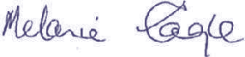
Melanie Eagle
Chairperson
Disability Worker Registration Board of Victoria

Contents
Responsible bodies declaration 3
Commissioner’s report 6
Board chairperson’s report 7
Year in review 2021-2022: Creating a safer, stronger disability sector 8
Why we’re here – working for a stronger, safer disability sector 11
Introduction 12
Scope of annual report 12
About us 13
Our values 14
Victorian Disability Worker Commissioner 14
Victorian Disability Worker Commission 15
Disability Worker Registration Board of Victoria 16
Our Minister 16
Case study: Notification from a service provider 17
Governance and organisational structure 18
Disability Worker Registration Board of Victoria 18
Board committees 19
Accountability of the Commission and Board 21
Ministerial Statements of Expectations 22
Our operating environment 22
Case study: Jay, youth mentor and registered disability worker 24
Disability Worker Regulation Scheme 25
Our regulatory framework 26
Our Scheme strategic plan 28
Vision 28
Purpose 28
Guiding principle 28
Strategic pillars 28
Pillar 1: Safety and compliance 30
Pillar 2: Registration 31
Pillar 3: Workforce standards 32
Case study: Notification about an unregistered disability worker’s conduct 33
Pillar 4: Engagement and communication 34
Pillar 5: Enablers 35
Case study: Complaint about an unregistered disability worker 36
Case study: Karyn, support coordinator and registered disability worker 37
Case study: Yunus, registered disability worker 38
2021-2022 financial information 39
Financial performance 39
Financial management compliance attestation 40
Compliance 41
Amending Scheme legislation 41
Government advertising expenditure 42
Disclosure of ICT expenditure 43
Disclosure of major contracts 43
Public sector values and employment principles 43
Workforce data 43
Occupational health and safety 44
Freedom of Information Act 44
Access to information 45
Competitive neutrality policy 46
Public Interest Disclosures Act 46
Building Act 47
Local Jobs First Act 47
Disability Act 48
Carers Recognition Act 48
Office-based environmental impacts 48
Consultancy expenditure 49
Declaration of pecuniary interests 49
Disclosure of grants and sponsorships 49
Compliance with DataVic access policy 49
Appendix 1: Disclosure index 50
Appendix 2: Workforce data 53
Appendix 3: Scheme safety and compliance, and registration data 57

Commissioner’s report
I am pleased to present this report of the Victorian Disability Worker Commission, jointly with the Disability Worker Registration Board of Victoria.
The annual report shows that in its second year, the Commission is starting to make a difference in the lives of many people with disability. It is also clear that the Commission is delivering on the Victorian Government’s objective to set a higher standard for the safety and quality of services for Victorians with disability.
In 2021-2022 we responded to many complaints and notifications regarding a range of services for people with disability funded from various sources. These included contacts from a significant number of disability workers and practitioners in Victoria working outside of the NDIS. This is a reminder of why the Commission exists for all disability workers.
We also developed a new combined strategic plan that aligns with performance indicators to illustrate how we are delivering on key objectives and outcomes over time. The new strategic plan and monitoring and evaluation framework shows an integrated approach combining the expertise of the Commission and the Board.
This year we stepped up our community engagement to understand what people with disabilities and their supporters most need from our work. We continue to ramp up our information and education resources and events, to build awareness and understanding about what we do, and how people can make a complaint, notification or registration application.
I acknowledge the support received from former Ministers and thank Minister Brooks and his office who have already been very supportive. I look forward to working with him and the team.
Thank you to the Disability Worker Registration Board of Victoria Chair and its members with whom we have worked closely this year in their first year of voluntary registration of disability workers.
Finally, despite the challenges for the sector in our second year, I know that the Commission and Board have continued to make this a sector where all workers can be proud of what they do and where people with disability are safe and well supported.
For this progress I am grateful to the remarkable, hard-working and dedicated staff of the Commission, without whom none of the results reported herein would have been possible.
Dan Stubbs
Commissioner

Board chairperson’s report
I am pleased to present the Board’s second annual report, jointly with the Victorian Disability Worker Commission and Commissioner.
The Disability Worker Regulation Scheme is the first of its kind in Australia. It seeks to lift the standard of services provided by disability support workers and practitioners in Victoria.
In the context of the continuing pandemic, it has been a challenging year for the disability sector, including engagement with disability workers to encourage registration.
Disability worker registration started on 1 July 2021. As of 30 June 2022, we have received 610 applications and registered 400 disability workers. Of the 610 workers who applied, 64 per cent are women, 52 per cent are over 40 years of age and 18 per cent are disability practitioners (professionally qualified workers).
There is currently no fee for registering as a disability worker. During the year, the Board decided to continue this in 2022-2023.
An important component of the Board’s work is determining registration standards. This includes continuing professional development requirements and adopting a framework for developing future registration standards. Meanwhile the Board has decided to continue the approach of having work experience as a basis to qualify for registration until September 2023.
The Board works across government to create efficiencies in the registration process, such as a proposal to accept an NDIS worker screening clearance in lieu of criminal record check for registration. I acknowledge my Board colleagues who have brought their diverse perspectives and experience to the work of the Board.
The Board has undergone a membership evolution with the resignations of Stephanie Gotlib, Paul Ravenarki and Scott Sheppard and I thank them for their Board contributions. I am pleased to welcome members, Maryanne Diamond AO and Colleen Furlanetto OAM who were appointed to the Board in August 2021. I acknowledge the contribution of all Board Committees particularly the Registration Standards Guidelines and Accreditation Committee.
I thank the Commissioner, Dan Stubbs, who leads the dedicated staff of the Commission. They enable us to collectively achieve our strategic aims. In particular I would like to thank Vanessa Stafford, the Board Secretary, who has supported me and the Board to undertake our work.
Finally, I would like to thank the department and Minister Brooks for supporting us as a relatively new entity.
Melanie Eagle
Chairperson

Year in review 2021-2022: Creating a safer, stronger disability sector

Awareness and education
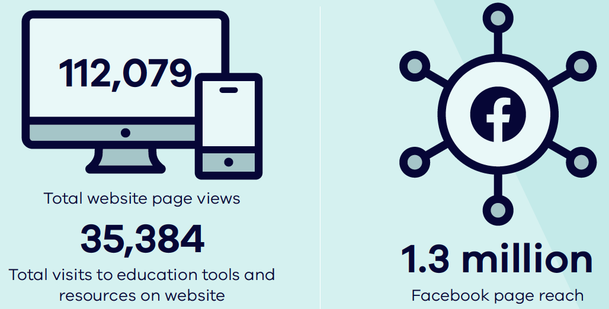
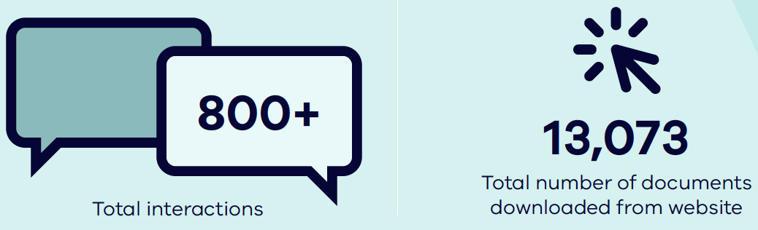

Interactions with the Scheme

Registering disability workers
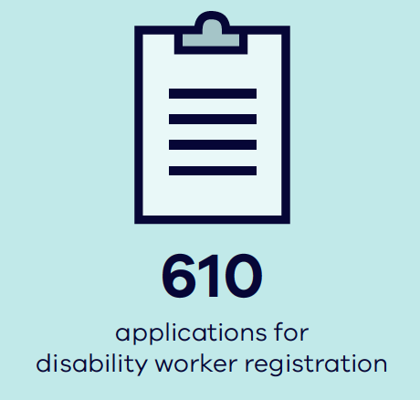
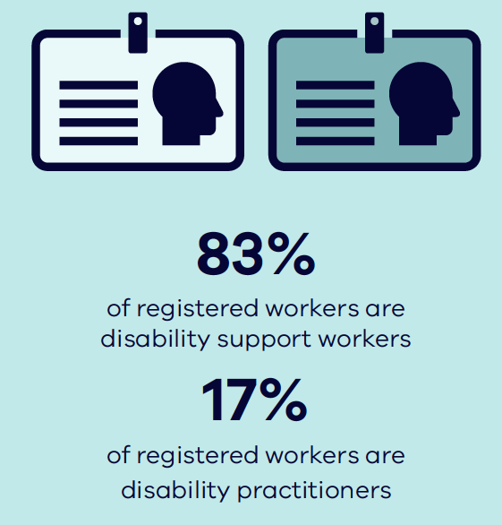

Responding to concerns about disability workers’ conduct
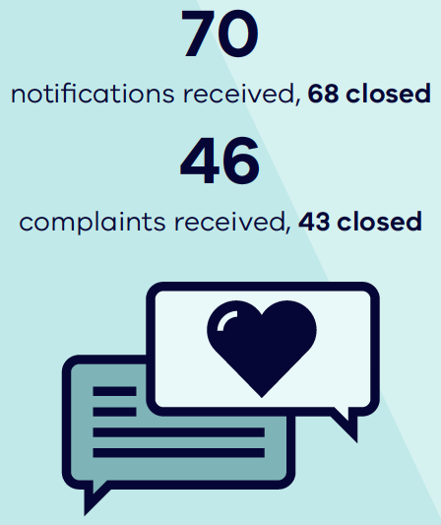
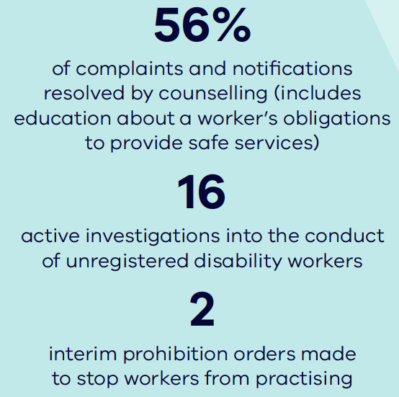

Why we’re here – working for a stronger, safer disability sector
We exist to protect one of Victoria’s most vulnerable communities – people with disability.
We are a young organisation at just two years old. Our organisation started in unprecedented circumstances at the beginning of the COVID-19 pandemic. During this time, we have seen significant movement and change in the disability sector, including ongoing social services regulation reforms. The environment has created uncertainty in the sector and the workforce. There are resulting challenges for a new organisation like the Commission.
Disability workers are passionate and proud of their work. Every day, disability workers provide diverse services to people with disability. This could be anything from high-level 24-hour personal care to ad hoc support when needed. Most disability workers are highly committed and give people with disability excellent care.
But we know there are times when there are concerns and when people with disability can be harmed. We, too, have heard the stories being told at the Royal Commission into Violence, Abuse, Neglect and Exploitation of People with Disability. The stories reinforce how critical it is to protect vulnerable people from harm and neglect. People who pose a serious risk of harm must be stopped from providing disability services.
It is important that people with disability feel safe with their disability worker. We have made it easier for people to raise their concerns through our online complaints and notifications service. While the majority of disability workers are excellent, the Commission has also acted to prohibit workers who do not do the right thing.
A huge amount of trust is involved between a worker and a person with disability. Knowing upfront that the worker has been properly assessed can instil great confidence. Australia’s first professional registration scheme for the disability workforce aims to give people that confidence. Registration forms part of the Victorian Government’s zero tolerance approach to abuse of people with disability.
Workers who register are giving people with disability, their families and carers confidence that they are skilled, safe and professional. They are showing they want to be part of the change that ensures the right people are working with our loved ones.
We have come a long way in a short time. We have put in place safeguards to protect the community and the disability sector that have never existed in Victoria.
The Victorian disability sector is on a journey unlike any other state in Australia. It is showing its commitment to raising standards and supporting a quality workforce. It is doing the work to ensure people with disability have the choices and protections they should always have had.
Victoria is leading the way in building better safeguards for the sector.
We are proud to be part of creating a stronger, safer disability sector for Victoria.

Introduction
This is the second annual report of the Victorian Disability Worker Commission (Commission) and the Disability Worker Registration Board of Victoria (Board).
We were established in 2018 under the Disability Service Safeguards Act 2018 (DSS Act). Our major functions started in 2020.
Although the DSS Act establishes us as distinct legal entities, the Commission, the Board and the Victorian Disability Worker Commissioner (Commissioner) work together to regulate disability workers in Victoria.
We are presenting our annual report of operations and financial statements in a combined annual report.

Scope of annual report
On 21 March 2021 the Assistant Treasurer, the responsible minister, determined that under the Financial Management Act 1994:
- the Board and Commission may prepare a single annual report of operations and financial statements in its first reporting period and subsequent years, under section 53(1)(a)
- the Board and Commission may combine their financial statements with the Department of Families, Fairness and Housing’s financial statements, under section 53(1)(b).
In this report:
- ‘the Commission’ is the Victorian Disability Worker Commission
- ‘the Board’ is the Disability Worker Registration Board of Victoria
- ‘the Commissioner’ is the Victorian Disability Worker Commissioner
- ‘the Scheme’ is the Disability Worker Regulation Scheme.

About us
The Victorian Disability Worker Commissioner is the head of the Commission. The Commissioner regulates the conduct of unregistered disability workers and has the power to prohibit a worker from practising in Victoria. Dan Stubbs is the Victorian Disability Worker Commissioner.
The Disability Worker Registration Board of Victoria registers disability workers who meet certain standards set by the Board. The Board can also register disability students. The Board regulates the conduct of these registered workers and students. The Board, chaired by Melanie Eagle, formed in August 2019.
The Victorian Disability Worker Commission supports the Commissioner and Board. The Commission deals with complaints and notifications about disability workers and can investigate their conduct.
The Commission also communicates to the public about disability workers. It maintains the Board’s register of registered workers and the Commission’s register of prohibited workers.
Figure 1 illustrates the interrelationship between the roles of the Commission, the Commissioner and the Board.
For more information on the Commission and Board, visit the Commission’s website <https://www.vdwc.vic.gov.au>.
Figure 1: Interrelationships between the Commission, the Commissioner and the Board
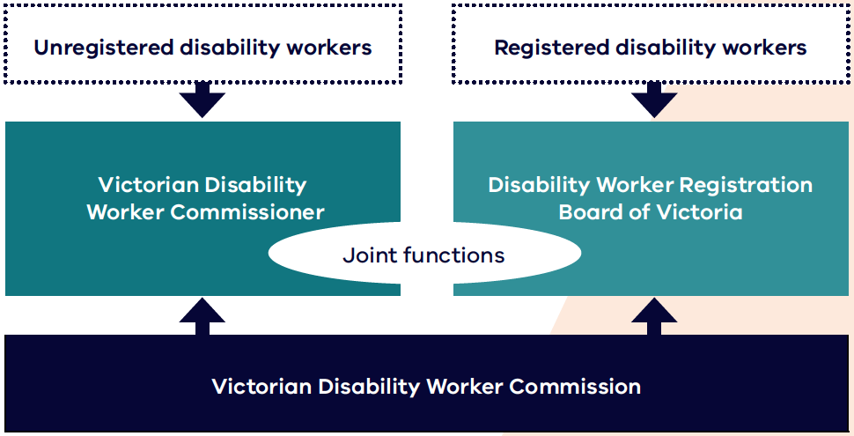

Our values
Our values inform what we do and how we do it.

Diversity and inclusion
- We have inclusive recruitment and employment practices that foster diversity in our workforce.
- We ensure that diverse communities see themselves in who we are and what we do.
- We are committed to being an accessible workplace and an accessible regulator for our diverse stakeholders.

Independent and fair
- We treat everyone with respect, listening to all parties involved.
- We do what we say we will do and take proportionate action.
- The community sees our processes and decisions as independent and transparent.

Fearless and accountable
- We use our powers to hold others accountable for their actions.
- We are responsible for our actions and are open to scrutiny and feedback.
- We continually evaluate and improve our operations.

Trust and respect
- We are respectful and professional with colleagues and the community.
- We foster trust by assessing matters impartially.
- We have confidence in and are respectful of each other’s skills and capabilities.

Empathy and dignity
- We take a person-centred approach to everything we do.
- We ask people what they need from us and how we can work with them.
- We are responsive and flexible to support the diverse communities and people we serve.

Victorian Disability Worker Commissioner
The Office of the Commissioner is a ‘special body’ under the Public Administration Act 2004 (section 6).
The Commissioner has all the duties, functions and powers of the Commission under the DSS Act. The Commissioner also has the power to issue prohibition orders about unregistered disability workers, where there is a serious risk to the public or a person.
Dan Stubbs was appointed as the Commissioner in September 2019.

Victorian Disability Worker Commission
The Commission takes complaints about registered and unregistered disability workers. It also helps the Board exercise its functions regarding registered workers.
The Commission is a public entity under the Public Administration Act 2004 (section 5).
The Commission’s functions for registered disability workers and disability students include:
- administrative support to the Board to enable the Board to exercise its functions around registering and regulating registered disability workers, disability students and accrediting training programs
- with the Board, set up and maintain a public register of disability workers and a register of disability students
- if appropriate, conciliate complaints
- enter into agreement with the Board about fees, the Board’s budget and services the Commission will provide to the Board
- monitor, identify and advise the Minister about trends around complaints, notifications and other related matters
- carry out and support research into complaints handling and ways of improving disability workers’ practices and services
- public information and education about disability workers and their conduct, complaint handling standards, and complaints and notifications processes.
For unregistered disability workers, the Commission has the following functions:
- put in place efficient procedures for receiving and dealing with complaints
- receive, assess and deal with complaints and notifications – if appropriate, refer them to the Board
- if appropriate, conciliate complaints
- advise the Minister on matters referred to the Commission by the Minister
- enquire into or investigate matters referred to the Commission by the Minister and report to the Minister
- monitor, identify and advise the Minister on trends around complaints, notifications and other related matters.

Disability Worker Registration Board of Victoria
The Board registers and regulates registered disability workers and students.
The Board is a public entity under the Public Administration Act 2004 (section 5).

Functions
The Board’s functions include:
- set standards for registering disability workers and registered disability worker practice
- accredit training programs and supervised practice arrangements that qualify people for registration as a disability worker
- assess the probity and qualifications of applicants for registration and to register suitably qualified disability workers
- register suitably qualified disability workers
- register disability students to undertake supervised practice, as part of an approved program of study
- deal with matters of impairment for registered disability workers and disability students
- receive, assess and deal with notifications and complaints about registered disability workers and disability students
- monitor registered disability workers’ compliance with registration and practice standards
- collect and provide data for disability workforce planning and system improvement
- regulate the advertising of services provided by registered disability workers.
As a new regulator some of these functions will be undertaken in future registration years.

Our Minister
The Board and the Commission are separately accountable to the Minister for Disability, Ageing and Carers.
From June 2022, the responsible minister is the Hon Colin Brooks MP.
Other ministerial appointments during the reporting period:
- the Hon Luke Donnellan MP (December 2018 to October 2021)
- the Hon James Merlino MP (October 2021 to December 2021)
- the Hon Anthony Carbines MP (December 2021 to June 2022).

Case study: Notification from a service provider

Notification
We received a mandatory notification from an employer about Charlie, an unregistered disability worker.
Charlie, a registered nurse, provides medical and personal care to Jessie, who lives in supported independent living accommodation. Jessie has an intellectual disability and medical condition that needs close monitoring and regular medication.
The notifier alleged that Charlie had not followed Jessie’s medical support plan and administered incorrect medication.

What we did
We contacted Charlie and advised him of the notification. Charlie denied the conduct. Charlie told us he was aware of Jessie’s medical condition but was not aware of the medical support plan.
We assessed the service provider’s investigation report, the medical support plans and Charlie’s response.

Outcome
Charlie was counselled to educate him on his obligations and practices as a disability worker to follow medical support plans and maintain accurate, up-to-date records.
We assessed that Charlie's conduct was not consistent with the following clauses in the Code of Conduct:
- Clause 3: Provide support and service in a safe and competent manner with care and skill
- Clause 5: Promptly take steps to raise and act on concerns about matters that may impact the quality and safety of supports and services provided to people with disability.
As Charlie is a registered nurse, we also referred the matter to the Australian Health Practitioner Regulation Agency (AHPRA). AHPRA advised that they had placed training requirements on Charlie's practice because of the notification.
Please note: This case study shows a type of matter the Commission responded to in
2021-2022. This case study uses pseudonyms, and some details have been changed to protect the anonymity of the participants.

Governance and organisational structure
The Commission’s organisational structure is shown in Figure 2.
Figure 2: Organisational structure of the Commission
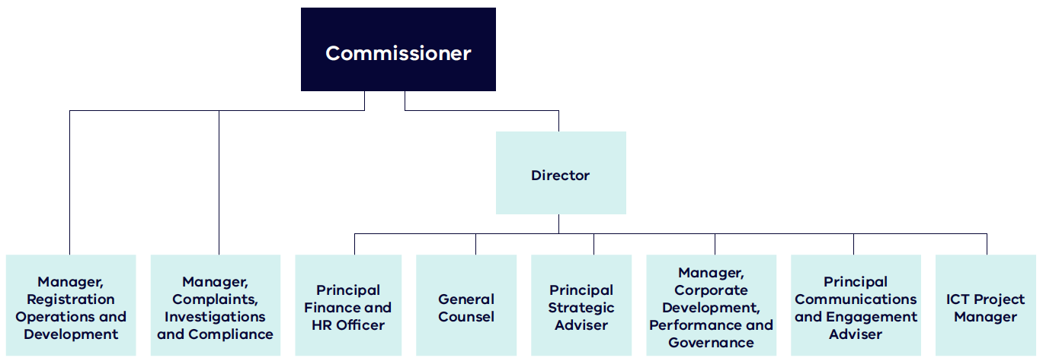

Disability Worker Registration Board of Victoria

Board membership
The chairperson and members of the Board are appointed by the Governor-in-Council on the Minister’s recommendation.
The Board’s membership must include:
- at least two members (and not more than two- thirds of members) who are not and have never been registered disability workers
- at least two members (and not more than two-thirds of members) who are registered disability workers
- at least three members who are people with disability.
Board membership at 30 June 2022 was:
- Melanie Eagle (Chairperson)
- Christian Astourian
- Christine Bigby
- Gobi Chandran
- Maryanne Diamond (appointed August 2021)
- Colleen Furlanetto (appointed August 2021)
- Alexandra Gunning
- Jill Linklater
- Geoffrey Southwell.
Directors whose term expired or who resigned during the reporting period:
- Stephanie Gotlib – resigned January 2022
- Paul Ravenarki – resigned February 2022
- Scott Sheppard – resigned May 2022.
The Board does not employ staff. The Commission supports the Board by providing administrative assistance and support to enable it to exercise its functions for registration and regulation of registered disability workers. In future, this will include registration and regulation of disability students and accreditation of training programs.

Board meeting attendances
Table 1: Meetings attended and eligible to attend during the reporting period
Name | Number of meetings
Melanie Eagle (Chair) | 9 of 11
Christian Astourian | 11 of 11
Christine Bigby | 11 of 11
Gobi Chandran | 5 of 11
Maryanne Diamond AO | 9 of 10
Colleen Furlanetto OAM | 10 of 10
Stephanie Gotlib | 5 of 7
Alexandra Gunning | 11 of 11
Jill Linklater | 10 of 11
Paul Ravenarki | 4 of 7
Scott Sheppard | 9 of 10
Geoffrey Southwell | 10 of 11

Board committees

Panels and Assessors Committee
The Panels and Assessors Committee was established 23 June 2021 to assess and shortlist applicants for the list of approved persons from which to appoint to health and professional standards panels. The committee met twice in the reporting period: 21 January and 15 February 2022.
Members:
- Melanie Eagle (Chair)
- Christine Bigby
- Geoff Southwell.

Registration Applications Assessment Committee
The Registration Applications Assessment Committee considers and makes recommendations for approval by the Board on complex or sensitive registration assessment matters referred to the Board. The committee met twice in the reporting period: 22 March and 26 April 2022.
Members:
- Melanie Eagle (Chair)
- Gobi Chandran
- Maryanne Diamond
- Colleen Furlanetto
- Alexandra Gunning
- Jill Linklater.

Registration Standards, Guidelines and Accreditation Committee
The Registration Standards, Guidelines and Accreditation Committee helps the Board exercise its standards, guidelines and accreditation functions. The committee develops recommendations on:
- qualifications to be approved under the DSS Act
- the registration standards or guidelines
- work planning and resourcing.
The committee met eight times during the reporting period.
Members:
- Christine Bigby (Chair)
- Melanie Eagle
- Stephanie Gotlib (resigned January 2022)
- Alexandra Gunning
- Scott Sheppard (resigned May 2022)
- Geoff Southwell.

Shared Audit and Risk Committee
The Board and Commission established a Shared Audit and Risk Committee in April 2021.
The committee helps the Board and Commission fulfil their statutory responsibilities under the Financial Management Act 1994 and associated Standing Directions 2018.
The Commission and Board appoint members of the Shared Audit and Risk Committee in line with the committee’s Charter.
Key responsibilities of the committee:
- help the Board and Commission review the effectiveness of their internal control environment, covering effectiveness and efficiency of operations, reliability of financial reporting and compliance with applicable laws and regulations
- review information in the report of operations on financial management, performance and sustainability
- determine the scope of the internal audit function and ensure its resources are adequate and used effectively, including coordination with external auditors
- maintain effective communication with external auditors, consider recommendations made by internal and external auditors, and review the implementation of actions to resolve issues raised
- oversee the effective operation of the risk management framework.
The Commission and Board nominate committee meeting attendees.
In the reporting period, the Shared Audit and Risk Committee held five meetings and participated in the Scheme risk management workshop in March 2022.
Members of the Shared Audit and Risk Committee at 30 June 2022:
- Binda Gokhale (independent chair)
- John Gavens (independent deputy chair)
- Ken Parsons (independent member).

Accountability of the Commission and Board
The Commission and Board must exercise their respective powers and perform the duties set out in sections 9 and 22 of the DSS Act.
The Commission and Board are subject to the general direction and control of the Minister and any specific written directions given by the Minister.
Under the Public Administration Act 2004, the Commission and Board must:
- inform the responsible minister and the portfolio Secretary (Department Families, Fairness and Housing) of known major risks (significant or emerging) to their effective operation and risk management systems it has in place to address those risks
- provide the responsible minister, unless prohibited from doing so by or under any law, with any information relating to the entity or its operations as he or she requests.

Ministerial Statements of Expectations
The Minister issued Statements of Expectations to the Board, the Commissioner and Commission on 26 April 2022. The Statements of Expectations inform the Commission and Board’s 2022-2023 business plan.
Key expectations include:
- develop a risk-based and proportionate regulatory approach that prevents or minimises the risk of harm to people with a disability
- strengthen collaboration and engagement with other regulators and agencies
- promote complaints and notifications as well as the uptake of registration
- maintain and promote the public register of registered disability workers and public register of banned workers
- raise community awareness of the work of the Commission and Board.

Our operating environment
In Victoria, 17 per cent of people identify as having a disability. Thirty-two per cent of people with disability sometimes or always need help with self-care, mobility or communication.
In Victoria, just over 10 per cent of the 1.1 million Victorians with disability are eligible for a National Disability Insurance Scheme (NDIS) plan. This means that many Victorians receive support outside the NDIS framework.
The Scheme covers both NDIS and non-NDIS disability workers and protects people with disability, including those who are not NDIS participants. This represents the majority of Victorians with disability who use support services.
In Victoria, many bodies work together to support safe disability services. We work with other agencies and organisations, including other workforce regulators including:
- NDIS Quality and Safeguards Commission
- Australian Health Practitioner Regulation Agency (AHPRA)
- Health Complaints Commissioner
- Mental Health Complaints Commissioner
- Commission for Children and Young People
- Victorian Institute of Teaching
- Office of the Public Advocate
- Disability Services Commissioner.
In Victoria, we also work closely with the Department of Justice and Community Safety, which administers NDIS worker screening, and the Department of Families, Fairness and Housing.
Disability support work is complex. It needs a workforce with the skills and expertise to provide safe, quality supports.

More broadly, there are pressures on the supply of the workforce in the disability sector. Key factors impacting the size of the workforce include:
- competition for workers with other sectors including aged care and childcare
- casualisation of the workforce, which is female dominated
- relatively low pay rates.
A high turnover rate amongst casual disability workers has also added pressure to the disability workforce. The turnover rate has increased from 18 per cent in December 2020 to 22 per cent in June 2021.
During 2021 and 2022, the COVID-19 pandemic has continued to have unprecedented public health, social and economic implications for the community. These effects have been acute for people with disability and the disability workforce.
From an operational perspective, the COVID-19 pandemic has meant that the operations of the Commission and Board have mainly been conducted online. Staff did not begin returning to offices and workplaces until early in 2022.
In this context, as new organisations, the Commission and Board have focused our work on building awareness of the Scheme with stakeholders. Our regulatory approach has reflected this aim. We actively provide a ‘no wrong door’ approach to support people with disability and help resolve their queries, including by referring matters to appropriate agencies.

Case study: Jay, youth mentor and registered disability worker
Jay is a 43-year-old youth mentor working with children with complex backgrounds. A large number of the children mentored by Jay have a disability.
Originally from the UK, Jay was a professional basketball player who volunteered as a mentor for children caught up in gang culture.
Since migrating to Australia, he has continued mentoring. He started his own business and works mainly with young people in correctional facilities.
Registration helps Jay as his business is now recognised as a professional disability service provider. It ensures the community knows he has the skills to work with children with disability.
He also sees the recognition registration provides as a benefit for the whole sector.
Registration and being recognised as professional are important as an individual, and to increase confidence in the sector and the appeal of entering the sector as a worker
– Jay, registered disability worker

Disability Worker Regulation Scheme
The Scheme, established through the DSS Act, promotes the quality, safety, responsiveness and sustainability of the disability workforce in Victoria.
Through the Victorian Parliamentary Inquiry into Abuse in Disability Services, we heard of the abuse and neglect of people with disability, including conduct by disability workers.
The inquiry found that Victoria needed more effective safeguards to:
- protect people with disability
- ensure disability workers deliver high-quality care.
The Scheme delivers this in two key ways:
- regulating and registering disability workers according to agreed standards
- strengthening safeguards through mechanisms to report concerns about the conduct of disability workers, ensuring they can be investigated and action taken.
The Scheme covers:
- registered Victorian disability workers
- unregistered Victorian disability workers
- students training to be disability workers in Victoria.
All disability workers must comply with the Code of Conduct, which outlines the obligations of disability workers to respect and uphold the right to safe and quality supports and services.
In a first across Australia, the Scheme also provides for voluntary registration of disability workers. Registration ensures disability workers meet rigorous standards for safety, skills and professionalism – no matter how they are employed or how their service is funded.
The Board sets standards for this registered workforce, and registers and regulates those workers. To be assessed as suitable to hold registration, disability workers must:
- have either professional qualifications or relevant work experience
- meet standards around English competency
- comply with standards around criminal history.
The Commission provides an independent complaint service so that anyone can complain about the conduct of a disability worker.
Disability workers and employers must notify the Commission of certain conduct that places service users at risk.
The Commission and Board can act to resolve complaints and respond to concerns about a disability worker’s conduct. This can include:
- conciliating complaints
- counselling workers to educate about upholding the Code of Conduct
- making agreements
- conducting investigations
- referring the issue to other bodies.
The Board and Commissioner can also take urgent action, if needed, where a disability worker’s conduct puts people at risk.

Our regulatory framework
It is a guiding principle of the Scheme that people with a disability have the same rights as other people in the community.
Other guiding principles of the Scheme are that:
- the registration of disability workers and disability students should happen in a way that is transparent, accountable, effective, efficient and fair
- fees should be reasonable, considering the effective and efficient operation of the registration scheme
- restrictions on the practice of disability workers should only occur if it is in the public interest and they are necessary to ensure that disability services are provided safely and are of an appropriate quality.
The Commission uses a risk-based framework to take proportionate action against the conduct of unregistered disability workers in Victoria.
The guiding principles of the Commission’s regulatory approach are:
- Protective: protect vulnerable Victorians and help them avoid harm.
- Consistent, risk based and evidence based: consistent and objective decisions and outcomes by remaining informed and curious.
- Empathetic and responsive: respectful, fair and tailored engagement with all parties to ensure all views are heard.
- Transparent and accountable: assessment, conduct and enforcement uphold procedural fairness.
- Collaborative: work collaboratively with other entities to ensure compliance with legislative obligations and respect primary jurisdictions.
- Building a better, safer workforce: support a better, safer workforce through improving the understanding of expected standards of safe service delivery.
To support the Commission and Board to achieve the goals of the Scheme, in 2022 they developed:
- Scheme strategic plan: the plan gives an overview of our outcomes in the short and long term, and an indication of our priorities over the next two years
- Scheme risk register: this helps us make decisions by tracking the risks that might affect the Scheme
- Scheme business plan: this annual plan gives an overview of where we will focus our efforts in the next year to efficiently manage the Scheme
- Scheme monitoring evaluation and learning framework: the framework describes our desired Scheme outcomes, how we plan to achieve them and establishes realistic measures to monitor progress towards the outcomes.

Section 7 Guiding principles, Disability Service Safeguards Act
It is a guiding principle of the regulatory scheme under this Act that persons with a disability to whom disability services are provided have the same rights as other members of the community:
- to be respected for their human worth and to be treated with dignity as individuals; and
- to live free from abuse, neglect and exploitation; and
- to realise their individual capacity for physical, social, emotional and intellectual development; and
- to exercise choice and control over their own lives; and
- to access information and communicate in a manner appropriate to their communication and cultural needs; and
- if a child, actively to involve the child’s family and any other caregivers in decisions affecting the child and to have information and support to enable this to occur; and
- to choose disability workers with the values, skills and qualifications that meet their needs; and
- to access services which support their quality of life.

Our Scheme strategic plan
In 2022, the Commission and Board worked together to create a Scheme strategic plan based on five pillars that encompass the strategic goals and outcomes. From this plan came the following vision, purpose and guiding principle.

Vision
People with disability can choose services that best meet their needs and support their quality of life, free from abuse and neglect.

Purpose
We regulate all workers providing disability services in Victoria, regardless of how they are funded. We set standards for registration and training, resolve complaints and prohibit unsafe workers.

Guiding principle
People with disability who use disability services have the same rights as other members of the community.

Strategic pillars
- Safety and compliance
- Registration
- Workforce standards
- Engagement and communication
- Enablers.

Figure 3: Our strategic plan 2022 to 2024
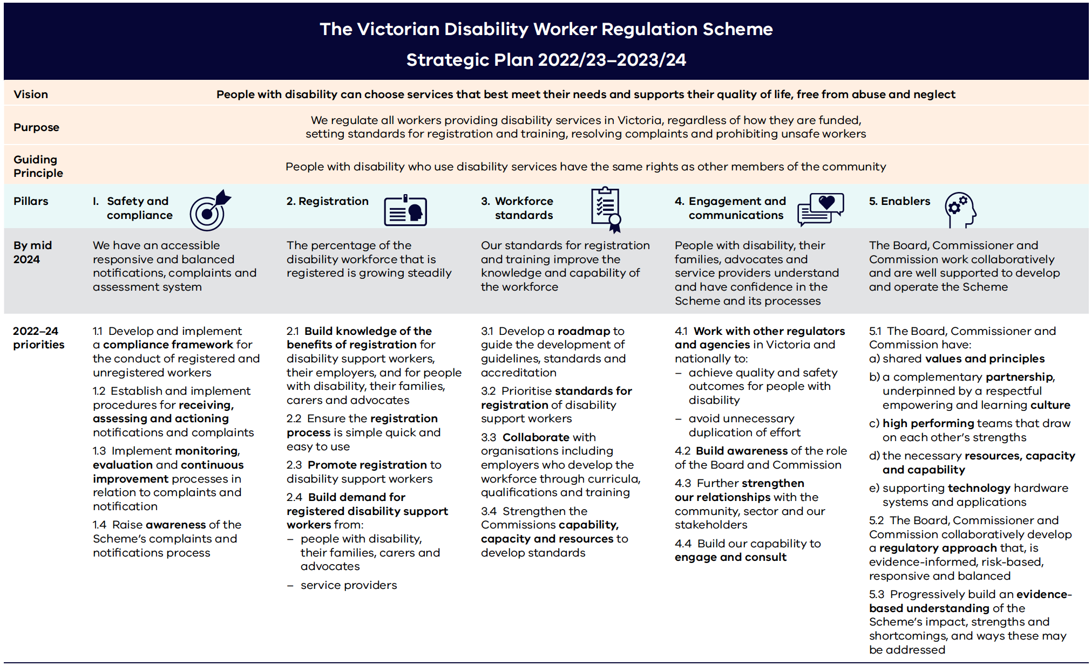

Pillar 1: Safety and compliance
Outcome by 2024: We have an accessible, responsive and balanced notifications, complaints and assessment system.

Description
The Commission’s complaints and notifications service improves the safety and quality of care and service standards across the Victorian disability sector.
We established robust policies and procedures to ensure the way we receive complaints and notifications and how we assess them is accessible, responsive and proportionate.
The service is independent, impartial and free. It takes into account the obligations of disability workers and their responsibility to comply with their obligations.

Highlights in 2021-2022
We received and managed 46 complaints, 70 notifications and 393 enquiries.
- The Commission has a ‘no wrong door’ policy to help enquirers get to the right place. It continues to work with other regulators and entities to help people get the right advice when they need it.
- Feedback from the disability sector continues to inform the improvement of processes for receiving and assessing complaints, notifications and undertaking investigations.
- The Commission launched a website subscription service for the community to get alerts about updates to prohibition orders.
- The Commission made a submission into the Commonwealth Regulatory Alignment Reform to increase safeguards for people with a disability in aged care and veterans in December 2021.

Our priorities for 2022 to 2024
- Develop and put in place a regulatory framework for the conduct of registered and unregistered workers.
- Put in place procedures for receiving, assessing and acting on notifications and complaints.
- Put in place monitoring, evaluation and continuous improvement processes for complaints and notifications.
- Raise awareness of the Scheme’s complaints and notifications process.

Pillar 2: Registration
Outcome by 2024: The percentage of the disability workforce that is registered is growing steadily.

Description
Disability worker registration aims to achieve a safer, stronger disability sector. Registration supports a high-quality disability workforce by ensuring workers’ suitability is independently assessed by the Disability Worker Registration Board of Victoria.
Registration fills a critical gap by ensuring registered disability workers meet set standards for safety, skills and professionalism – no matter how they are employed or how the service they provide is funded.

Highlights in 2021-2022
- Voluntary Victorian disability worker registration – the first of its kind in Australia – launched on 1 July 2021. Disability support workers and disability practitioners became eligible to apply for registration to show they are safe, skilled and professional.
- Disability worker registration was free for workers. It enabled those without qualifications to apply and have their skills and track record taken into account.
- The public register of Victorian disability workers launched on 1 October 2021. The register allows anyone to search the registration status of Victorian disability workers. View the Register of Victorian disability workers website <https://portal.vdwc.vic.gov.au/publicregister>.
- The Commission received funding from the Regulatory Reform Incentive Fund (administered by the Department of Treasury and Finance) to simplify the registration process for disability workers with an NDIS worker screening clearance. This project will be run with the Department of Families, Fairness and Housing in 2022-2023.

Our priorities for 2022 to 2024
- Build knowledge of the benefits of registration for disability support workers, their employers, and people with disability, their families, carers and advocates.
- Ensure the registration process is simple, quick and easy to use.
- Promote registration to disability support workers.
- Build demand for registered disability support workers from people with disability, their families, carers, advocates and service providers.

Pillar 3: Workforce standards
Outcome by 2024: Our standards for registration and training improve the knowledge and capability of the workforce.

Description
Establishing workforce standards and appropriate training is key to improving the quality of disability work. It will also lift standards of disability services across Victoria.
These workforce standards form part of the assessment of an applicant’s suitability to be registered as a disability worker. Lifting these standards contributes to disability workers delivering high quality and safe disability services. This in turn keeps people with disability safe when receiving these services.
Lifting workforce standards also contributes to raising the perception of the workforce. It provides a mechanism for registered workers to demonstrate their competencies and professionalism in providing disability services.

Highlights in 2021-2022
- The first registration year started with registration standards decided following consultation with the disability sector in 2020 and 2021. These include criminal history, English language competency, continuing professional development and the Code of Conduct for registered workers.
- The Board established a Board committee to lead and coordinate the development of future standards and guidance material, the Registration Standards Guidelines and Accreditation Committee.

Our priorities for 2022 to 2024
- Develop a roadmap to guide the development of guidelines, standards and accreditation.
- Prioritise standards for registration of disability support workers.
- Collaborate with organisations, including employers who develop the workforce through programs of study, qualifications and training.
- Strengthen the Commission’s capability, capacity and resources to develop standards.

Case study: Notification about an unregistered disability worker’s conduct

Notification
We received a mandatory notification from an employer about the conduct of unregistered disability worker, Samuel.
Samuel was providing services to Rosie, who lives in supported accommodation and has a neurological disability.
The notification alleged Samuel pushed Rosie and used a loud voice during the day after she had displayed disruptive behaviours.

What we did
We contacted Samuel about the notification. Samuel acknowledged using a loud voice to redirect Rosie. He denied using physical force to push her out of the room.
We reviewed Rosie’s behaviour support plan. It stated that support workers are only to use a firm voice at bedtime to manage challenging behaviour. At other times, workers are to adopt a calmer tone.
We reviewed the service provider’s investigation report. It found that the two support workers who reported the alleged conduct had not observed the incident. They heard the loud voice and had inferred that Samuel had pushed her.

Outcome
We assessed that Samuel’s conduct was not consistent with the following clauses in the Code of Conduct:
- Clause 3: Provide support and service in a safe and competent manner with care and skill
- Clause 5: Promptly take steps to raise and act on concerns about matters that may impact the quality and safety of supports and services provided to people with disability.
Samuel was counselled, providing him education on his obligation as a disability worker to know the details of behavioural support plans and how to safely implement them.
Please note: This case study shows a type of matter the Commission responded to in
2021-2022. This case study uses pseudonyms, and some details have been changed to protect the anonymity of the participants.

Pillar 4: Engagement and communication
Outcome by 2024: People with a disability, their families, carers and advocates, disability workers and service providers understand and have confidence in the Scheme and its processes.

Description
The primary aim of the Commission’s communications and engagement is to build awareness and understanding of the Scheme and the role of the Commission and the Board across the disability sector and the broader community.
A core component of this work is providing information and resources and communicating our role through engagement activities.
Strengthening our relationships with the community, disability sector and other major stakeholders is essential to meeting our objectives.

Highlights in 2021-2022
- Held a public event to launch disability worker registration on 1 July 2021.
- Conducted two public awareness and information campaigns for the Commission’s complaints function (throughout March and April 2022) and disability worker registration (throughout June, July and August 2022).
- Provided a range of ways for the community to contact us for enquiries or information, including e-newsletters, website and social media.
- Participated in and hosted various information sessions about the Scheme for the disability sector.
- Produced extensive in-language and Auslan resources, as well as closed captioning for events.

Our priorities for 2022 to 2024
- Work with other regulators and agencies in Victoria and nationally to:
  - achieve quality and safety outcomes for people with disability
  - avoid unnecessary duplication of effort.
- Build awareness of the role of the Board and Commission.
- Further strengthen our relationships with the community, sector and our stakeholders.
- Build our capability to engage and consult.

Pillar 5: Enablers
Outcome by 2024: The Board, Commissioner and Commission work collaboratively and are well supported to develop and operate the Scheme.

Description
The strong performance and working relationship between the Commissioner, the Board and the Commission is fundamental to an accessible, effective and sustainable Scheme.
Integral to the success of the scheme across the disability sector is the jointly developed strategic plan that guides the work of the Commission and Board as it evolves beyond the establishment stage.

Highlights in 2021-2022
- Developed a Scheme-wide strategic plan to guide the work of the Commission and Board to 2024, including an interim action plan in 2022.
- Established a measurement, evaluation and learning framework. It has been embedded in work across the Commission to support our performance and learning.
- Developed an online registration application pathway with Service Victoria.
- The Board and Commission made an annual regulatory management agreement.
- The Minister for Disability, Ageing and Carers issued his Ministerial Statement of Expectations for the Board and the Commission in April 2022.

Our priorities for 2022 to 2024
The Board, Commissioner and Commission have:
- shared values and principles
- a complementary partnership, underpinned by a respectful empowering and learning culture
- high performing teams that draw on each other’s strengths
- the necessary resources, capacity and capability
- supporting technology hardware systems and applications.
The Board, Commissioner and Commission collaboratively develop a regulatory approach that is evidence-informed, risk- based, responsive and balanced.
Progressively build an evidence-based understanding of the Scheme’s impact, strengths and shortcomings, and ways these may be addressed.

Case study: Complaint about an unregistered disability worker

Complaint
We received a complaint from a mother who was concerned about the conduct of Chris, an unregistered disability worker.
Chris was providing services to her child, Calum. Calum is a young adult with intellectual disabilities.
Chris was providing support to Calum for community participation. During this, Chris took Calum to his own medical appointment, where Chris received treatment.

What we did
We contacted Chris about the complaint. Chris acknowledged he took Calum to the appointment. He explained that it was an urgent appointment scheduled during his shift as he had been experiencing pain before his shift.
Chris advised that he did not want Calum to miss his community access time so had decided to take him to the medical appointment.

Outcome
Chris was counselled, providing him education on his obligations under the Code of Conduct.
Calum’s mother confirmed that she was happy with the outcome of the complaint and our help to address her concerns.
Please note: This case study shows a type of matter the Commission responded to in
2021-2022. This case study uses pseudonyms, and some details have been changed to protect the anonymity of the participants.

Case study: Karyn, support coordinator and registered disability worker
Karyn is a 49-year-old disability worker in central Victoria. She works as a direct care support worker for someone with complex disability. She is also a support coordinator who helps people with their NDIS plans.
Employed as a support worker for eight years and an unpaid carer for 15 years, Karyn has seen big changes in the sector.
One of the biggest changes was the introduction of the NDIS and the difficulties navigating plans. Seeing that support was needed in this area, Karyn moved into the disability workforce.
Karyn sees disability worker registration as a way to ensure the right people are entering the workforce.
Registration is so important as it means professionalism is being recognised and brought to the sector.
– Karyn, support coordinator and registered disability worker

Case study: Yunus, registered disability worker
Yunus is 18 years old and based in the northern suburbs of Melbourne. He has been working with people with disabilities for over two years.
Coming from a family with culturally and linguistically diverse (CALD) speakers, Yunus has focused his career on working with clients from CALD backgrounds.
He is now a proud support coordinator. He liaises with various organisations to ensure that people with disabilities are being supported regardless of who they are or what their disability is.
Having both family and friends with cognitive and physical disabilities, Yunus was familiar with the needs of people with disability in the community even before starting a career in the disability sector. He also knew the gaps where these needs were not being met.
Yunus’ long-term plan is to finish his Bachelor of Nursing and become a specialist support coordinator.
For Yunus, being registered gives him an extra layer of confidence in his skills that he can demonstrate to both clients and employers.
Being registered means I am able to show clients that I am trusted and qualified. I can also show potential employers I am willing to take that extra step for my career.
– Yunus, NDIS support coordinator and registered disability worker

2021-2022 financial information

Financial performance
Pursuant to a determination by the Assistant Treasurer on 21 March 2021, the financial statements of the Board and the Commission are prepared and consolidated with the financial statements of the Department of Families, Fairness and Housing. Disclosures required under the Financial Management Act 1994, Standing Directions and Financial Reporting Directions as notes to the financial statements are referenced in the department’s annual report.
The following are the principal operating expenses incurred by the Commission and Board in the financial year 2021-2022:
Table 2: Commission and Board operating expenses 2021-2022
Expenditure item | Amount ($)
Staffing employee expenses | 4,654,479
Other operating expenses | 4,003,911
Depreciation | 9,429
Grants and sponsorships | 8,500
Total | 8,676,319

Scheme funding
The DSS Act establishes a Disability Worker Regulation Fund, administered by the Commission (section 277). Payments to the Fund include:
- all fees, fines and penalties paid to the Board or the Commission
- any other funds the Board receives
- any money the Commission receives from the Public Account. The fund does not form part of the consolidated fund.
The 2021 State Budget identified funding for the Scheme in the 2021-2022 and 2022-2023 financial years only. In the 2021-2022 State Budget, $9.602 million was allocated in 2021-2022 to operate the Scheme. A forward budget of $10.094 million was identified in 2022-2023.

Financial management compliance attestation
I, Dan Stubbs, on behalf of the Responsible Body, certify that the Victorian Disability Worker Commission has no material compliance deficiency with respect to the applicable Standing Directions under the Financial Management Act 1994 and Instructions.
Dan Stubbs
Victorian Disability Worker Commissioner
Victorian Disability Worker Commission
Date signed: 5 September 2022
I, Melanie Eagle, on behalf of the Responsible Body, certify that the Disability Worker Registration Board of Victoria has no material compliance deficiency with respect to the applicable Standing Directions under the Financial Management Act 1994 and Instructions.
Melanie Eagle
Chairperson
Disability Worker Registration Board of Victoria
Date signed: 5 September 2022

Compliance

Amending Scheme legislation
There were no substantive amendments to the Disability Service Safeguards Act 2018 in the
reporting period.
On 1 July 2021 a new version of the Disability Service Safeguards Act 2018 came into force following
the repeal of:
- Division 2 of Part 17 (consequential amendments)
- Parts 18, 19 and 20 (regarding the enactment of Part 12A of Residential Tenancies Act 1997).

Government advertising expenditure
The advertising and campaign expenditure for the Commission in 2021-2022 is listed in Table 3.
Table 3: Advertising and campaign expenditure 2021-2022
Campaign | Summary | Start, end date | Advertising (media) expenditure (excl GST) | Creative and campaign development expenditure (excl GST) | Research and evaluation expenditure (excl GST) | Print and collateral expenditure (excl GST) | Other campaign expenditure (excl GST) | Total
Disability Worker Regulation Scheme Public Awareness Campaign – Phase 3 (Registration) | To build awareness and understanding about registration and how to register | June to September 2021 | Nil | Nil | $16,290 | Nil | Nil | $16,290
Disability Worker Regulation Scheme Public Awareness Campaign – Phase 4 (Complaints Campaign) | To build awareness and understanding of the complaints process and motivate audiences to seek information | March to April 2022 | $181,943 | $91,547 | $15,263 | Nil | Nil | $288,753
Disability Worker Regulation Scheme Public Awareness Campaign – Phase 5 (Registration) | To build awareness and understanding of registration and how to register | June 2022 | $98,119 | $30,493 | $50,405 | Nil | Nil | $179,017

Disclosure of ICT expenditure
The ICT expenditure for the Commission in 2021-2022 is listed in Table 4.
Table 4: ICT expenditure 2021-2022
Expenditure type | Amount ($)
Business as usual (BAU) ICT expenditure | 855,376
Non-BAU ICT expenditure: Operational | 119,737
Non-BAU ICT expenditure: Capital | Nil
Non-BAU ICT expenditure: Sub-total | 119,737
Total | 975,112

Disclosure of major contracts
The Commission and Board did not enter into any major contracts during 2021-2022. A major contract is one valued at $10 million or more.

Public sector values and employment principles
The Public Administration Act 2004 outlines the values and employment principles that apply to the public sector.
The Commission complies with these employment principles and regularly updates its policies and procedures to advance them. Our employment policies and practices, including the VPS common policies, are consistent with the principles. For example, merit and equity in selection processes to ensure applicants are assessed and evaluated fairly and equitably based on key selection criteria and other accountabilities without discrimination.
The Commission’s staff are employed under the Victorian Public Service Enterprise Agreement 2020.
No time has been lost as a result of industrial relations disputes.

Workforce data
Appendix 2: Workforce data has details of the Commission’s employee workforce data.
The Board has no employees.

The Commission makes the health, safety and wellbeing of our staff a priority

Occupational health and safety
The Commission makes the health, safety and wellbeing of our staff a priority. This commitment as an employer is embedded in the Victorian Public Service Enterprise Agreement 2020 and associated common policies.
The goal of the Commission’s occupational health and safety policy is to ensure all staff (and others accessing the Commission’s premises) remain safe and healthy at work with a continued commitment to occupational health and safety compliance, active risks and hazards assessment and control.
The Commission works closely with the Department of Families, Fairness and Housing’s Health, Safety and Wellbeing team to adopt their up-to-date health and safety procedures and guides. A focus on mental wellbeing is also part of the Commission’s strategy. Two staff members
will undergo mental health first aid certification to create a safe workplace for employees.
The Commission consulted with all staff members through surveys and meetings to co-create a hybrid work policy, keeping in mind all COVID-19 safety procedures, which included regular deep cleaning, flexible desk arrangements with individual storage pouches and IT equipment, sign in records for visitors and staff and prompt communication.
Staff elect a health and safety representative to represent their views on health and safety to the Commission. The representative can inspect any Victorian Disability Worker Commission and Disability Worker Registration Board of Victoria workplace in the event of an incident or a situation where there is an immediate risk to health and safety. They can also take part in investigations when an incident or injury has occurred. Various Occupational Health and Safety positions, namely fire wardens, floor warden, designated management representative and first aid representative were recently reviewed and filled. Elected representatives are undergoing relevant certifications and refresher training.
The performance outcomes for 2021-2022:
- number of reported hazards or incidents – nil
- number of ‘lost time’ standard claims – nil
- average cost per claim (including payments to date and an estimate of outstanding claim costs as advised by WorkSafe) – nil.

Freedom of Information Act
The Freedom of Information Act 1982 (FOI Act) gives the public access to documents held by the Commission and the Commissioner.
The purpose of the FOI Act is to extend, as far as possible, the right of the community to access information held by:
- government departments
- local councils
- ministers
- other bodies subject to the FOI Act.
This applies to documents both created by agencies and supplied to agencies by an external organisation or individual.
Information about the type of material produced by the Commission and Commissioner is available on the Commission website’s Part II Statement under the FOI Act page <https://www.vdwc.vic.gov.au/about/part-ii-statement-under-freedom-information-act>.
The FOI Act allows an agency to refuse access to certain documents or information, either fully or partially. Examples of documents that may not be accessed include:
- Cabinet documents
- some internal working documents
- law enforcement documents
- documents covered by legal professional privilege, such as legal advice
- personal information about other people
- information given to an agency in confidence.
FOI requests must generally be processed within 30 days. However, when external consultation is needed, processing time is 45 days. These timeframes may be extended in consultation with the applicant.
If an applicant is not satisfied with a decision made by an agency, they can seek a review by the Office of the Victorian Information Commissioner (OVIC) within 28 days of receiving a decision letter (section 49A).

Making a request
To make a Freedom of Information request, email the Commission's FOI Officer <foi@vdwc.vic.gov.au>.
An application fee applies. Access charges may also be payable if the document request is large and the search for material is time consuming.
When making FOI requests, applicants should ensure requests:
- are in writing
- clearly identify what types of material or documents are being sought
- include the relevant fee.

Freedom of information statistics
During the reporting period, the Commission and Commissioner received no requests under the FOI Act. The Commission and Commissioner were not required to make any FOI decisions in the reporting period.
During the reporting period, no requests were subject to a complaint or internal review by OVIC. No requests went to the Victorian Civil and Administrative Tribunal.

More information
More on the operation and scope of FOI is in the OVIC website’s Freedom of Information section <https://ovic.vic.gov.au/freedom-of-information>.

Access to information
The Commission and Board disclose information online and through printed publications.
We also provide information services:
- in person
- by phone
- in our annual report
- on the Commission’s website <https://vdwc.vic.gov.au>.

Competitive neutrality policy
Where services compete or may compete with the private sector, government businesses must ensure any advantage arising solely from government ownership be removed if it is not in the public interest.
Government businesses must cost these services as if they were privately owned.
Competitive neutrality policy supports fair competition between public and private businesses. It gives government businesses a tool to improve resource allocation decisions. This policy does not override other policy objectives of government. It focuses on efficiency in providing services.
The nature of the functions of the Board and Commission as independent regulators do not fall within the scope of the competitive neutrality policy.

Public Interest Disclosures Act
The Public Interest Disclosures Act 2012 (PID Act) encourages and helps people to make a disclosure about corrupt or improper conduct by a public officer or a public body.
The PID Act protects people who make disclosures in line with the Act. It also sets up a system for the matters disclosed to be investigated and rectified.
The Commission, the Commissioner and the Board are subject to the PID Act.
The entities are committed to the aims and objectives of the PID Act. They recognise the value of transparency and accountability in administrative and management practices. They support disclosures that reveal improper conduct or detrimental action.
The entities have established procedures for public interest disclosures. They have processes to protect people from detrimental action in reprisal for making a public interest disclosure.
The procedures are available on the Commission website’s Public interest disclosures page <https://www.vdwc.vic.gov.au/about/public-interest-disclosures>.

Making a public interest disclosure
Under the PID Act, the Commission and Board cannot receive public interest disclosures.
Contact the Independent Broad-based Anti- Corruption Commission (IBAC) to make a public interest disclosure about improper conduct or detrimental action by:
- the Board or its members
- the Commission or its officers or employees
- the Commissioner.
Contact IBAC:
- by mail – Independent Broad-based Anti- Corruption Commission, GPO Box 24234, Melbourne VIC 3001
- online – IBAC website’s Report corruption or misconduct page <https://www.ibac.vic.gov.au/reporting-corruption/report>
- by phone – 1300 735 135.

Additional information available on request
In compliance with the requirements of the Standing Directions 2018 of the Minister for Finance (FRD 22), details in respect of the following items (where applicable to the entities) have been retained.
This information is available on request, subject to the provisions of the FOI Act, other applicable laws and policies.
- A statement that declarations of pecuniary interests have been duly completed by all relevant officers.
- Details of shares held by a senior officer as nominee or held beneficially in a statutory authority or subsidiary.
- Details of publications produced by the entities and how these can be obtained.
- Details of changes in prices, fees, charges, rates and levies charged by the entities.
- Details of any major external reviews carried out on the entities.
- Details of major research and development activities undertaken by the entities.
- Details of overseas visits undertaken, including a summary of the objectives and outcomes of each visit.
- Details of major promotional, public relations and marketing activities undertaken by the entities to develop community awareness of the entities and their services.
- Details of assessments and measures undertaken to improve the occupational health and safety of employees.
- A general statement on industrial relations within the entities and details of time lost through industrial accidents and disputes.
- A list of major committees sponsored by the entities, the purposes of each committee and the extent to which the purposes have been achieved.
- Details of all consultancies and contractors including consultants or contractors engaged, services provided and expenditure committed for each engagement.
To request this information, email the Commission’s FOI Officer <foi@vdwc.vic.gov.au>.

Building Act
The Commission and Board do not own or control any government buildings. Because of this, they are exempt from notifying compliance with the building and maintenance provisions of the Building Act 1993.

Local Jobs First Act
The Local Jobs First Act 2003, introduced in August 2018, brings together the Victorian industry participation policy and Major project skills guarantee policy. These were previously administered separately.
Departments and public sector bodies must apply the Local jobs first policy in all projects valued at:
- $3 million or more in metropolitan Melbourne or for statewide projects
- $1 million or more for projects in regional Victoria.
No procurements initiated by the Commission or Board in the reporting period were assessed as falling within the policy.

Disability Act
The Disability Act 2006 reaffirms and strengthens the rights of people with disability. The Act recognises that this needs support across the government sector and within the community.
The Commission and Board actively seek to provide services in a way that reduces barriers and promotes inclusion and participation of people with disability.
The Commission supports the government’s Getting to work: Victorian public sector disability employment action plan 2018–2025. This is a long- term employment plan for people with disability in the public sector.
The government’s action plan target was six per cent representation by 2020 and 12 per cent by 2025. The Commission’s priority and target for employing people with disability is 20 per cent. This target was met in 2021-2022.
The Commission has also adopted the Disability confident recruitment guide, which helps recruiting managers to:
- improve their ability to recruit talented people with disabilities
- ensure recruitment processes are inclusive and barrier free for all candidates.
The Commission also participates in the Australian Network on Disability’s Stepping Into intern program. This is a paid internship scheme that matches talented university students with disability with supporting organisations.
Consistent with the functions of the Board, the Act requires that at least three members of the Board are people with disability.

Carers Recognition Act
The Commission and Board support the principles of the Carers Recognition Act 2012 to recognise the importance of carers and care relationships in our community.
The principles and obligations of the Act are encompassed within:
- VPS Enterprise Agreement
- VPS common policies
- flexible working arrangement guidelines, which support staff in their roles as carers.

Office-based environmental impacts
The Commission is committed to reducing our environmental footprint by promoting awareness and reducing environmental impacts.
The Commission has 48 personnel (VPS and contractors) and an accommodation space of 578 square metres.
The Commission aims to minimise electricity use by using efficient appliances and office equipment, including energy-efficient lighting.
The Commission uses 100 per cent recycled paper, creates and stores records electronically and encourages double-sided printing.
The Commission also separates waste systems into recycled, glass, landfill and compost.
As a result of public health measures during the COVID-19 pandemic, Commission staff worked from home for extended periods during 2021-2022.
The Commission has one assigned government vehicle. Staff are encouraged to use public transport for business activities.

Consultancy expenditure

Details of consultancies valued at $10,000 or greater
No consultancies were engaged in 2021-2022 where the total fees payable to the individual consultancy were greater than $10,000.

Details of consultancies under $10,000
No consultancies were engaged in 2021-2022 where the total fees payable to the individual consultancy were less than $10,000.

Declaration of pecuniary interests
All Commission officers exercising a financial delegation have completed a declaration of pecuniary interest in line with the Commission’s delegation and conflict of interest policies.

Disclosure of grants and sponsorships
The Commission provided sponsorship of $9,350 (including GST) for the National Disability Summit held on 2 to 3 December 2021.

Compliance with DataVic access policy
The Commission and Board are subject to the DataVic access policy.
No data was provided to DataVic in the reporting period.

Appendix 1: Disclosure index
The Commission and Board’s consolidated annual report is prepared in line with all relevant Victorian legislation and pronouncements. This index helps identify the Commission and Board’s compliance with statutory disclosure requirements.

Year in review
Legislation | Requirement | Page
FRD 22 | Manner of establishment and responsible minister | About us
FRD 22 | Nature and range of services provided | About us
FRD 22 | Functions, powers and duties | - About us  - Accountability of the Commission and Board  - Disability Worker Regulation Scheme
FRD 22 | Performance reporting (non-financial) – operational | Our Scheme strategic plan
FRD 22 | Summary of the financial results for the year | 2021-2022 financial information
FRD 22 | Major changes or factors affecting performance | Our operating environment

Governance and organisational structure
Legislation | Requirement | Page
FRD 22 | Organisational structure and corporate governance | About us  Governance and organisational structure
FRD 22 | Board’s role and membership | Governance and organisational structure
FRD 22 | Audit and Risk Committee membership | Shared Audit and Risk Committee
FRD 22 | Employment and conduct principles | Public sector values and employment principles

Workforce data
Legislation | Requirement | Page
FRD 22 | Public sector values and employment principles | Public sector values and employment principles
FRD 22 | Occupational health and safety | Occupational health and safety
FRD 29/  FRD 22 | Workforce data disclosures | Appendix 2: Workforce data
FRD 22 | Workforce inclusion policy | Public sector values and employment principles
FRD 10 | Disclosure index | Appendix 1: Disclosure index
FRD 15 | Consistency of budget and departmental reporting | Table 7: Annualised total salary of senior employees

Other disclosures as required by FRDs
Legislation | Requirement | Page
FRD 25 | Local Jobs First | Local Jobs First Act
FRD 22 | Disability Act 2006 | Disability Act
FRD 22 | Disclosure of government advertising expenditure | Government advertising expenditure
FRD 22 | Details of consultancies over $10,000 | Details of consultancies valued at $10,000 or greater
FRD 22 | Details of consultancies under $10,000 | Details of consultancies under $10,000
FRD 22 | Disclosure of ICT expenditure | Disclosure of ICT expenditure
FRD 12 | Disclosure of major contracts | Disclosure of major contracts
 | Declaration of pecuniary interests | Declaration of pecuniary interests
FRD 22 | Application and operation under the Freedom of Information Act 1982 | Freedom of Information Act
FRD 22 | Compliance with Building Act 1993 | Building Act
FRD 22 | Statement on competitive neutrality policy | Competitive neutrality policy
FRD 22 | Application of the Public Interest Disclosures Act 2012 | Public Interest Disclosures Act
FRD 24 | Reporting on office based environmental impacts | Office-based environmental impacts
FRD 22 | Statement of availability of other information available on request | Additional information available on request

Compliance attestation and declaration
Legislation | Requirement | Page
SD 5.1.4 | Attestation for compliance with Ministerial Standing Directions | Financial management compliance attestation
SD 5.2.3 (c) | Declaration in the report of operations | Responsible bodies declaration

Legislation
Legislation | Page
Freedom of Information Act 1982 | Freedom of Information Act
Building Act 1993 | Building Act
Public Interest Disclosures Act 2012 | Public Interest Disclosures Act
Local Jobs First Act 2003 | Local Jobs First Act
Financial Management Act 1994 | Responsible bodies declaration  Shared Audit and Risk Committee  2021-2022 financial information
Public Administration Act 2004 | Victorian Disability Worker Commissioner  Victorian Disability Worker Commission  Disability Worker Registration Board of Victoria  Accountability of the Commission and Board  Public sector values and employment principles  Appendix 2: Workforce data
Disability Act 2006 | Disability Act
Carers Recognition Act 2012 | Carers Recognition Act

Appendix 2: Workforce data
The following is the number of (headcount) staff and full-time staff equivalent (FTE) of all active Commission employees in the last full pay period in June of the most recent financial year (2021-2022).
It does not include:
- external contractors or consultants
- temporary staff employed through employment agencies
- people who are not employees but are appointees to a statutory office, as defined in the Public Administration Act 2004.
Table 5: Workforce data as at June 2022
Topic | Group | All: Number | All: FTE | Ongoing: Full-time | Ongoing: Part-time | Ongoing: FTE | Fixed term and casual: Number | Fixed term and casual: FTE
Gender | Women | 25 | 22.5 | 12 | 7 | 17.1 | 6 | 5.4
Gender | Men | 13 | 13 | 10 | 0 | 10 | 3 | 3
Gender | Self-described | 0 | 0 | 0 | 0 | 0 | 0 | 0
Age | 15 to 24 years | 0 | 0 | 0 | 0 | 0 | 0 | 0
Age | 25 to 34 years | 4 | 4 | 3 | 0 | 3 | 1 | 1
Age | 35 to 44 years | 17 | 15.7 | 9 | 4 | 12.9 | 4 | 2.8
Age | 45 to 54 years | 12 | 11.2 | 6 | 3 | 8.2 | 3 | 3
Age | 55 to 64 years | 4 | 4 | 4 | 0 | 4 | 0 | 0
Age | 65 years and over | 1 | 0.6 | 0 | 0 | 0 | 1 | 0.6
Classification | VPS 1 to 6 | 37 | 34.5 | 22 | 7 | 27.1 | 8 | 7.4
Classification | VPS 2 | 0 | 0 | 0 | 0 | 0 | 0 | 0
Classification | VPS 3 | 3 | 3 | 2 | 0 | 2 | 1 | 1
Classification | VPS 4 | 11 | 11 | 10 | 0 | 10 | 1 | 1
Classification | VPS 5 | 12 | 10.8 | 6 | 4 | 8.8 | 2 | 2
Classification | VPS 6 | 11 | 9.7 | 4 | 3 | 6.3 | 4 | 3.4
Classification | Executives | 1 | 1 | 0 | 0 | 0 | 1 | 1
Total | Total employees | 38 | 35.5 | 22 | 7 | 27.1 | 9 | 8.4

Table 6: Workforce data as at June 2021
Topic | Group | All: Number | All: FTE | Ongoing: Full-time | Ongoing: Part-time | Ongoing: FTE | Fixed term and casual: Number | Fixed term and casual: FTE
Gender | Women | 18 | 16.4 | 0 | 0 | 0 | 18 | 16.4
Gender | Men | 8 | 8 | 0 | 0 | 0 | 8 | 8
Gender | Self-described | 0 | 0 | 0 | 0 | 0 | 0 | 0
Age | 15 to 24 years | 0 | 0 | 0 | 0 | 0 | 0 | 0
Age | 25 to 34 years | 3 | 3 | 0 | 0 | 0 | 3 | 3
Age | 35 to 44 years | 11 | 9.8 | 0 | 0 | 0 | 11 | 9.8
Age | 45 to 54 years | 8 | 7.6 | 0 | 0 | 0 | 8 | 7.6
Age | 55 to 64 years | 4 | 4 | 0 | 0 | 0 | 4 | 4
Age | 65 years and over | 0 | 0 | 0 | 0 | 0 | 0 | 0
Classification | VPS 1 to 6 | 25 | 23.4 | 0 | 0 | 0 | 25 | 23.4
Classification | VPS 2 | 0 | 0 | 0 | 0 | 0 | 0 | 0
Classification | VPS 3 | 4 | 4 | 0 | 0 | 0 | 4 | 4
Classification | VPS 4 | 7 | 7 | 0 | 0 | 0 | 7 | 7
Classification | VPS 5 | 9 | 7.8 | 0 | 0 | 0 | 9 | 7.8
Classification | VPS 6 | 5 | 4.6 | 0 | 0 | 0 | 5 | 4.6
Classification | Executives | 1 | 1 | 0 | 0 | 0 | 1 | 1
Total | Total employees | 26 | 24.4 |  |  |  | 26 | 24.4

The following table shows the annualised total salary for the Commission’s senior employees (by $20,000 bands, for executives and other senior non-executive staff).
Table 7: Annualised total salary of senior employees
Income band (full-time annualised salary) | Executive officers | STS
$200,000 to $219,000 | 1 | Nil
Total | 1 | Nil

Appendix 3: Scheme safety and compliance, and registration data

Registration applications: 1 July to 30 June 2022
Table 8: Applications by status
Application status | Number of applications | Per cent
Registration granted | 400 | 65.6%
Withdrawn under section 153(5) | 87 | 14.3%
Withdrawn by applicant | 75 | 12.3%
Application remains open | 48 | 7.9%
Total applications received | 610 | 100.0%
Table 9: Applications by division
Division | Number of applications | Per cent
Disability Practitioner | 111 | 18.2%
Disability Support Worker | 499 | 81.8%
Total | 610 | 100.0%
Table 10: Applications by pathway
Pathway | Number of applications | Per cent
Multiple pathways chosen | 9 | 1.5%
Training | 46 | 7.4%
Experience | 158 | 25.9%
Qualifications | 397 | 65.1%
Total | 610 | 100.0%

Table 11: Applicant demographics – age
Age range | Number of applications | Per cent
Under 20 years | 7 | 1.2%
20 to 29 years | 83 | 13.6%
30 to 39 years | 133 | 21.8%
40 to 49 years | 148 | 24.3%
50 to 59 years | 170 | 27.9%
60 years and over | 69 | 11.3%
Total | 610 | 100.0%
Table 12: Applicant demographics – gender
Gender | Number of applications | Per cent
Women | 391 | 64.1%
Men | 218 | 35.7%
Self described | 1 | 0.2%
Total | 610 | 100.0%

Contact and submissions
The Commission is committed to ensuring that our service is accessible and responsive.
We continue to provide guidance on the Scheme for people with disability, families, carers, disability workers and service providers. This includes advice to disability workers and their employers on their obligations under the DSS Act.
We offer a range of ways for people to contact us:
- through our website
- dedicated phone line
- emails
- referrals.
To ensure responsiveness, we have a ‘no wrong door’ approach. This means that not only do we support people contacting us, we work closely with other entities to help people to get to the right place.
In our second year of operations, most people contacted us with enquiries (77 per cent), as the sector continued to engage with us to understand the Scheme.

Table 13: Number of contacts
Type of contact | Number | Percent (%)
Complaint | 46 | 9.0%
Enquiry | 393 | 77.2%
Notification | 70 | 13.8%
Total | 509 | 100.0%
Most complaints and enquiries were made by phone as shown in Tables 14 and 15.
Table 14: Complaints by mode of submission
Mode of submission | Number | Percent (%)
Email | 7 | 15.2%
Phone | 27 | 58.7%
Website | 7 | 15.2%
Other | 5 | 10.9%
Total | 70 | 100.0%
Most notifications were made using the online complaints and notification form on our website. Feedback from service providers suggests they have found the website to be more convenient, particularly as they become more familiar with the Scheme and their notification obligations.

Enquiries regarding complaints or notifications
Making a complaint
The Commission manages complaints about disability workers providing disability services.
Complaints can be made by anyone in the community who is concerned about the professional conduct of a worker.
A person can make a complaint about a disability worker’s professional conduct, including:
- the standard of the disability services provided by the disability worker
- the knowledge, skill or judgement possessed by the disability worker
- the disability worker’s suitability to hold registration
- the disability worker’s capacity to practise in a safe manner
- alleged breaches of the Disability Service Safeguards Act 2018, or an approved code of conduct
- notifiable conduct.
Table 15: Enquiries by mode of submission
Mode of submission | Number | Percent (%)
Email | 105 | 26.7%
In person | 1 | 0.3%
Phone | 157 | 40.0%
Referral from other entity | 1 | 0.3%
Relay service | 1 | 0.3%
Website | 127 | 32.3%
Other | 1 | 0.3%
Total | 393 | 100.0%
Table 16: Notifications by mode of submission
Mode of submission | Number | Percent (%)
Email | 20 | 28.6%
Phone | 7 | 10.0%
Website | 43 | 61.4%
Total | 70 | 100.0%
Table 17: Mode of submission for all matters
Mode of submission | Number | Percent (%)
Email | 132 | 25.9%
In person | 1 | 0.2%
Phone | 191 | 37.5%
Referral from other entity | 1 | 0.2%
Relay service | 1 | 0.2%
Website | 177 | 34.8%
Other | 6 | 1.2%
Total | 509 | 100.0%

Table 18: Notifications by type of conduct for matters closed 2021-2022
Conduct | Number | Percent (%)
Sexual misconduct – s58(b) | 2 | 2.9%
Worker's capacity to practice as disability worker – s58(c) | 2 | 2.9%
Intoxication while practising – s58(a) | 4 | 5.9%
Significant departure from accepted professional standards – s58(d) | 60 | 88.2%
Total | 68 | 100.0%
Table 19: Notifications in 2021-2022 by type of service given by unregistered disability worker in 2021-2022
Type of service | Number | Percent (%)
Type of service not yet assessed as matter in initial consideration | 5 | 7.1%
Accommodation supports (including specialist disability accommodation and supported independent living) | 44 | 62.9%
Day services | 5 | 7.1%
Home modifications | 1 | 1.4%
In-home supports | 15 | 21.4%
Total | 70 | 100.0%
As shown in Table 19, notifications by type of service given by unregistered disability worker in 2021-2022, notifications received about unregistered disability workers were mostly about:
- disability services in supported independent living (or group homes) – 63 per cent
- in-home support – 21 per cent.

Notifications
Disability workers and employers must tell us about a concern that a disability worker may be putting safety at risk. These matters are called 'notifications'. There are four types of notifiable conduct:
- intoxication when practising
- sexual misconduct while practising
- having an impairment that detrimentally affects the worker's capacity to practice safely
- placing a person or the public at risk of harm because of a significant departure from accepted professional standards.
Most mandatory notifications about unregistered disability workers closed in 2021-22 were about conduct considered a significant departure from accepted professional standards (88 per cent). Smaller numbers of reports were about:
- alleged sexual misconduct while practising
- an impairment that may detrimentally affect the worker's capacity to practice safely
- being intoxicated by alcohol or drugs while practising.
Table 20: Notifications received in 2021-2022 by notifier type
Notifier | Number | Percent (%)
Relationship not yet assessed | 6 | 8.6%
Colleague or other disability worker | 10 | 14.3%
Employer | 54 | 77.1%
Total | 70 | 100.0%
Table 20 shows the majority of notifications received in 2021-2022 about disability workers were made by the employer (77 per cent).
The unregistered disability worker was employed by a NDIS provider in 97 per cent of notifications closed during 2021-2022.
All matters about workers employed by NDIS registered service providers were referred to the NDIS Quality and Safeguards Commission, as required by the Disability Service Safeguards Act 2018 (DSS Act).
Table 21: Outcomes of notifications closed in 2021-2022
Action taken | Number | Percent (%)
Counselling | 43 | 63.2%
No further action | 25 | 36.8%
Total | 68 | 100.0%
Table 21 shows that of the 68 closed notifications, 43 (63 per cent) were closed with the Commission deciding to counsel the disability worker. This means that the disability worker was given education on the Code of Conduct and their obligations under the DSS Act.
Twenty-five matters needed no further action. This is mostly because there was not enough information available to the Commission about the alleged conduct.
With the DSS Act imposing new obligations, deciding to counsel the worker may often be a proportionate response. This compliance focus aims to ensure that disability workers fully understand their obligations. As the Scheme becomes more mature and expectations and understanding of regulatory obligations improve, a proportionate response is likely to include a wider range of compliance and enforcement tools.

Complaints
Table 22: Complaints received in 2021-2022 by initiator
Initiator | Number | Percent (%)
Service user | 33 | 71.7%
Advocate | 7 | 15.2%
Carer | 1 | 2.2%
Family member or friend | 3 | 6.5%
Other | 2 | 4.4%
Total | 46 | 100.0%
Table 22 shows that we received 46 complaints about unregistered disability workers.
Seventy-two per cent of complaints were made by a person receiving disability services in 2021-2022.
This contrasts with only 17 per cent of complaints in 2020-2021 from a person receiving a disability service.
The majority of complaints (56 per cent) related to services provided in the home.
For complaints closed in 2021-2022, the vast majority of the unregistered disability workers worked for a registered NDIS service provider (81 per cent). This is similar to notifications.
All matters about workers employed by NDIS registered service providers were referred to the NDIS Quality and Safeguards Commission, as required by the Disability Service Safeguards Act 2018.
Similar to 2020-2021, people raised a range of issues in complaints – some may have raised multiple issues.
The Commission classifies complaints by the primary issue raised by the complainant. In
2021-2022, the majority of complaints related to competency and safety, or the knowledge skills and judgement of the worker (Table 23).

Table 23: Primary issue raised in complaints closed in 2021-2022
Type of conduct | Number | Percent (%)
Abuse and neglect | 5 | 11.6%
Alleged contravention of the code of conduct | 7 | 16.3%
Competency and safety | 12 | 27.9%
Freedom of expression, self-determination and decision making | 1 | 2.3%
Integrity, honesty and transparency | 1 | 2.3%
Knowledge, skills or judgement of the disability worker | 10 | 23.3%
Standard of disability services | 7 | 16.3%
Total | 43 | 100.0%
Table 24: Outcomes of complaints closed in 2021-2022
Action taken | Number | Percent (%)
Counselling | 20 | 46.5%
Complaint withdrawn | 1 | 2.3%
Not a disability worker | 1 | 2.3%
Settle by agreement | 2 | 4.7%
Closed due to lack of information | 1 | 2.3%
No further action taken | 18 | 41.9%
Total | 43 | 100.0%
As shown in Table 24, for complaints closed in 2021-2022, 46 per cent were resolved by a worker being counselled. With the Code of Conduct being a new obligation, deciding to counsel the worker may often be a proportionate regulatory action. It is appropriate that the Commission educates workers on their obligations under the Act and the Code of Conduct. This focus aims to ensure that disability workers fully understand their obligations.

Investigations
Table 25: Investigations started in 2021-2022 – basis of investigation
Source | Number | Percent (%)
Notification | 3 | 75.0%
Own motion or Commissioner initiated | 1 | 25.0%
Total | 4 | 100.0%
In 2021-2022, the Commission worked on 16 investigations into the conduct of unregistered disability workers. Four of these investigations were started in 2021-2022. One investigation was finalised in 2021-2022.
The Commission issued interim prohibition orders against two unregistered disability workers in 2021-2022. An interim prohibition order prohibits a disability worker from delivering disability services for a specified time, for a period of up to 12 weeks.

Australian Bureau of Statistics 2018, Disability, ageing and carers, Australia: summary of findings, Australian Government, Canberra. Cited in Department of Families, Fairness and Housing 2022, Inclusive Victoria: state disability plan 2022–2026, State of Victoria, Melbourne, p 12.
Australian Institute of Health and Welfare 2020, People with disability Australia, Australian Government, Canberra.
Australian Bureau of Statistics 2018, Disability, ageing and carers, Australia: summary of findings, Australian Government, Canberra.
National Disability Services Victoria, Victorian disability workforce environmental scan for 2022, February 2022, p 6.

